Dear Marie:

Sorry, the C1 and C3 is out of stock, we have other designs for you for choose, just write down the quantity of each design you like ,before the word“pair” .thank you very much.

Sorry again,
Bonnie

C2 size: 11, 12,13cm 5------ pairs
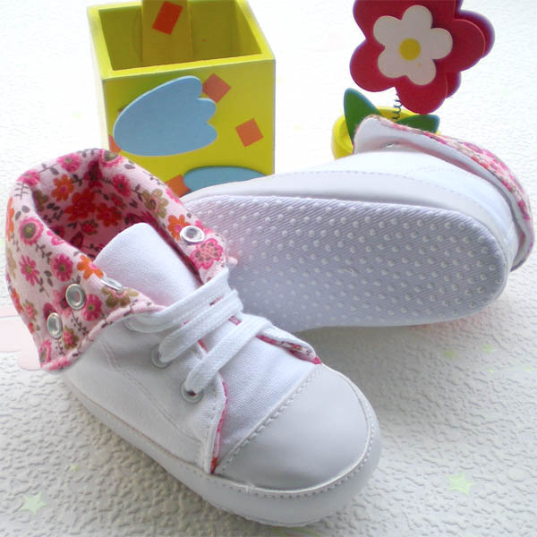

C4 size:10, 11, 12,cm ---5--- pairs
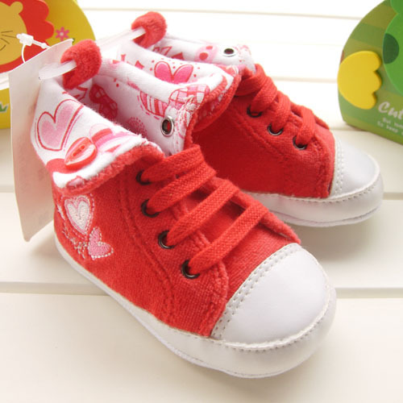

C5 size: 10.5, 11.5, 12.5,13.5cm ---20--- pairs
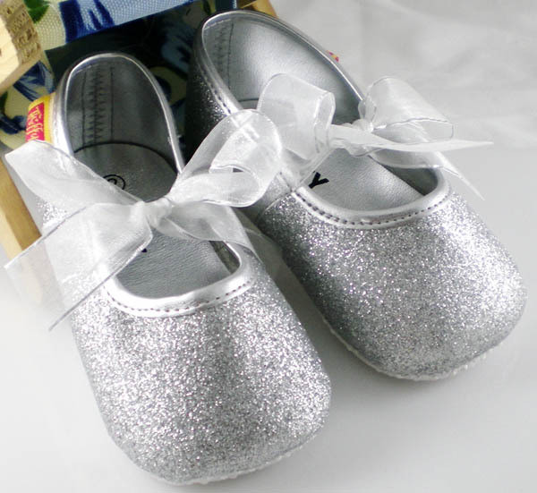

C6 size: 10.5, 11.5, 12.5,13.5cm --20---- pairs
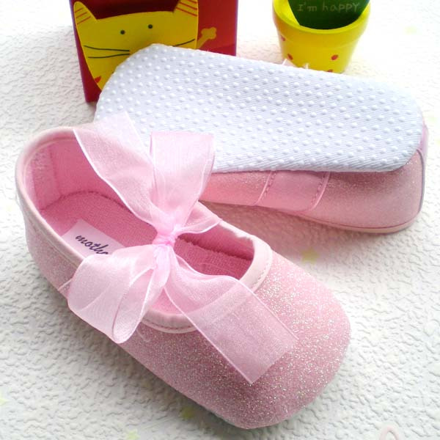

C7 size:10, 11, 12,cm --5---- pairs
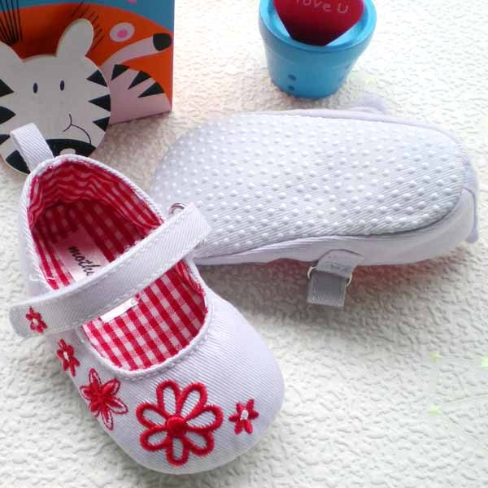

C9 size:12,13cm brand：disney --5--- pairs
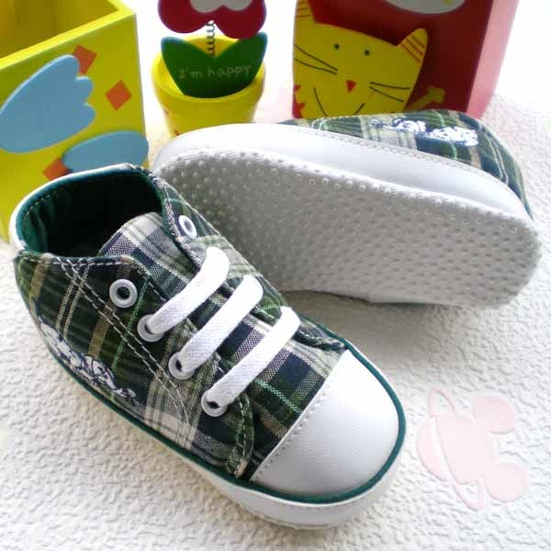

C13 size:12.5cm -0---- pairs
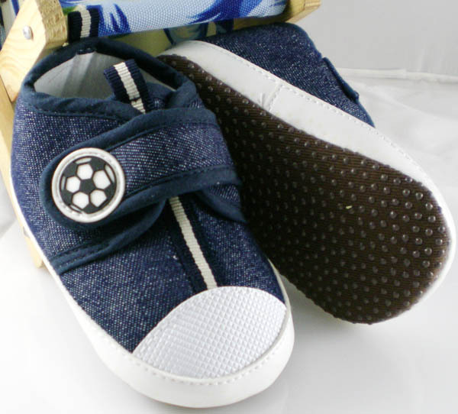

AD4236 size: 11, 15, 16cm brand : disney --5--- pairs
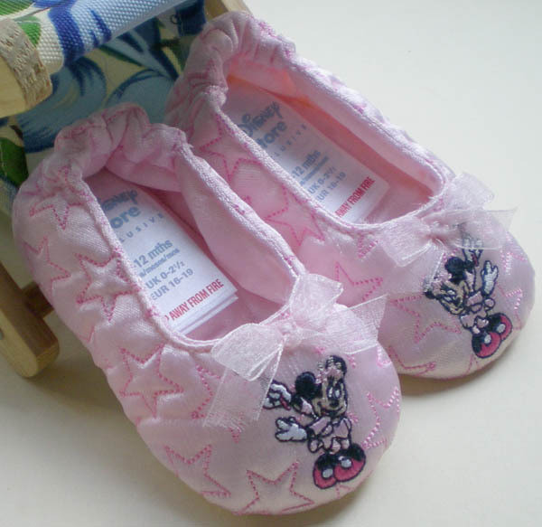

AD4245 size: 14.5, 15, 16cm brand : disney ----- pairs
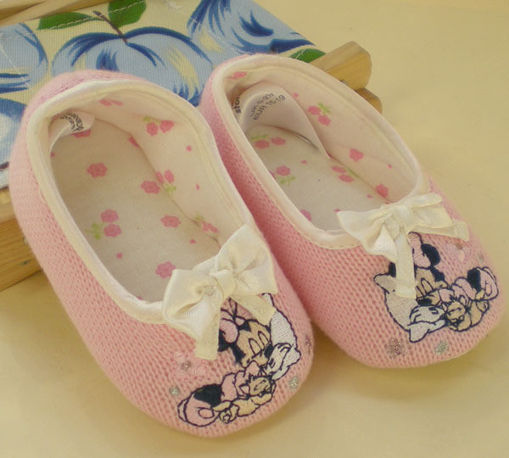
AA12101 size:11,12,13cm brand：Mothercare -5----- pairs
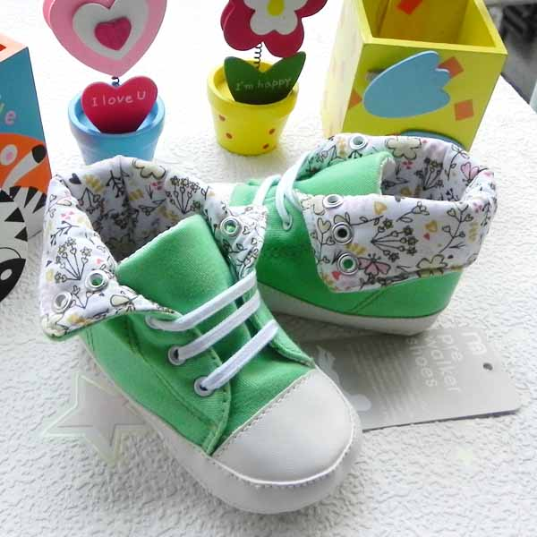
AA112301 size:11,12,13cm brand：Mothercare ------ pairs
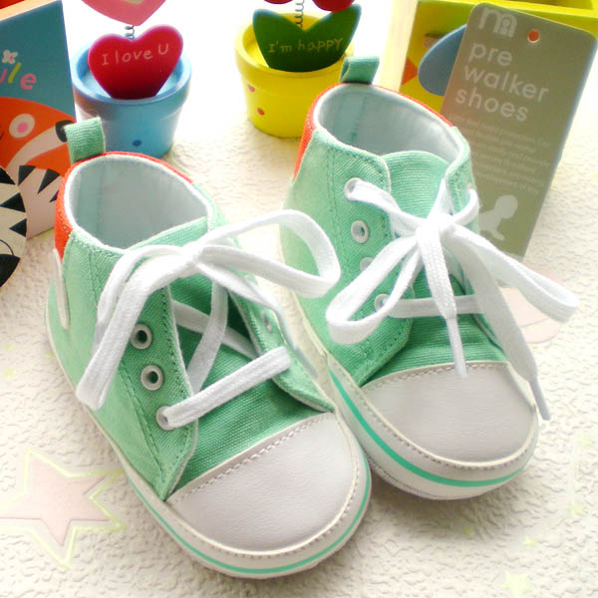

AA112302 size:11,12,13cm brand：Mothercare --5---- pairs
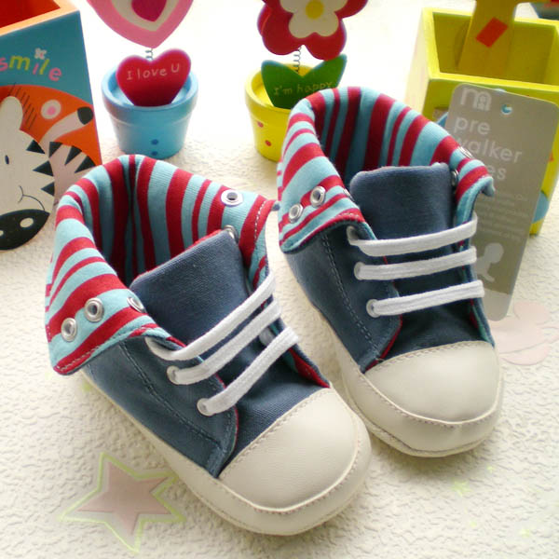

AA112304 size: 11, 12, 13cm --5---- pairs
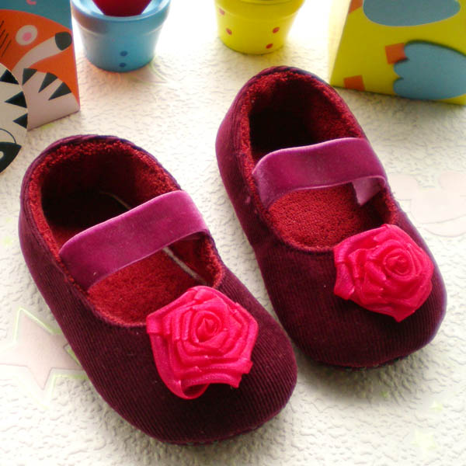

SS2059-0 size: 11, 12, 13cm brand:old navy ------ pairs
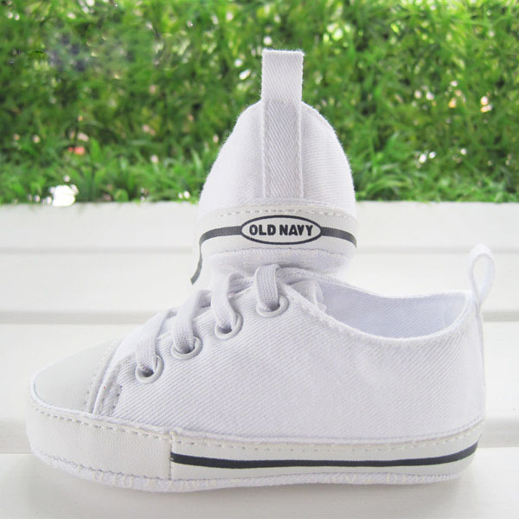

SS2059-0 size: 11, 12, 13cm brand:old navy ------ pairs
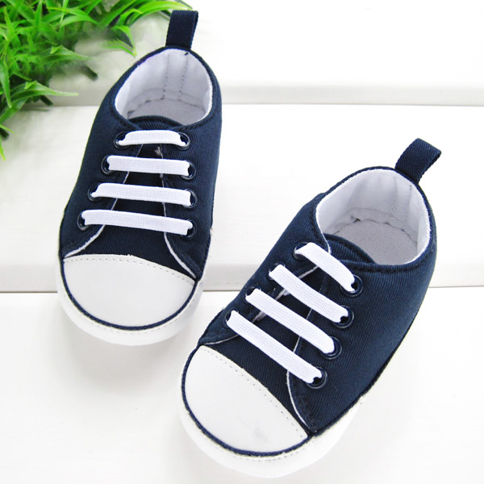

SS2059-0 size: 11, 12, 13cm brand:old navy ------ pairs
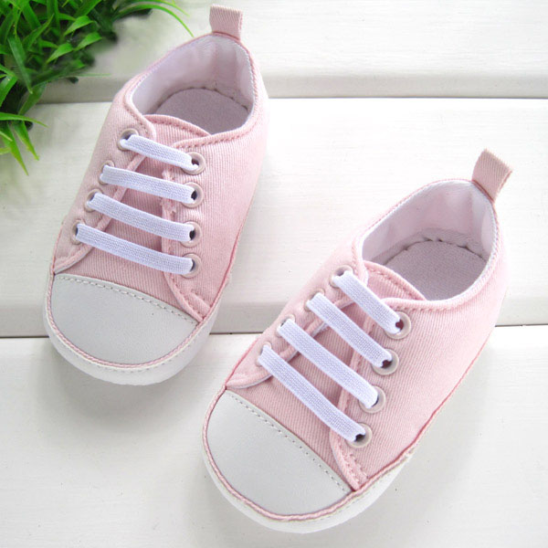

EE112103 size: 10, 11, 12,cm --5---- pairs
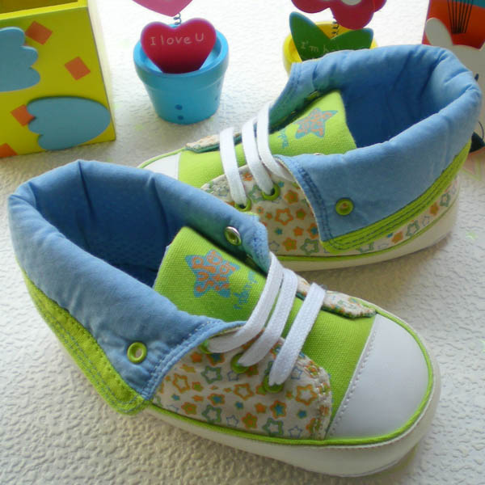

AE1121002 size: 10, 11cm --5--- pairs
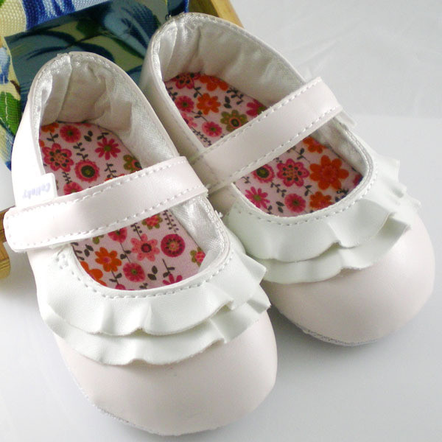

AA12103 size: 11, 12, 13cm ----- pairs
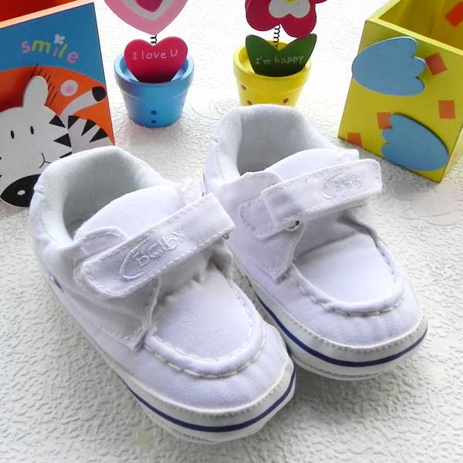

AA12102-1 size: 11, 12, 13cm ----- pairs
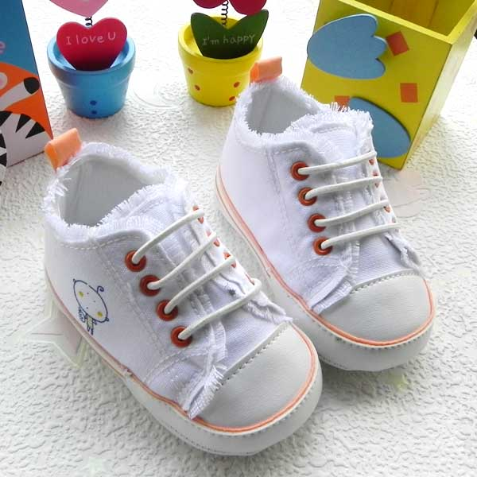

AA12102-2 size: 11, 12, 13cm ----- pairs
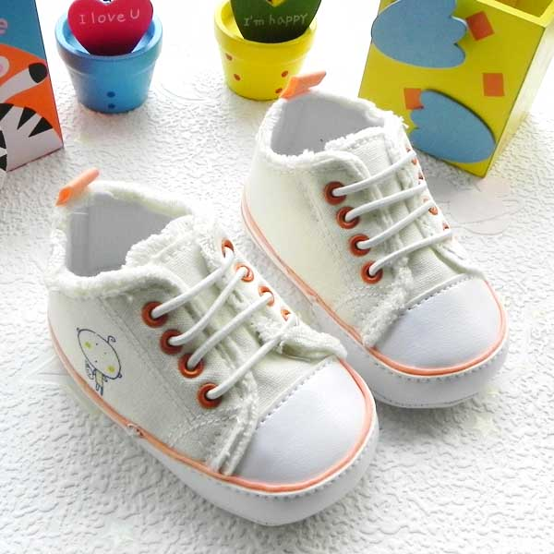

EE817004 size: 10, 11, 12, 13cm ----- pairs
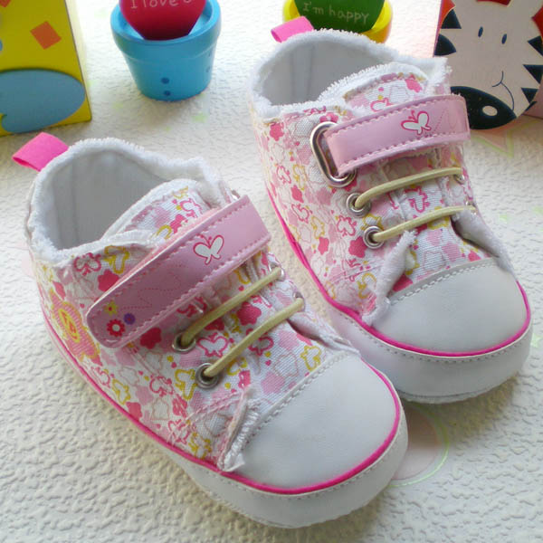

EE817004 size: 11.5, 12.5, 13cm ----- pairs
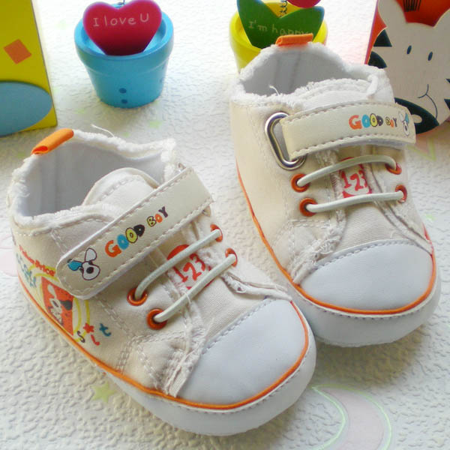

EE817006 size: 11, 12, 13cm ----- pairs
