Welcome to Kindness House
Kindness House is a leading online retailer selling donated second hand and new Books, DVD’s, CD’s and console Games. Kindness House offers over 5000 leading brand/title books, dvd’s, cd’s and console games at unbelievable prices, we are not only saving these items from going to land fill but we are also ensuring that their second life contributes to the world!
Kindness House is different! Yep not only are you getting some fantastic deals and products but your order is also going to make a big change! Kindness House distributes ALL PROFITS to charities and organizations. More importantly than that our community helps us decide which ones we should be supporting and we make sure we review them thoroughly and get detailed updates and reports back to us on what the funds are doing within their organization.
So please enjoy Kindness House, buy up big and take pride in the fact that you are doing more than just shopping, you are making a significant and powerful change!
Kindness House Promise: The Kindness House online store exist purely to support, help and change the lives of all living beings. We do this through the online sale of donated books, DVD’s, CD’s and games.
Our Mission, which we have chosen to accept, is to provide a wonderful online shopping experience to the consumer which is the key to fulfilling our ultimate obligation to provide consistently attractive returns to be distributed to charities big and small!
Our Values: very simple really. Value 1: generate funds ethically and morally with an environmentally sustainable approach. Value 2: support any charity that fosters and supports a compassionate, fair and rewarding life to all and any living being.
The difference: Kindness House will operate as a professional online retailer and do all within its power to generate funds ethically and morally.
Distribution of funds will only be done following a full week review of the charity by a Kindness House ambassador, a report provided and commented by you guys, our loyal customers & supporters.
The selected charities will be required to provide The Kindness House community (you!), online updates on the use/outcome of the funds provided.
We need your help, we cannot do this alone: Ultimately it is all about you, your donations, your orders, your support we promise will make a MASSIVE difference!

Some other logos we liked

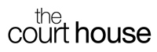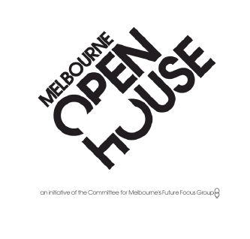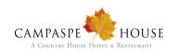
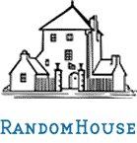
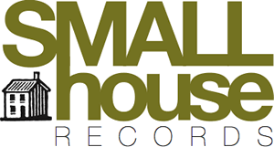


Other text and comments / NOTES – need to be reviewed father.
“We’re not a traditional company with an add-on “cause” component. Social and environmental responsibility is the core of our business. In fact it is our soul.”
Access to books and educational materials are basic human rights. That's why books sold on KindnessHouse.com are priced at level’s making them more affordable to lower income families. We also run programs to donate books and educational DVD’s/cd’s to schools, libraries and communities that do not have adequate resource for their communities.
Every book, dvd or cd purchased from Kindness House contributes to improved welfare for all beings throughout the world and the promise of a better life. Clearly, we can’t do this work without our customers. That's why we’re so passionate about trying to offer the best price, selection, customer service, and overall shopping experience.
Thanks for joining us in our mission to create a kinder & more compassionate world, one online order at a time.
Auditing: We are committed to our mission statement and guarantee that all profits will go to charities and NGO’s as such we shall release an independent audit each financial year.
Who we are: Kindness House is an initiative of The Paterson Family Trust, The Winsome Constance Kindness Trust and Simple Net.
Getting Involved:
Everyone can help, big and small. Our wish list:
Volunteers to assist in product entry and fulfillment
Bloggers / Online experts – talk about us, promote us!
Collection bin locations – Put a Kindness Bin in your office / origination
DONATE – books, dvd’s and cd’s
BUY something from us! In fact buy a lot form us!

Kindness House is an online store with a heart and a soul. Created to make difference to all being lives it is driven & supported by passionate people and a passionate consumer community.
Kindness House takes donated goods and turns them into a commitment to do well. The kindness of people can be overwhelming and the power of the consumer un matched.
Catch phrases? Needed?

Every purchase funds change!

The online store with a soul!

e-commerce for change

The only online retailer where shopping is much more than buying something, it is changing lives.

Kindness House – giving good’s a second chance

Kindness House – giving book’s, games & dvd’s a second chance

Kindness House – book’s, games & dvd’s that make a change

Kindess House – good will shopping

Kindness House Online – Giving goods a second chance
An initiative of Kindsome & Paterson Family Trust

Kindness House Online – Giving goods a chance to help
An initiative of Kindsome & Paterson Family Trust

Australia’s largest companionate online retailer

For all charities big & small

Quality of Our Books, DVD’s, CD’s and Console Games
We strive to provide the highest quality product and for your benefit we have provided a simple Product Condition guide to help you understand what products you are buying, they are:
Brand New: The highest quality, perfect condition, generally still wrapped or with pricing label on it, donated or sourced as a brand new item.
Good as New: Pristine, Very, very good quality, fully functional and could just about pass as a brand new item, but we just legally cannot say it is.
Fair (for books only): Good condition may have a few marks but nothing too serious
Poor (for books only): It has had better days no doubt about it
Some important notes:
DVD’s, CD’s & Games will only be listed under Brand New or Good as New, we Endeavour to test each product but unfortunately cannot provide any guarantee that they work. If you have any problems then feel free to contact us and I am sure we can assist you.

