
Campaign Analysis: OO.com.au

Overview

The following brief is for the development of a product landing page for Tom Tom products for the website www.oo.com.au

The page will display three links to three GPS products:
- http://www.oo.com.au/TomTom_XXL_540_GPS_-_12_7cm_5_P48200.cfm
- http://www.oo.com.au/TomTom_Go_750_11_1cm_4_3_Wi_P40498.cfm
- http://www.oo.com.au/TomTom_Go_950_Live_GPD_-_11_1c_P53316.cfm
Design Considerations
Please keep the following in mind when designing:

- Traffic from this page will be directed to the appropriate product specific page on www.oo.com.au so please ensure there is a level of consistency in visual theme between this page and the main website.
- Try to keep calls to action above the fold as much as possible.
- The view product buttons should be some of the most visually dominant elements on the page – they are where the eye should be drawn.
- Page width should be 955 pixels to match the main site.
Design Brief
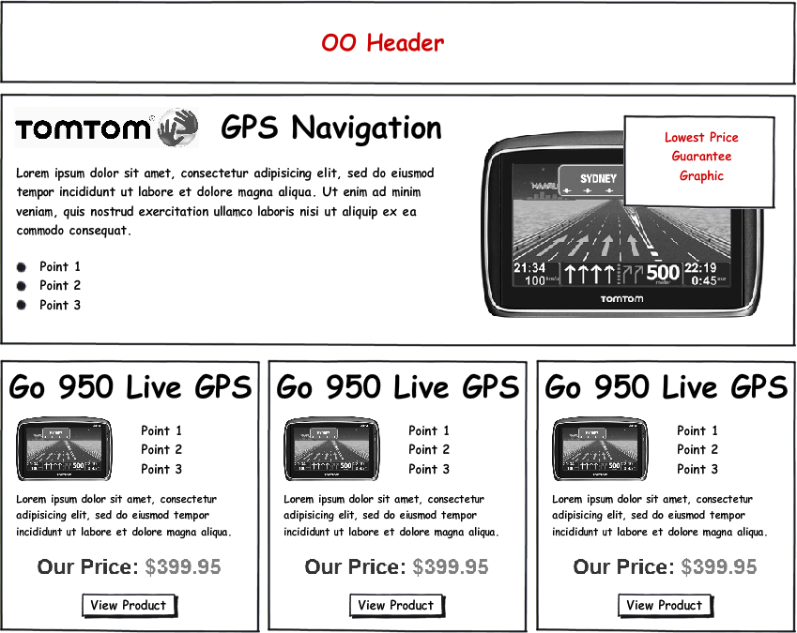

OO Header
Currently the header graphic being used for landing pages is this:


While you are free to use this graphic please feel free to use something different if it better fits the rest of the design. The essential element to show is the OO logo itself (you can find a good quality version at http://www.magnumpr.com.au/Files/Images/oo%20logo-layers-rgb.jpg :


Hero Shot Area
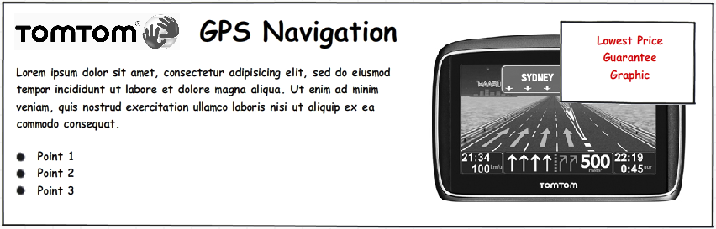

Please let your design skills determine the layout of this section. There needs to be space for the following elements:
- The TomTom logo / heading
- A small paragraph of text
- 3 – 4 dot points
- A TomTom GPS image
- A graphic saying “Lowest Price Guarantee” presented in such a manner as to make that aspect really stand out.
Feel free to use placeholder text for the presentation of this area.

Product Box
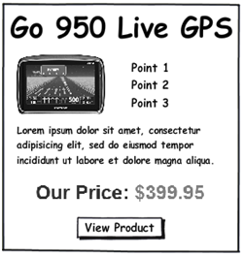

Again please feel free to use placeholder text – we need the product name, some dot points, a very small paragraph of text and a visually arresting ‘View Product’ button.

