New Absorbing Website Redesign

Purpose

To change the look and feel of the absorb website (www.absorbing.com) to a white design. Site will incorporate similar elements of the current site content, showcasing their client’s and the work we do for them, but also highlighting the new areas and product ranges which we aim to move into such as iphone app’s, ipad apps, and bespoke blog development work.

Aim

To Showcase the work we do for our clients & what we can do for prospective clients and drive sales enquiries off the back of this.

Must Haves:

Site has to remain minimal and clean in design taking inspiration from the absorb logo and sites such as Apple’s website but being able to incorporate the Absorb logo. Creative Uses of the logo for the header area would also be good to see as this is another reason for getting the redesign (to make the header more striking, see coloursonic example )

Homepage will be full width of the page without side navigation, side navigation will only appear once the user starts interacting with the site itself.

We would like to include an area where people can “Ask Absorb’s Digital specialists any Question” on digital marketing, so we will need a query box for this. This can be simply a pod / button which links to a query page.

Final design should make use of the glass type effect or fades in order to lift the elements off the page.

Absorb contact details should be prominent at the top of all the pages.

Any additional colour schemes, which can be subtely introduced from a creative perspective will also be welcomed.

We would like to use the pod style layout (as seen on many sites these days) again with clean lines and curved edges to the pods themselves.

SEM , bespoke build, Consultation, Social strategy,

Who We Are Page

Staff images: We have already had staff images commissioned (see attached folder). The “Who we are page” will have the staff images with either a hover over or a short description below it explain who the person is and what it is they do for the company. Please see Who We Are page for further details.

Number of pages required

- Homepage
- Who we are (staff photos page)
- Work - (case studies page)

Homepage

Flash pod (double) with quotes and examples of our work (use placeholder for this)

PPC
SEO
Social Media
Bespoke Api Development
IPad / Iphone App’s

Blog’s we like section

Pod for our relationship with the Marketing Society

“The Marketing Societies Social Media Partner”

We also need to find a visual way to represent each of these disciplines, PPC, SEO Social media etc…..we will be ditching the current images we have for these from the current homepage.

Our Work

This page should make the most (visually) of our clients logo’s and showcase them in a presentable way on a single page, which in turn links through to a full page where more detail of the client and work we do can be found. (attached)

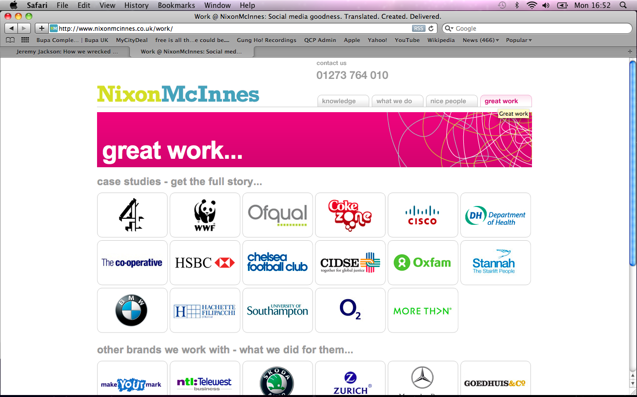

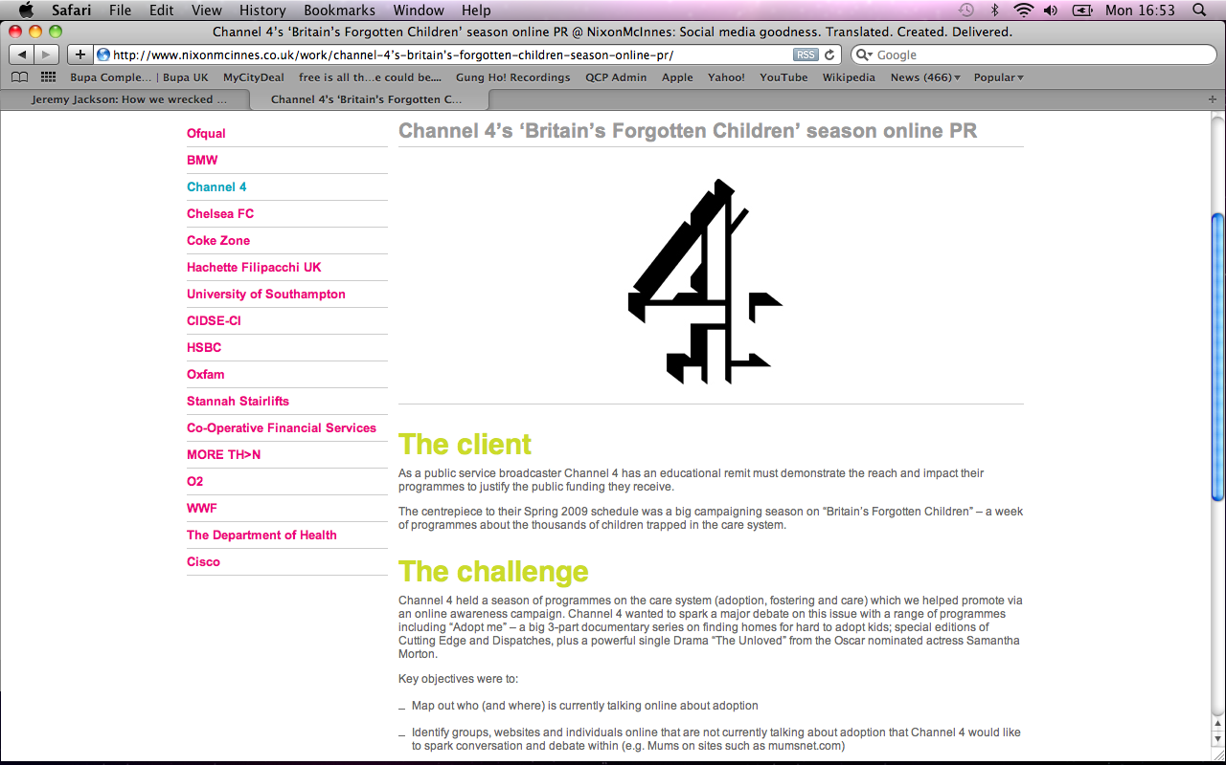

Who are we?

This is the page that will showcase the staff using the following style of image:




We would also like to be able to present members of staff along side the respective areas of work so for example an image would sit along side a case study for the respective area of work they work on. Some suggestions for this are below:

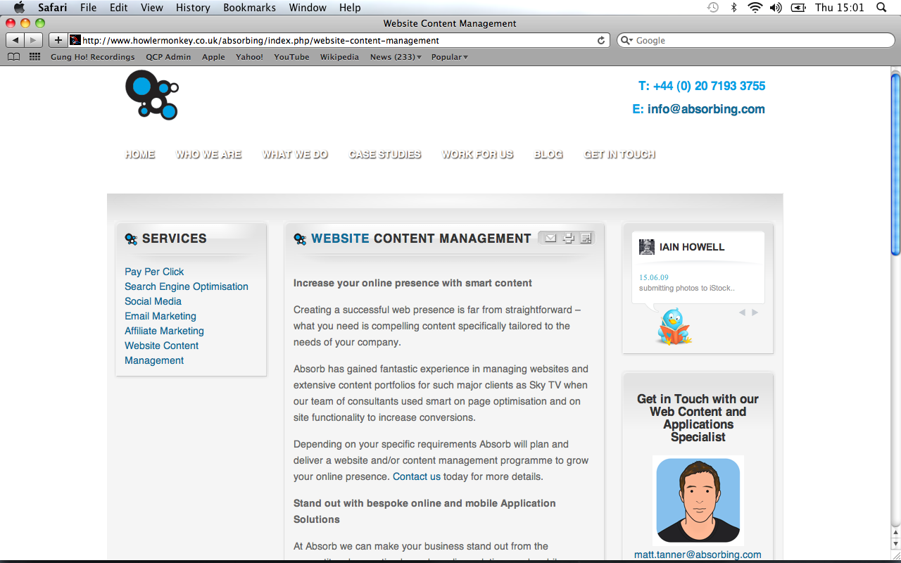
Pod Examples

New technology platforms

An example of an Iphone app pod which we would expect to see either on the homepage or on the main page within the site.

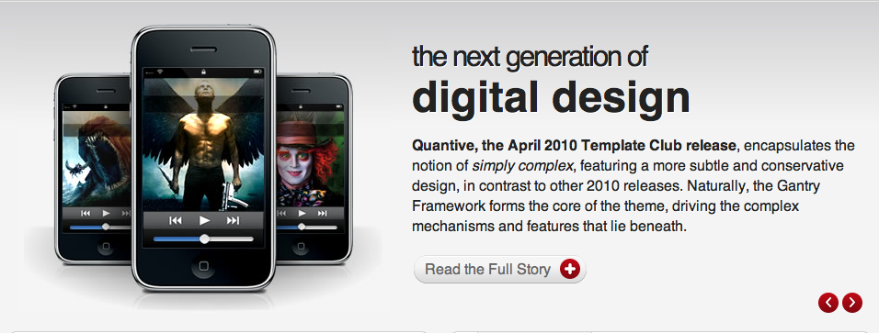

Colour sonic Homepage / Header Example

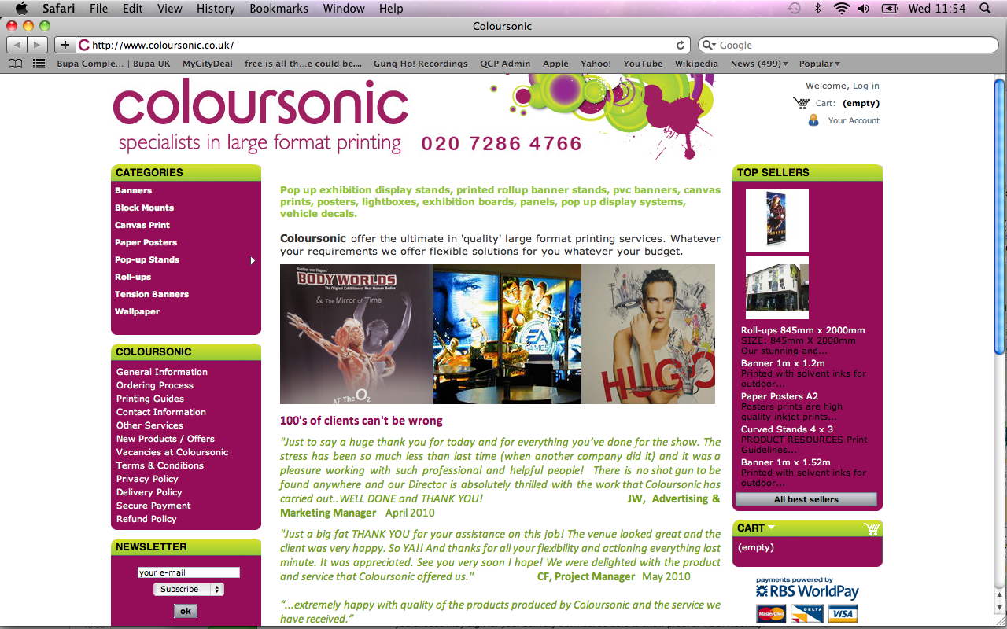

Specification Requirements

The final site is to be designed / coded and delivered on the Squarespace platform.

Designs to be provided in 300dpi psd layered files
Text layers to remain editable

Holding text can be taken from our current website, where this is not appropriate Lorem Ipsum can be used.

