- Navigation bar should be integrated with title bar. Please redesign the title bar, as basic layout of Tinydeal.com
Title bar in mainpage, all categories at the left
Title bar in product page, all categories at the left with pull down button (all other page will have this pull down button except home page)
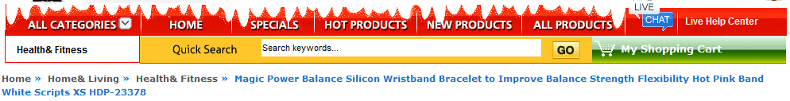
- Colour
We don't want the website color clash with our logo color. After discussion, we think the color COMBINATION of catchoftheday.com.au may be go well with our logo color. Catchoftheday.com.au logo colour is similar to ours.
If you have other bright/uplifting color in mind, you may add/replace the current color.

- Top of page
Move ‘my account’ from bottom to the top [“my account” (with drop down button), “help”(with drop down button), “view cart”, “sign in” ,”register” all close to each other, easier for customers to find]
e.g www.crazysales.com.au
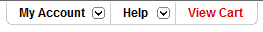

- Homepage Main Body
We want products under 3 tabs, while 3 tabs shown right under banners
Reference
www.crazysales.com.au

So the layout of proposed main page is like below with the “shop by categories” underneath.
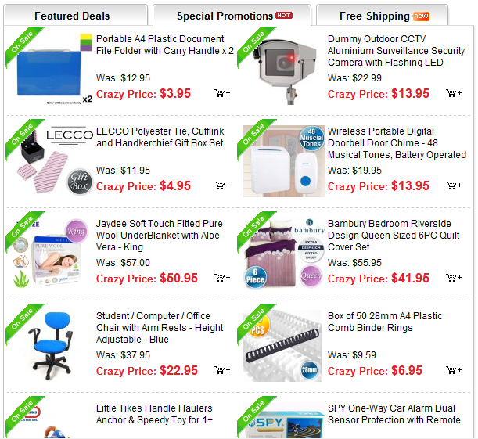

Then shop by categories underneath the above “Tabs”

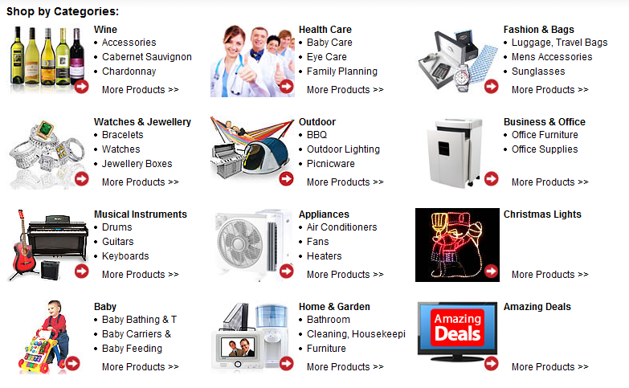
- Add top deal rolling block on left of the home page e.g http://demo.magentoshine.com/se95/
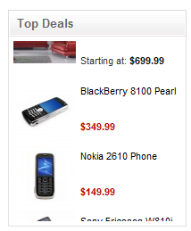
Add another block at right of the page (ie hottest sale of the week, products under $2, products under $10, best deals in cell phone, best deals in computer)
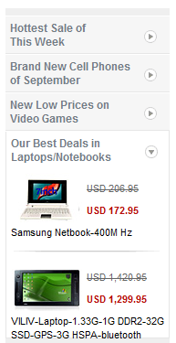

6. Subscription block, please take look at http://www.catchoftheday.com.au/. We need “email, facebook, twitter” (also mention exclusive deal only available to registered member)

7. Free shipping banner
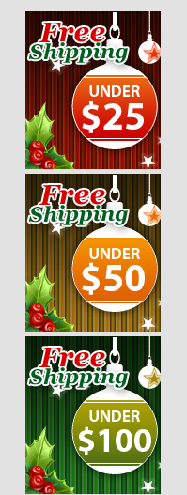

- Foot page – please Add
- Join our community (facebook, twitter, blog)
- Site utility (faq, site map, discount coupons)
- Help center (contact us, shipping & Returns, Newsletter Unsubscribe, Privacy Notice, Affiliate Help)
- My Account ( About Us, My Ordering Manager,Manage Address Book)
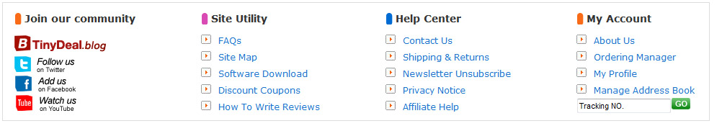

At last, we want when visitor open the website, they can see first three Feature deal/special promotion/ free shipping (total 9 in mainpage) without scrolling down the page.
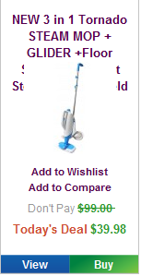
For product shown in Feature deal/special promotion/ free shipping

We need
Add to wishlist, add to compare, don’t pay, today’s deal, view, buy
Similar to our current format

- Below is a guide layout of the home page according to above requirements, hoping it assist you to understand the above:

my account (with drop down button), help(with drop down button), view cart, sign in ,register
logo
All seals of security and other websites
Foot page
hottest sale of the week, best deals in cell phone, best deals in computer
Three feature categories

(pet,furniture,gym)
3 banner
Product under $25
(free shipping)
Product under $50
(free shipping)
Product under $100
(free shipping)
Seo content
Shop by categories
Feature deal/special promotion/ free shipping
Top deal
Subscription block
Banner
Navigation menue
Home, hot product, new product, clearance
Hot keywords

Search box
Shopping cart

