IMAGES: Please collect all images from www.gen2cleaning.com.au
Front Page
A quality service that adds value
Gen 2 is considered one of Australia’s leading Commercial Cleaning service provider, dedicated to delivering a quality service that adds value.
Our business philosophy and international networks ensures we can deliver quality and cost effective cleaning solutions. Our highly skilled Management Team working across Australia and New Zealand has built a solid reputation maintaining the highest commercial cleaning standards.
Gen 2’s commitment to deliver quality is reflected in our rapidly growing clientele base and long term working relationships.

Gen 2 Is ISO certified across 3 International Standards
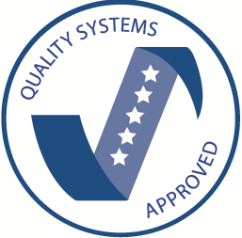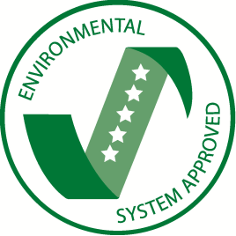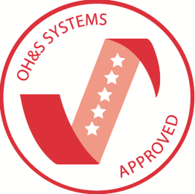
A member of
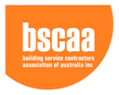
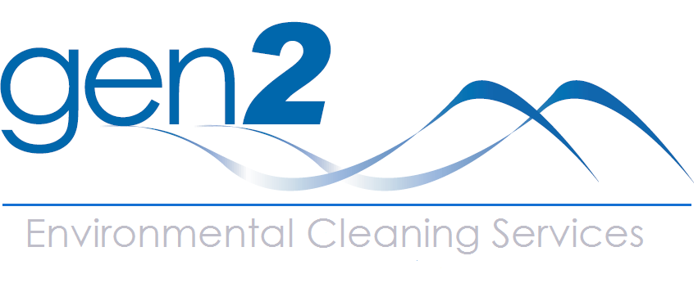

About
Image to say: A new generation dedicated to customer service
Established in 1995 and initially servicing commercial and strata offices, Gen 2 has progressively developed over 15 years to build a strong client network thought Australia and New Zealand.
Gen 2 now offers the highest commercial cleaning standards to commercial industry, retail and shopping centres, hotels and tertiary education facilities.
Our continual commitment and dedication to delivering a quality service has enabled Gen 2 to build a solid foundation and international presence.
Building relationships based on ethical conduct towards employees and clientele defines our unique working environments and is a vital key to our success.

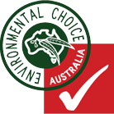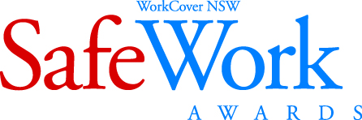

Culture (Integrity Stone)
Image to say (Or it could be solid)
Our principle to put the client first, separates us from the rest
Engrained within each employee are five company principles of Gen 2.
- Put the client first
- Lead with integrity
- Deliver a quality service
- Take personal responsibility
- Keep balance
Within these principles Gen 2 has created a company that rewards dependability, integrity, safety and provides the training and development for all employees.

Services (Office Blue and Yellow Glass).
Services
Image to Say: Gen 2. Making the management of your property easier and cleaner
Gen 2 has built a process orientated service with measurable quality control methods and procedures based on accountability.
Gen 2 delivers a wide range of quality services, ensuring that the management of your site is handled with competence and reliability.
Services
- General cleaning requirements
- Security – 24 hour emergency contact
- Consumables supply and replacement
- Wash room services
- Building maintenance
- Scrubbing machinery
- Pressure washing
- Window cleaning
- Carpet care
- Floor maintenance
- Graffiti removal

Contact Details:
Head Office Australia
102 Young Street
ANNANDALE NSW 2038
T: 1300 881 260
F: (02) 9568 3982
E: headoffice.australia@gen2cleaning.com.au

