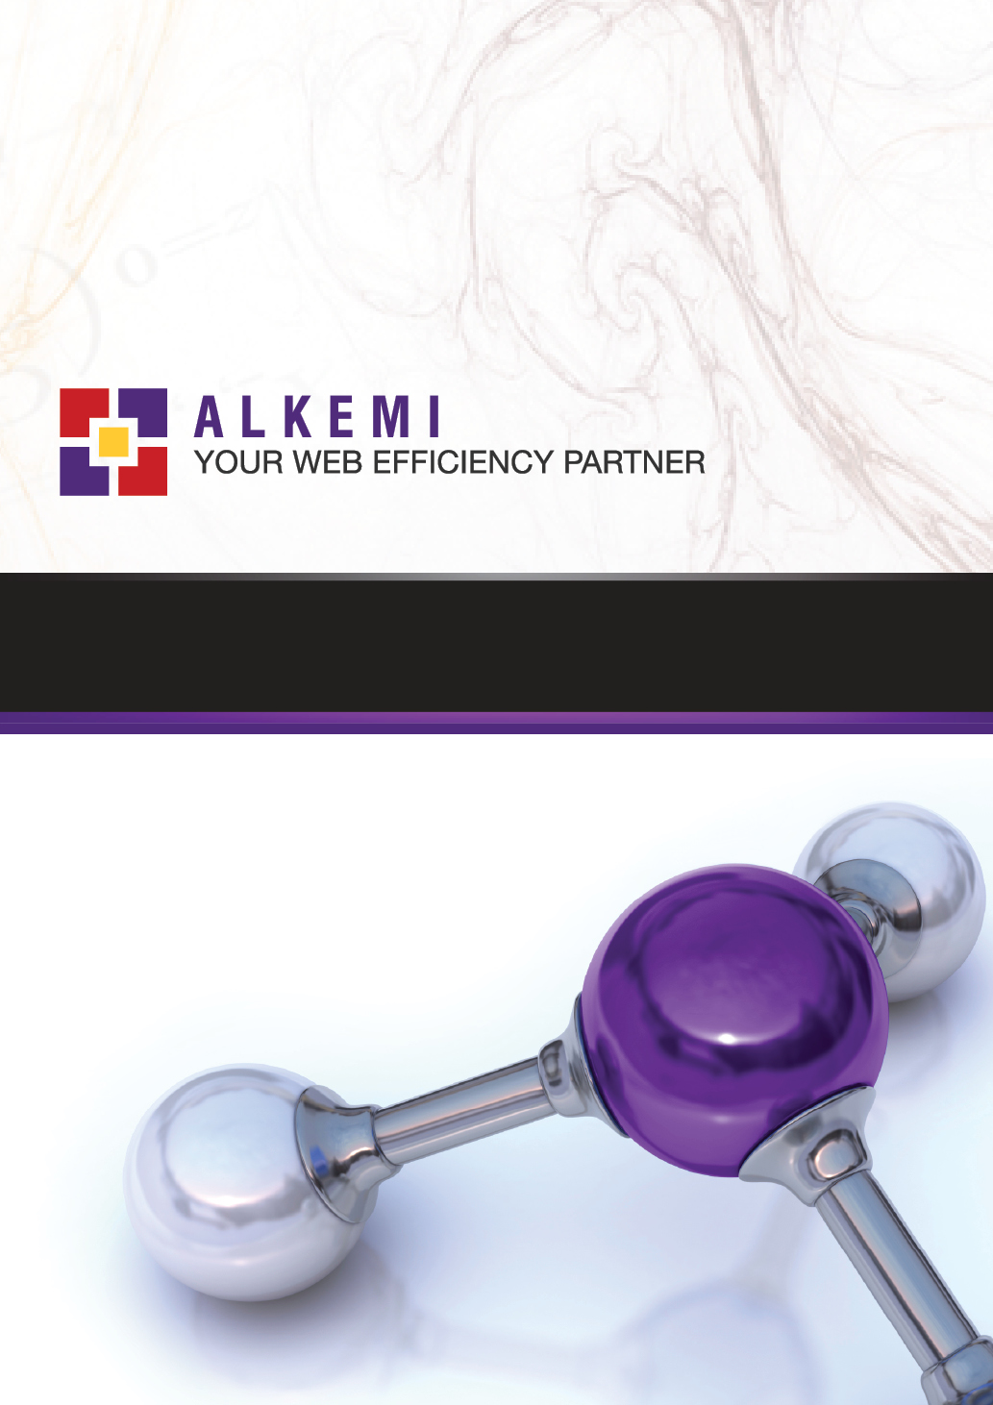
Design Brief: MsDivine
Overview

The following document is intended as a brief for the development of an interface design for www.msdivne.com.au

When developing the site design please have a focus on modern, stylish design. A good example of the kind of design style the client really like can be found at www.d-luxonline.com

As fashion products are the focus here clear, appealing presentation of product images is critical.
Homepage

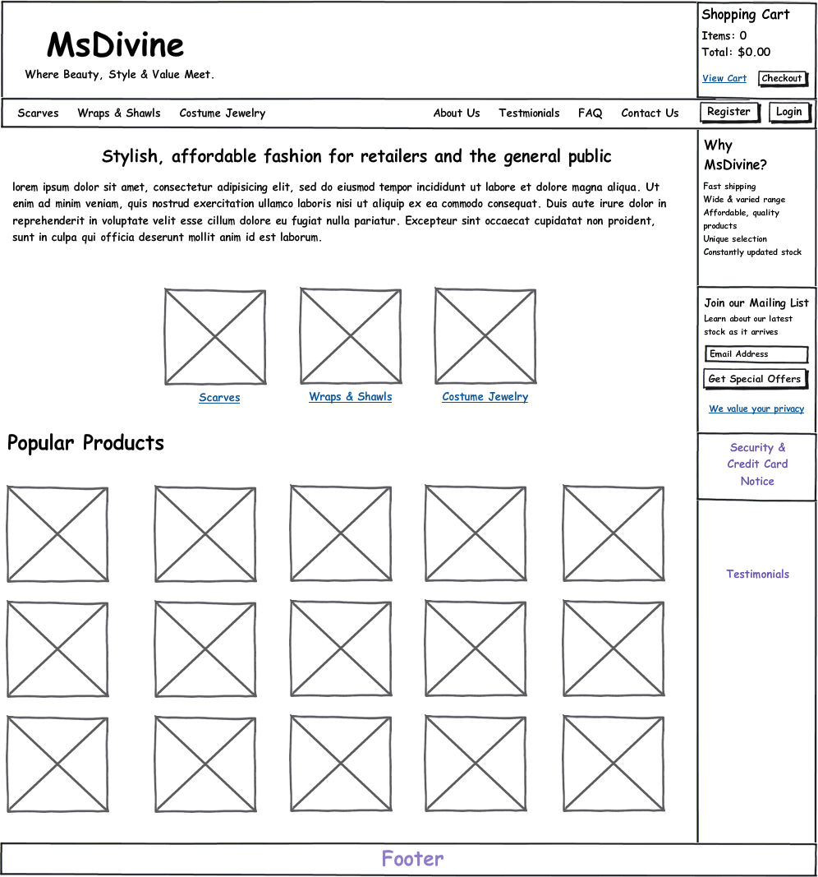

For the security and credit card notice please work in a secure padlock logo with the text “secure shopping” and a we accept area with both Visa and Mastercard listed.
For testimonials please use a standard one quote layout with a text link “View more testimonials...” at the bottom. Feel free to use placeholder info for the quote.

The featured products area is to be made up of products you can feel free to make up for illustration purposes. The format for these areas (indeed any product tile in this brief such as those present on category pages and recommended products) is as follows:
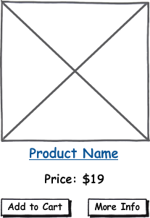

Look to work done on Mothers Love and OO.

For category images please find images via any image source you can (unless we’ve already been provided with product shots, etc)

Please include standard footer info, links plus a design by Alkemi link.

Product Category
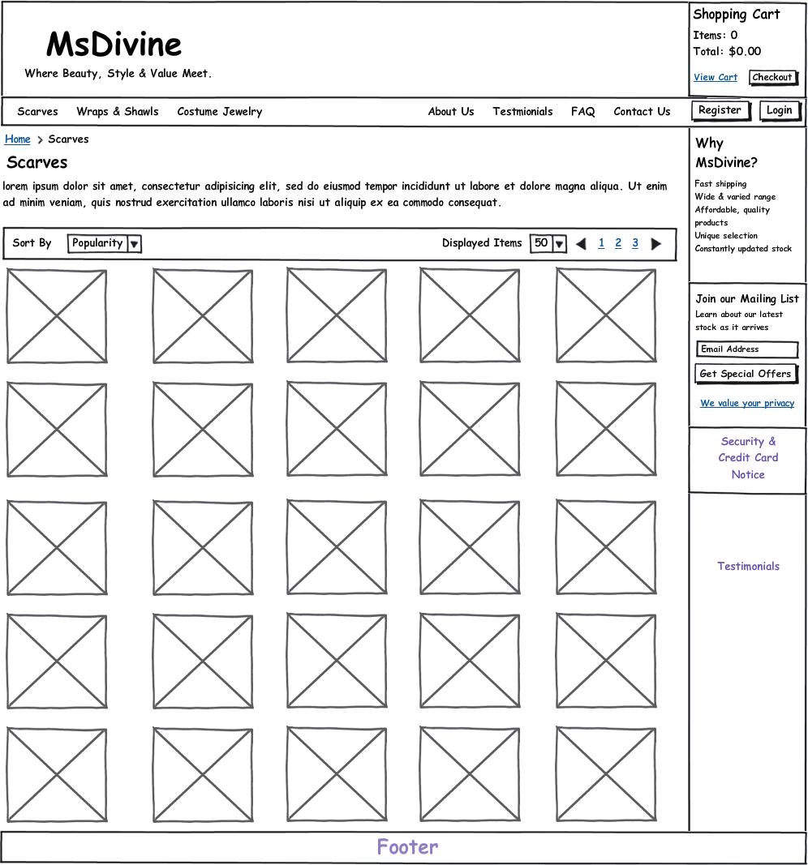

Product Page
