GulfCoastLuxuryMotors.com
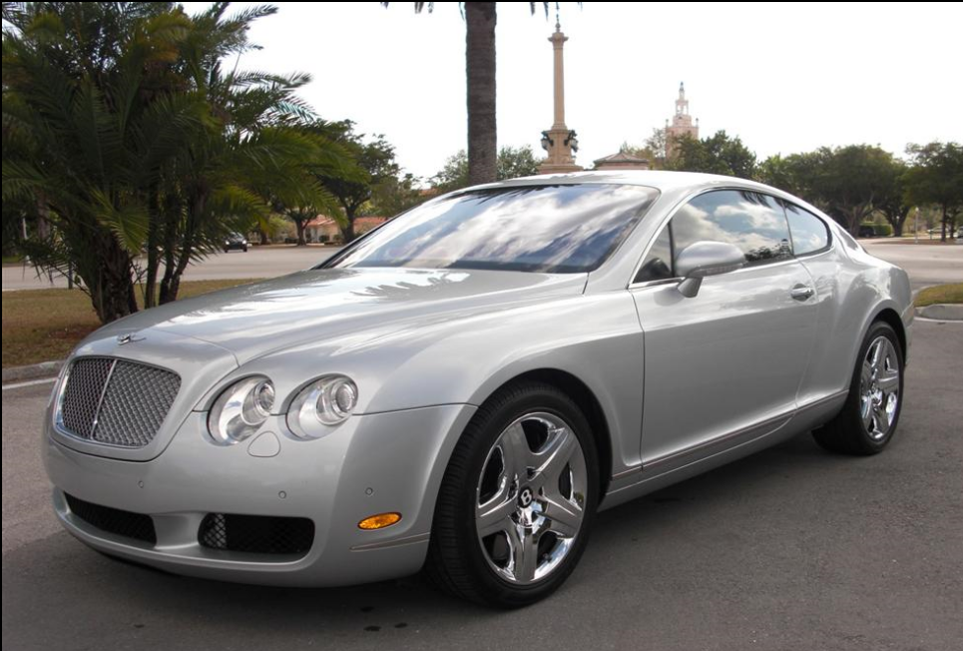
2006
Bentley Continental GT

