

Preamble
Located in Toronto Ontario, HydroSense Irrigation Design & Consulting Inc. provides complete and practical solutions for many different landscape irrigation challenges and applications. We operate as a wholly independent design and consulting firm without affiliation or proprietary interests in the products specified and service provided, ensuring our clients receive unbiased and non-conflicting deliverables.

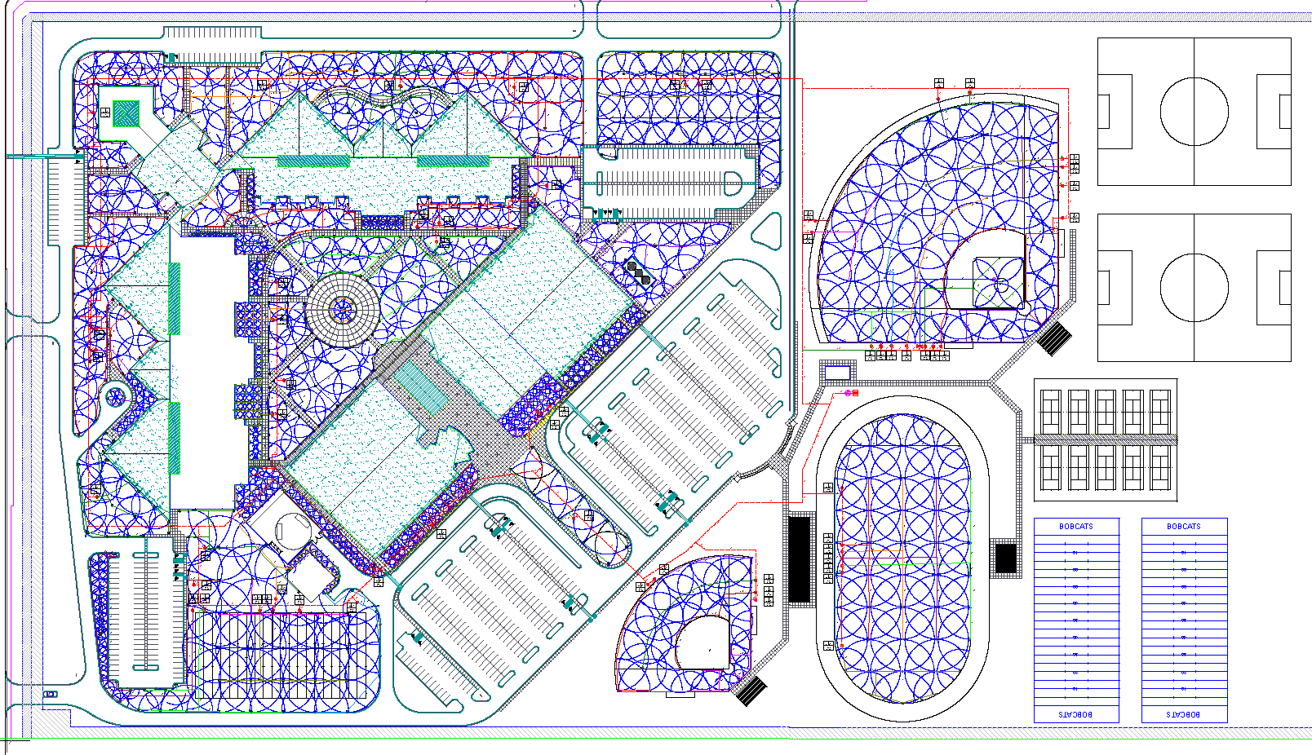
HydroSense employs initiatives for water conservation through sound irrigation design and alternate water supply solutions. Rainwater harvesting, gray water reclamation and climatologically-based SMART systems are just a few ways HydroSense can reduce the impact an irrigation system has on water supplies. The current ‘green building’ trends in the ICI construction and sports turf market are a testament to environmental impact reduction efforts in the early development stages of new projects. More recently, the advent of various LEED® initiatives for developers indicates a tangible shift towards environmentally responsible and sustainable plans and designs.

HydroSense services are delivered with the requisite expertise to realize any irrigation project from concept to completion, making us truly an end-to-end solution provider in our industry. As designers of irrigation systems and proponents of water conservation, it is our mandate to provide environmentally sound solutions while maintaining focus on our clients' best interests.

Plans & Specifications
HydroSense utilizes the experience acquired through years of commercial irrigation installations to competently and effectively provide solutions for new construction project objectives. From the initial concept and vision right through to substantial completion, HydroSense prepares concise written specifications with clear plans, details, and drawings for each system we are charged with.

Our clients, who range from landscape architects to city planners, depend on the unseen insurance that a properly designed, high-efficiency irrigation system provides for their landscape product. Our responsibilities go beyond the plans room and extend to the project site, ensuring the established specifications and contract details are followed and heeded explicitly.

Central Controls

Irrigation central control enables the programming, monitoring, and operation of irrigation systems from a central location. Central control systems are designed to allow a user to control a single site or a set of sites from a single computer. Central control software allows the water manager to set up programming to automatically control satellite controllers or two-wire decoders which operate the
irrigation valves. A central control system can monitor and adapt system operation and irrigation run times in response to conditions in the system or surrounding area. (weather conditions, pipe breaks, etc.). The system will also provide historical data to allow analysis and reporting of what ran when, how much water was used, and field problems.

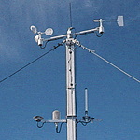
ET Based Irrigation (SMART Water Technology)
SMART irrigation systems work by monitoring and using information about specific conditions (such as ET, local soil moisture and type, rain, wind, slope, root depth, plant type, and more), and applying the right amount of water based on those factors. This will maintain healthy growing conditions for the landscape.

Audits & Assessments
An irrigation water audit consists of completing a series of field procedures for collecting and compiling irrigation system data. The auditor will analyze this data to accurately evaluate various performance characteristics such as distribution uniformity and precipitation rates, as well as site data like plant species type and micro-climate factors.

There is a direct correlation between an audited irrigation system with acceptable performance efficiency and how proper scheduling can impact water consumption. This stresses the importance of proper system performance and how scheduling must regularly change to return only the water lost to ET, and not simply an unknown arbitrary static amount.
