SDAB provides construction, design and project management services to schools and the wider education sector.
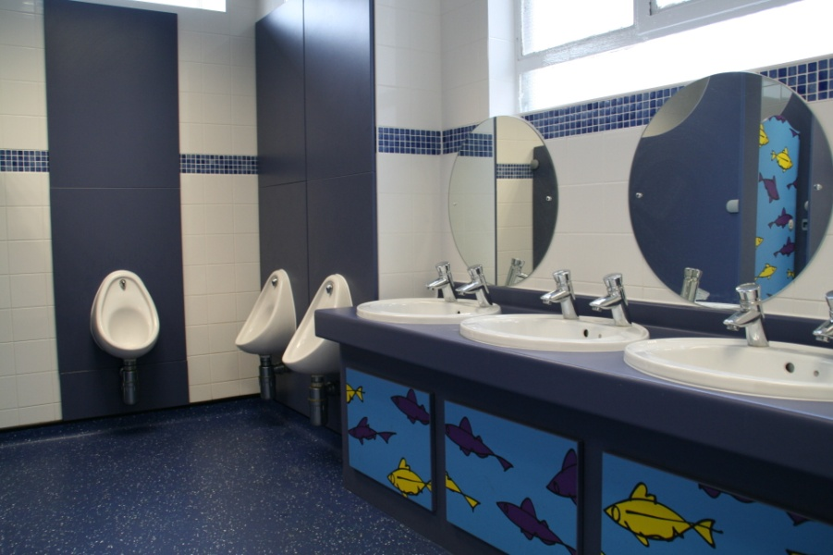
As a client you are always our number one priority and will enjoy unrivalled levels of service, integrity and reliability. Our projects are always carried out to the highest quality, at an agreed fixed cost and within the agreed time.
Services
New Builds and Extensions
Refurbishment of all areas including
- Receptions
- Toilet Areas
- Classrooms
- Corridors
- Staff Rooms
- Food Technology
- Design Technology
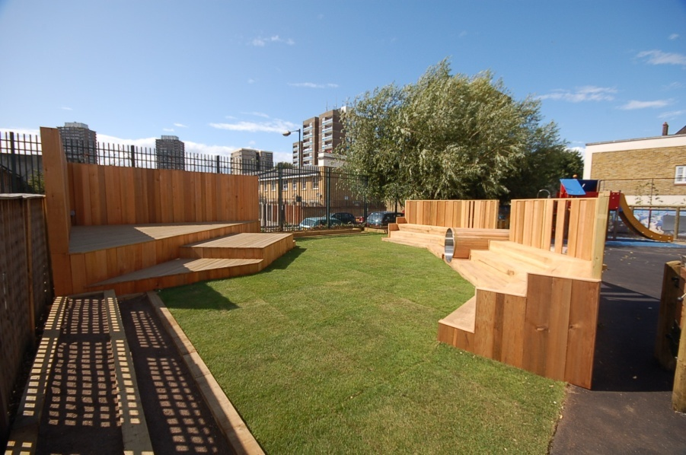
- ICT Suites
- Libraries
- Halls and Sports halls
Specialist Special Needs Rooms ,
- Changing rooms
- Sensory rooms
- Therapy pools
- Hoist Installations
- Access and DDA Compliance
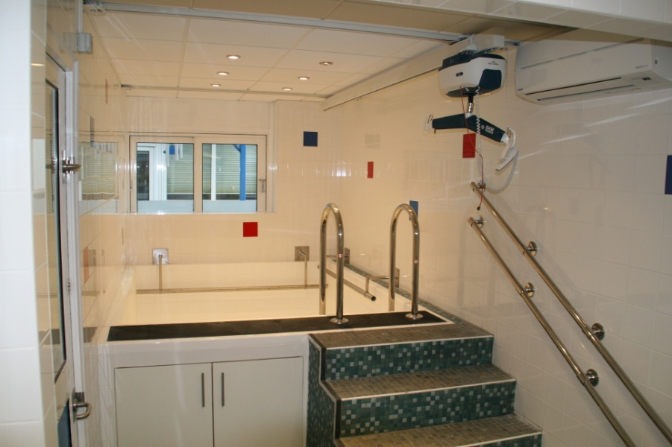
General buildings maintenance.
Playground design.
Playground equipment, surfacing and bespoke structures
Temporary buildings and classrooms
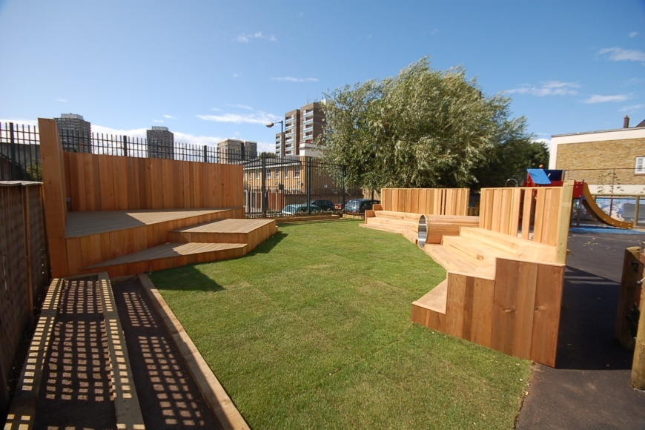
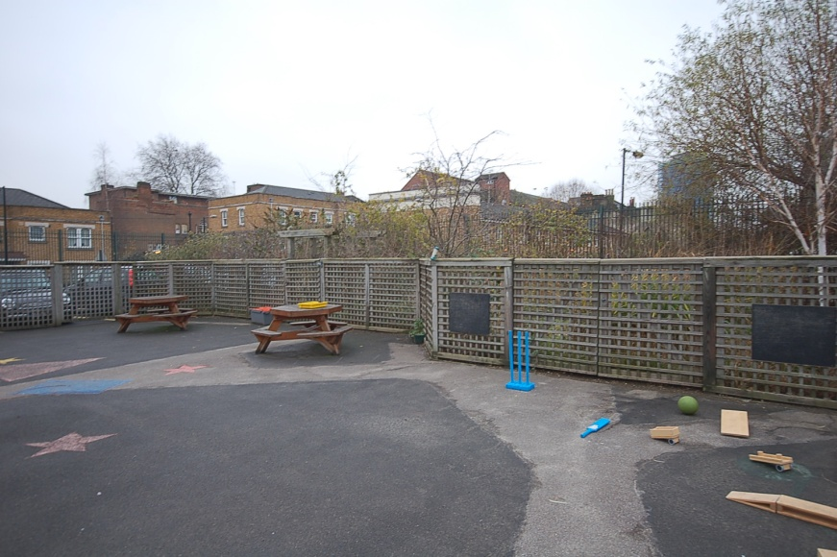
Before After
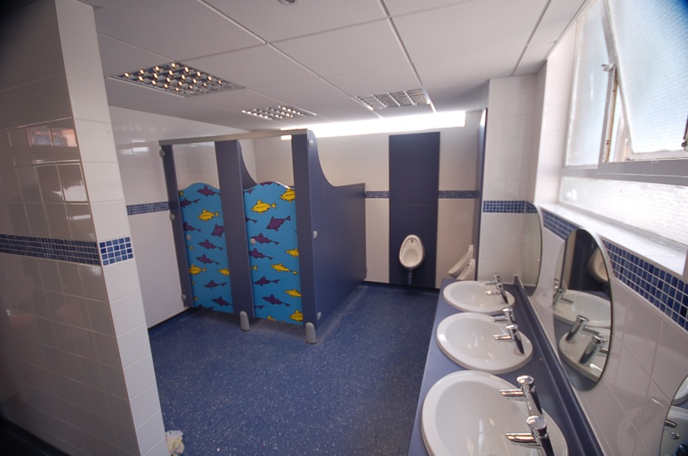
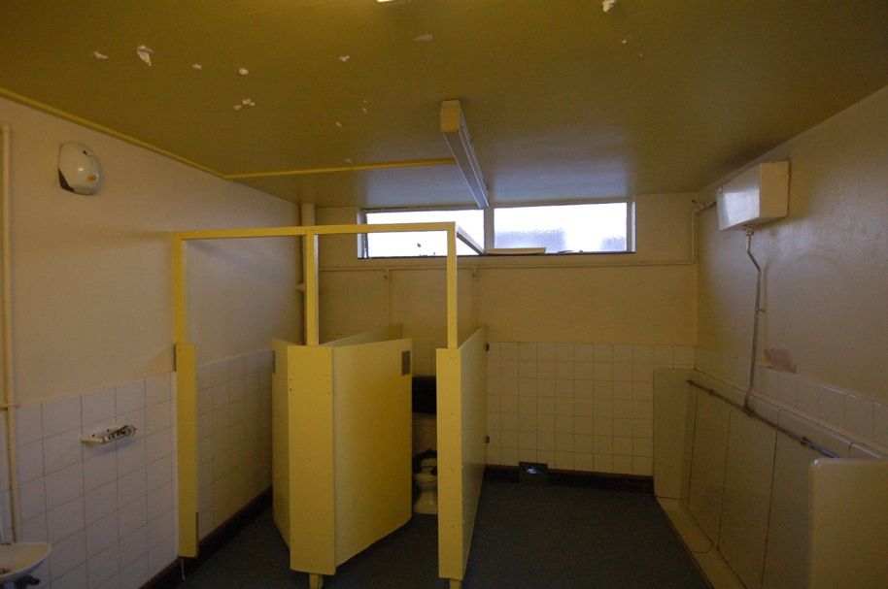
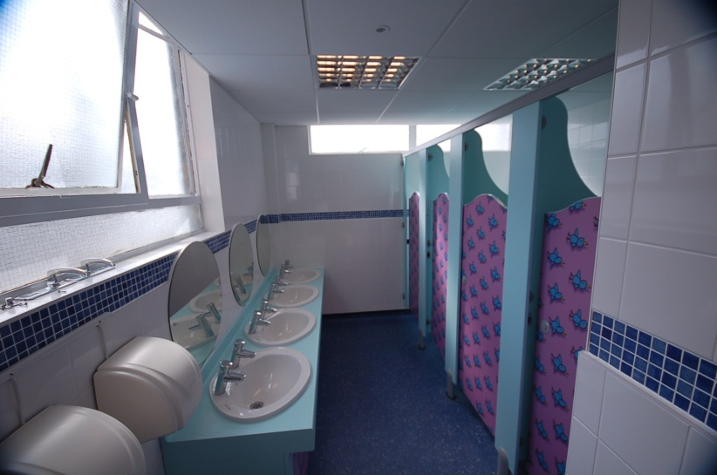
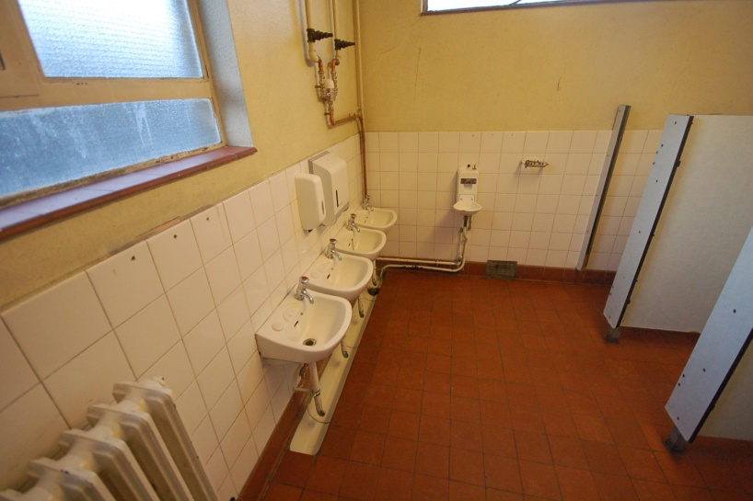
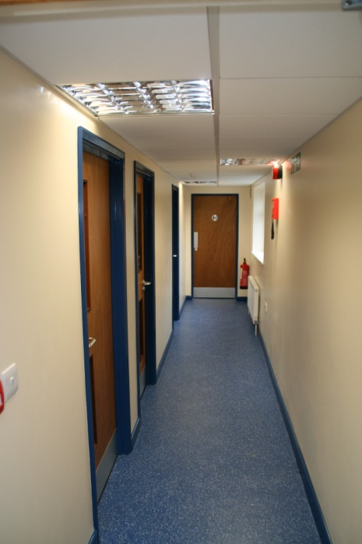
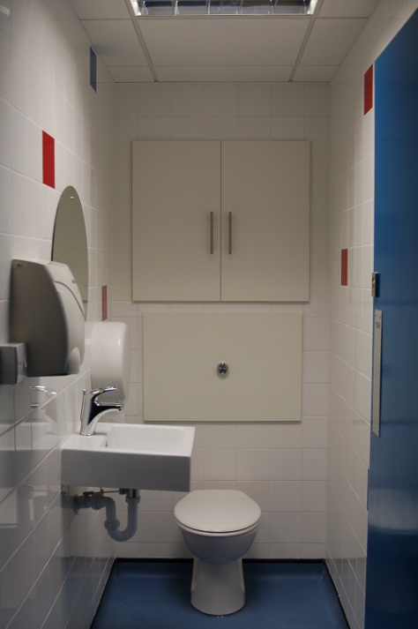

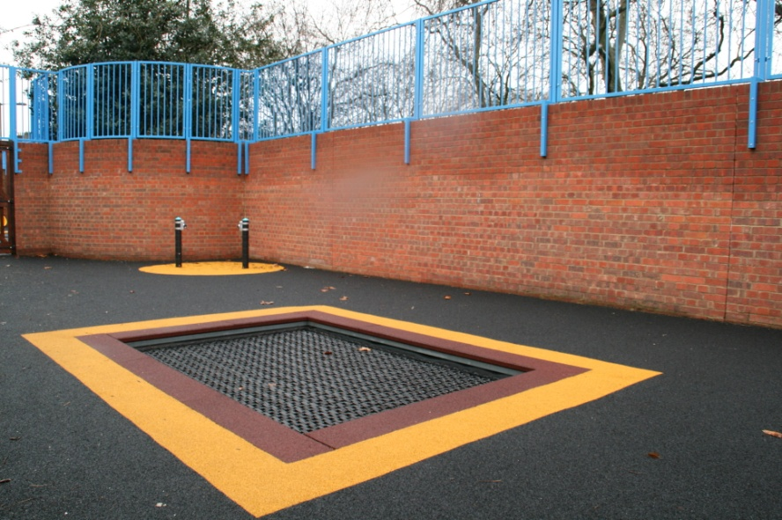
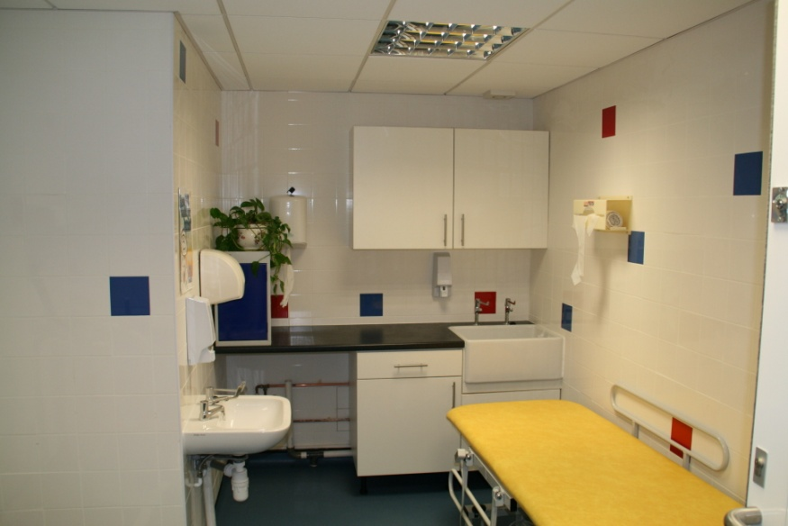
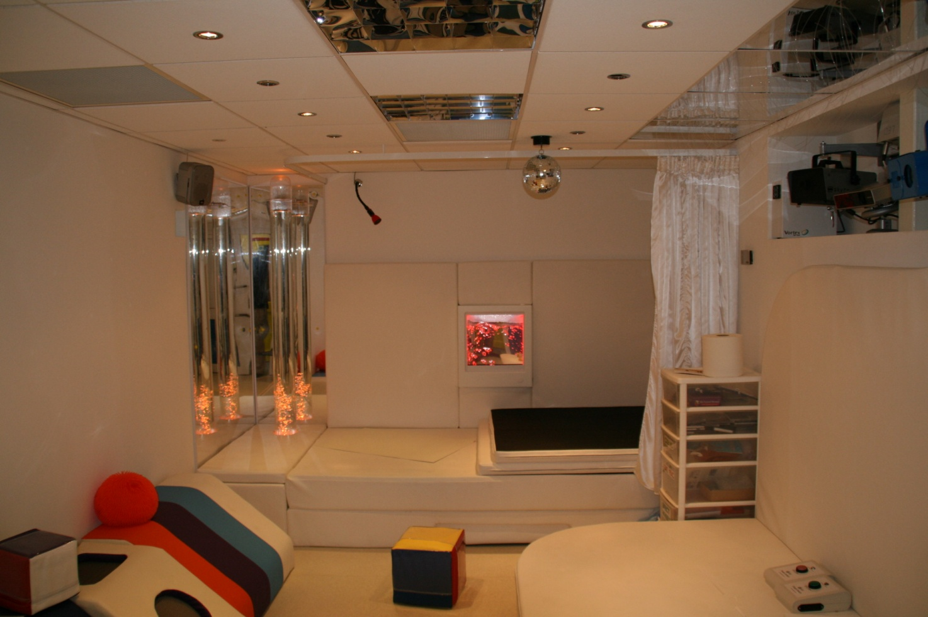
More Photos On This Page Can be Smaller

As a company we are passionate about the environment and our social responsibility. Wherever possible all construction materials are purchased from sustainable sources and our designs encompass many carbon and energy reducing elements as standard.
SDAB and and our employees organise many fundraising activities throughout the year the proceeds of which support charities and projects in developing countries. We are an equal opportunities employer that provides a professional environment that is challenging, rewarding, creative and respectful of ideas and individuals.
Design and Project Management
SDAB provides a detailed design service. By working in partnership with the Head Teachers and Team Leaders we are able to capture and interpret your vision for the works required. Design services we can offer include,
- Full Planning Permission Applications
- Single / Multiple Room Refurbishments
- Playground Design
- Furniture / Workspace Design and Layout
SDAB offer a dedicated Project Management Service aimed at schools having works carried out by BSF Local Authority contractors. When appointed we represent the school offering Technical, Financial and Project Management support to the Head teacher and Governors ensuring projects are delivered to your specification, within budget and on time
Client list
Addison Primary School ++++ Children's House Nursery +++++ Columbia Market Nursery ++++ Downsview School ++++ Henry Cavendish Primary ++++ Horizon School +++ Culloden Primary School ++++ Ickburgh School +++++ Northwold Primary ++++ Old Ford Primary School ++++ Old Palace Primary School ++++ Riverside Primary School +++++ London Borough of Southwark +++++ London Borough of Hackney London Borough of Tower Hamlets +++++ London Borough of Lambeth
Contact Information
School Design and Build Limited
Birkdale House, Outwood Lane, Kingswood, Tadworth, Surrey , KT20 6JW
Tel: 0845 658 9972
Fax: 0845 658 9972
Email: info@sdab.co.uk
Web: www.sdab.co.uk

