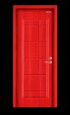
DW

REAL ESTATE SERVICES

