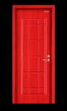
DUNN WORTHY

REAL ESTATE SERVICES

