The Way of the Ancient Archer
Front Line Leadership Program

Business Leaders are much like ancient archers who were the first to step to the line of battle. Confident, well-prepared, fearless and great in strength, vision and perseverance—these warriors led the way into battle.
The leaders of ancient archers were the ones who set these courageous, trained, brave warriors to the front-line. The way of the ancient archer is one of strong performance, agile, dependable, and cooperative. They were power houses. Their performance was based on a solid foundation of knowledge and teamwork and steady nerves. They had control, visionary insight and discipline to execute commands that supported the ranks of warriors behind them.
The way of the ancient archer is a lost way of life. They were warriors who won or lost kingdoms. They practiced their armed martial arts with precision. They practiced with such passion that they changed the bones in their bodies. Archeologists say they can always tell who was an archer. For the archer’s reach was long and powerful and dangerous to the competition. It’s very much like modern business.
Questionnaire
This questionnaire is designed to help front-line managers to correlate the qualities of timeless traits of competence, courage, speed, strength, awareness and insight from the core of archery over the history of mankind, to develop awareness and insight into developing their own style of leadership.

Instructions
- Read each question and the possible answers.
- Describe yourself. Place an X in the column that most describes how you are like this with work-related activities, in your team, or around people who you influence at work.
- 1 = Not at all
- 2 = Rarely, does not describe me
- 3 = Somewhat, between 30-40% of the time I could be like this
- 4 = Often, between 40-60% of the time I could be like this
- 5 = Usually, I am predictably like this (rarely am I unlike this)
NOTE: If none of the answer choices fit you, pick one that is the closest match.

Focusing on Target
When you get a new assignment from management, how much do you…. | 1 | 2 | 3 | 4 | 5
Focus your thoughts on how you will organize your team toward the assignment, on top of everything else you have to manage at work, instead of splitting up your attention between assignments?
Process external information affecting problems and obstacles, simultaneously, when planning to reach your goal, instead of designing an action plan first, then reviewing risks your team faces?
Know your job and launch an innovative action plan that is far better than what the competition is doing, instead of plotting out detailed goal definitions and action plans that use existing processes?
Think through the cause and effect of all tasks and team member actions, especially reactions from other teams or the market?
Visualize variations of success, what might be acceptable and innovative without being perfect?

Establishing Physical Form
How much do you…. | 1 | 2 | 3 | 4 | 5
Consider new ideas in the context of how your team will be able to accept, adapt to or implement them in your business world?
Use your understanding of all of the related business factors to consider new technologies, methods or programs while working on a current goal?
Study your behavior through mirrors, photographs, video, audio recordings and evaluate your performance with objectivity?
Study your behavior through evaluation techniques that allow you to compare your performance with the form and style of world class leaders?
Rehearse and study a new leadership style that can take your performance to greater achievements?

Turn the page
Visualizing the Result
How much do you…. | 1 | 2 | 3 | 4 | 5
Explain precisely and confidently the team goal, plan of action, assignments and processes are on your programs or projects?
Bring the group to consensus on the goal, plan of action, assignment and processes so they are able to articulate your vision?
Examine the balance of the workload in an action plan, gage the team’s confidence around the ability to accomplish the goal, and consider alternative team support before launching a plan?
Make incremental adjustments to the action plan or reallocate resources to accomplish the goal if the team schedule and performance is out of balance?
Monitor the team to ensure they are able to maintain a strong performance and offer support before the team performance degrades?

Calling Up Your Strength
How much do you…. | 1 | 2 | 3 | 4 | 5
Exercise your existing strengths to meet your current challenges?
Build new strengths with simple methods?
Gradually increase demands on your skill development?
Monitor the effects of your strengths on the team goals, and make adjustments to stay on target?
Apply the strengths that make you effective today and work on new power skills that you need for your next or long term business challenges?

Executing the Sequence
How much do you…. | 1 | 2 | 3 | 4 | 5
Stop and think about what you are going to do before doing it, hesitating or acting unsure, while leading your team?
Use notes and checklists throughout your team meetings to ensure that you touch every point that needs to be made to explain and motivate this group of people?
Focus on small steps to motivate the team instead of focusing on the end goal?
Focus on their weaknesses and ensuring they work harder on those areas when implementing a new program?
Let the team go and allow them to rely on self-motivation?

Turn the page

Evaluating Results
How much do you…. | 1 | 2 | 3 | 4 | 5
Use an absolute model or criteria before evaluating your results?
Evaluate the performance of the team against and plan and coordinate incremental adjustments to the plan, with the team, if the plan is not working as expected?
Evaluate the influence of external factors on the accomplishment of milestones and coordinate adjustments with the team?
Differentiate the team members who perform essential activity to accomplish the goal from performers who give extra effort only to impress the leader and gain favor?
Evaluate the accomplishment of core requirements with specific measurements?

Recognizing Effects
How much do you…. | 1 | 2 | 3 | 4 | 5
Control how you think about the individual and recognize the effectiveness of the performance?
Confront bias and find recognition in all situations?
Use recognition of achievement to motivate positive performance, throughout the plan or project?
Avoid negative comparison of the team result to the goal or pointing out a failure without reinforcing a solution that can be achieved?*
Be truthful and sincere when recognizing the results with the team?

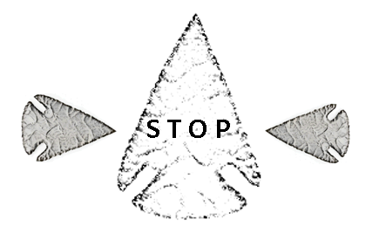
Wait for further instructions.

Calculate Your Raw Score
Go to the Scoring Worksheet (separate worksheet) and calculate your scores.
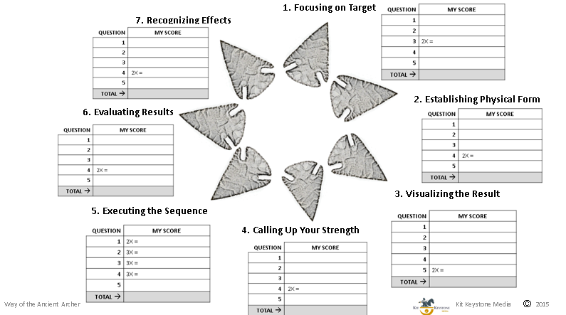
When you are done, insert your total scores for each category.

Insert Your Scores:
Category | Score
Focusing on Target

Establishing Physical Form

Visualizing the Result

Calling Up Your Strength

Executing the Sequence

Evaluating Results

Recognizing Effects

Wait for further instructions.

Create Your Personal Profile
Plot Your Profile, following the instructions on your worksheet.
The score chart only indicates what you described as having more or less of a trait. It is up to you to decide if that is a requirement for success in your business world. For example, decide the relevance of that trait to your work, business, company, the culture, or the constraints and the context of your team.
Next, determine how to use the Way of the Ancient Archer to strengthen your team, or create changes you want—even learning new things—so that you can adopt that trait into your leadership skills.
Ideas to Use My Scores in My Team
Category | How I will Use in my Team
Focusing on Target

Establishing Physical Form

Visualizing the Result

Calling Up Your Strength

Executing the Sequence

Evaluating Results

Recognizing Effects

Ideas to Change or Develop New Behaviors Based on My Scores
Category | Changes or Development
Focusing on Target

Establishing Physical Form

Visualizing the Result

Calling Up Your Strength

Executing the Sequence

Evaluating Results

Recognizing Effects

