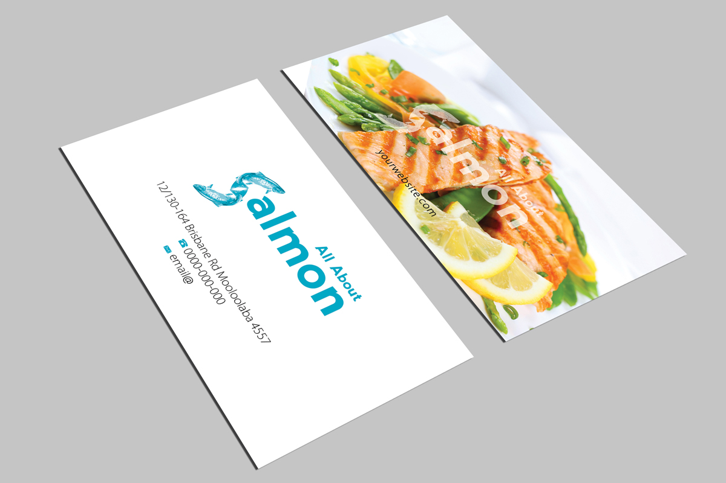

Please use the above salmon dish on the plate of your card.
If you can try the fish S and see if it can be a little more like this one.

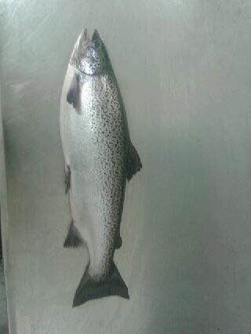

We need the salmon to be like this. This is a very good quality Atlantic salmon.

