PredictBench

Using multiple data sources, machine learning and cloud computing, PicNet’s PredictBench helps your organisation predicts sales volumes, demand, ROI or any other important factor. PredictBench is delivered and supported by the PicNet Software Engineering and Advanced Analytics team.

PredictBench is designed for corporates who have the business need to make accurate predictions about future business events. PredictBench is a predictive analytics solution that will help guide (or improve) your business decisions as well as assess your organisational risks and business potentials.

PredictBench combines machine learning, statistical modelling techniques and data mining to create reliable analysis that is unique to your business and accounts for the economic and environmental factors affecting your industry and the markets in which you operate.

Benefits

- Unlock the hidden value that lies within your current enterprise data
- Identify and evaluate new business opportunities
- Identify target markets and optimise communication strategies
- Enhance decision making
- Optimise business processes
- Reduce risk

PredictBench can help you with:

- Improved accuracy of sales and demand forecasting
- Improved customer segmentation and targeting
- Minimising customer churn
- Measuring ROI of marketing campaigns
- Supply chain optimisations
- Identification of fraudulent transactions
- Fault detection
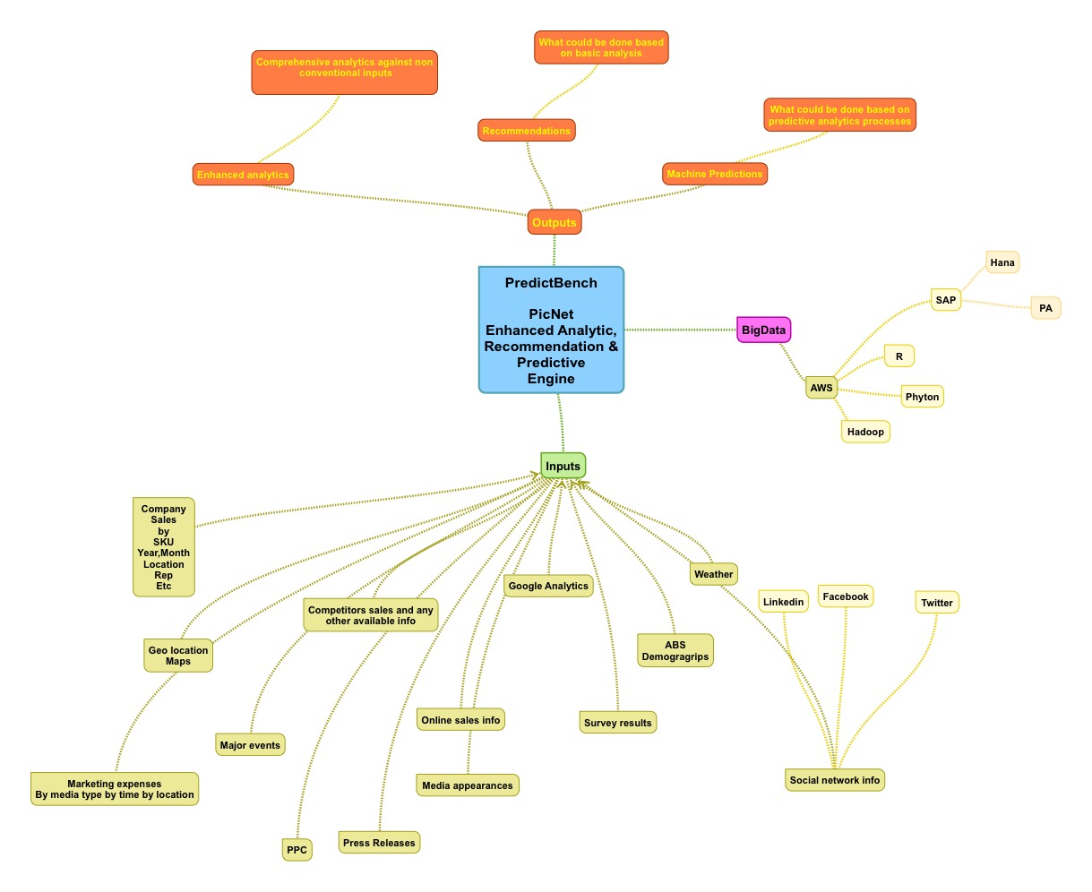
Figure – 1 PredictBench illustrated

Cost
A typical PredictBench prototype is developed between 4 – 8 weeks costing between $10 – $20K; dependent on a number of factors to be confirmed on consultation.

Contact us for an obligation free consultation.

Case Studies
FMCG: PicNet has recently built a sales and marketing reporting hub for one of Australia’s (and the World’s) largest FMCG organisations. This tool allowed our customer to do accurate forecasting of sales at a store by store level and allows for much better marketing ROI calculations of future marketing campaigns.

Supply Chain: Working with most of Australia’s largest content distributors (publishers) PicNet was able to accurately predict & forecast volumes of magazines sold throughout Australia at a store and suburb level. Magazine distributors can with this information optimise their printing and delivery costs without missing out on potential sales.

What is Predictive Analytics?
Once data reaches a certain level of complexity or size it is very difficult to analyse manually. Predictive Analytics is the use of computers to analyse this data. Computers are totally unbiased and they can churn through massive amounts of data in relatively short time. Predictive Analytics allows companies to unlock value from data that until now had been sitting idle.

