ABOUT THE DENTISTS

At URBAN SMILES we care about our patients. Our doctor and team want to help every patient achieve a healthy, beautiful smile that transcends the boundaries of their expectations and gives them a renewed sense of self-confidence. Here at URBAN SMILES, we work hard to give our patients the personal attention they deserve, and our patients can always count on receiving the best care for themselves and their family.

Here are a few reasons why URBAN SMILES is a unique practice, for unique individuals:
- Dr. Rob Andrew genuinely cares about his patients! He strives to treat every patient as he himself would expect to be treated. He even remembers his patients' names! Doesn't it feel nice to be remembered? We think so!
- Our Edmonton practice doesn't just clean teeth; Dr. Andrew is also a certified Invisalign invisible braces provider, giving patients cleaner, healthier, and straighter smiles!
- Our practice offers our patients treatments for everything having to do with your teeth, mouth, gums, and jaw – including treatments for bad breath! Oravital is a professional breath freshening product that is successful in treating bad breath due to a variety of oral conditions.
- The doctor and team at URBAN SMILES are committed to excellence. Through continuing education they are able to stay up-to-date with current industry technology and techniques. Patients can trust that the treatments they receive are going to give them the results they expect for the smile they've always wanted.
We hope to see you and your smile soon! Please contact our Edmonton dental practice to schedule an appointment today, and find out what it's like to work with a dental team committed to serving you!Dr. Rob Andrew

Rob has been practicing dentistry since 1986. He attended the University of Stellenbosch near Cape Town, South Africa, where he received his degree in dentistry. Rob also completed a two-year postgraduate course in esthetic dentistry (cum laude) at the same University in 1998 and is experienced in all phases of general dentistry. He wrote the University Co-ordinating Council's equivalency exam at the University of Alberta in 1999 and is a registered member of the Canadian Dental Association, the Edmonton District Dental Society, The International Association for Orthodontics and Functional Jaw Orthopedics. Rob completed a two-year mini-residency program in orthodontics and TMJ disorders in 2002 and believes that advanced education keeps his clinical skills perfected for the benefit of his patients.



Dr. Ousama Kabalan
Ousama was born and raised in Calgary. He relocated to Edmonton to attend the University of Alberta Dental School. Ousama thrives on problem solving which makes him the ideal person to help his patients obtain the Smile of their Dreams. In his spare time he enjoys working out, golfing and spending time with his family and friends.

SERVICES OVERVIEW:

Examinations
We start with an update of your medical and dental history, listen to your concerns, then we take necessary x-rays, examine the color, shape and overall condition of the soft tissues on the cheeks, lips, tongue and the floor of the mouth. We screen the temporomandibular joint for existing conditions. We evaluate the integrity of the teeth and any existing restorations, address any concerns the patient may have and then formulate an optimal treatment plan.

Cleanings
No smile stays beautiful without care and attention.

Smile Makeover
We are pleased and proud to offer our patients a variety of cosmetic and restorative procedures, which can enhance your smile through a unique combination of science and art.
Cosmetic dental procedures like teeth whitening can help you to look younger. Veneers and bonding can restore a youthful appearance by filling out fine lip lines and by concealing tooth discoloration and gaps. Tooth-colored fillings of composite or porcelain look like natural teeth enamel, and crowns, bridges, and dental implants can restore even a seriously damaged smile.
In order to make sure you receive the proper treatment required there are a couple of things we must first do. It is important to have a full examination done, which may be followed by x-rays, photos and impressions depending on the procedure required. Then we have a lab construct a wax-up of what the final stage will look like. If the patient approves and is fully satisfied with the wax-up we go ahead with the treatment.

AIR ABRASION
Air abrasion is relatively new technology intended to replace the dentist drill and the need for freezing on newly formed cavities.
The new instrument works like a tiny sandblaster. A small stream of compressed air blended with a super fine abrasive powder sprays onto the tooth to wear away the decay. The dentist will then fill the cavity with a tooth-colored filling material.
What patients like most about the air abrasion is that it is gentle, noiseless, odorless, and that there is no need for a drill or needle.

DIGITAL X-RAYS

Less Radiation, more accurate diagnosis
Until recently, our only option when taking X-rays was to place a film packet in your mouth and, using a traditional X-ray machine, expose the film packet, then wait up to 10 minutes for it to develop. With digital radiography, the process is computerized.

How does it work?
We place a sensor next to your tooth, and within seconds your X-ray is displayed in sharp, vivid detail on a computer screen. Because of this short exposure time, the amount of X-ray radiation is reduced by as much as 90 percent.

An efficient, computerized process
Once the X-ray image is on our computer screen, we can enhance it to make more precise diagnosis. We can save images on computer for instant retrieval, and once they are digitized, we can easily send them to insurance companies or specialists as needed.

HIGH TECH DENTISTRY

State-Of-The-Art Precision Diagnosis

Surgical Telescopes
When the doctor and hygienists work on your teeth, they will most likely be wearing a funny-looking pair of glasses. These are actually surgical telescopes that allow them to see and evaluate intricate details as they work. These special "glasses" help us to make tiny but important adjustments to the procedure that would go unnoticed with the naked eye. They are an invaluable tool in providing the most precise, beautiful dentistry possible.

Laser Cavity Detection
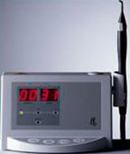Studies show that 50% of tooth decay goes undetected by present diagnostic methods. The new KaVo DIAGNOdent aids in diagnosing hidden decay more accurately and confidently. Most tooth decay occurs in the complex anatomy on the chewing surfaces where deep pits and grooves are difficult to keep clean. This also makes diagnosis with traditional methods difficult, because the outer tooth surface often appears to be intact. The DIAGNOdent is a new high tech laser system. It utilizes laser light of a defined wavelength to help detect and quantify demineralized tooth substances without x-ray exposure. This revolutionary new device is easy to use and turns caries detection into a harmless, measurable, more reproducible and exacting procedure.
With DIAGNOdent the doctor will be able to make better treatment decisions earlier, whether they call for further watching of suspect areas to monitor changes, preventive measures or placing a small filling. With the new KaVo DIAGNOdent, we are able to detect the invisible.

Intra-Oral Camera
The old saying "A picture is worth a thousand words" is so true. In the past, a dentist would check your teeth and then explain their findings in terms that were difficult for some patients to understand. With the aid of this new and exciting camera, the doctor and staff of The Smile Zone can show you exactly what they are seeing. Even better, the image is magnified 35 times its normal size and displayed on a flat screen monitor. This dramatically improves our ability to diagnose small cavities, dental fractures and leaking fillings which allows for earlier treatment and the prevention of more serious problems. The intra-oral camera is also great for before & after photos as well as supporting documentation for insurance claims. You have to see it to believe it.

Computerized Injections (Shots) - The Wand
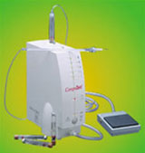The wand is the latest addition to injections (shots) to make them virtually painless. It is not the needle that hurts, it is the sting of the solution. "The Wand" is a computer-controlled system that delivers a slow, even flow of anesthetic, which allows the dentist to give a very comfortable and virtually pain-free injection. It also allows the dentist to perform new and improved injections that are precise enough to just numb the targeted area, so now a patient can leave the dentist without a crooked smile, drooling or slurred speech. It also does not look like the typical dental syringe, therefore, it does not trigger that "fearful" reaction that many children and adults experience.

SEALANTS
Dental decay is the most prevalent disease among children. Sealants are highly effective in preventing and reducing tooth decay, beyond what has been done by fluoride and other preventative measures.
Sealants are simply a thin plastic coating applied to the chewing surface of back teeth, covering pits and grooves where bacteria and food lodge and cause tooth decay. Sealants can be white, clear or tinted and can't be seen when you talk or smile.
Applying dental sealants is an easy and simple process. First the teeth are thoroughly cleaned. Next a mild solution is applied to help bond the sealant properly. Then the sealant is placed on the tooth to seal the grooves and only takes about 60 seconds to harden and set with our curing light. That is it, no discomfort and it is done very quickly.

SOFT TISSUE LASER
LASER is an acronym for Light Amplification by Stimulated Emission of Radiation. Lasers have become part of our daily lives; they're in our computers, and we see them in the grocery store when we buy our food. Now, with new advancements in technology, lasers have become an important part of dentistry as well.
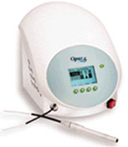The laser is used for soft tissue procedures, such as:
- cosmetic gum recontouring
- lesion removal
- treatment of gum disease
- removal of excess gum tissue
- gum surgery
The benefits of the laser include:
- faster healing
- less bleeding
- reduced swelling
- Pediatric Dentistry
- A child's first visit to the dentist should be enjoyable and positive. The more you and your child know about the first visit, the better you will feel. Children are not born with a fear of the dentist, but they can fear the unknown. Our office makes a practice of using pleasant, non-frightening, simple words to describe your child's first dental visit and treatment. We want you to feel at ease from the moment your family arrives at our office.
- According to the American Academy of Pediatric Dentistry (AAPD), children should visit the dentist by their first birthday. It is important that your child's newly-erupted teeth (erupting at 6-12 months of age) receive proper dental care and benefit from proper oral hygiene habits right from the beginning.
- To prepare for your child's visit, we have created an activity kit to familiarize your child with their teeth and help them look forward to their dental visit.
- Crown Lengthening
- Crown lengthening is a procedure that involves removal of gum tissue, bone or both to expose more tooth structure in order to restore the tooth.
- When a tooth is decayed, badly worn below the gumline or has a short clinical crown height, there is insufficient tooth structure for a restoration. That is a few indications for crown lengthening.
- Crown lengthening can reshape damaged bone where bone loss has occurred around teeth, surgery might be performed to smooth the uneven or irregular surface of the damaged bone or to clean the root surfaces of affected teeth. The gum tissue will reposition and promote healing. It will also improve the appearance/aesthetics of your gumline excess gum tissue can create the appearance of short teeth and a "gummy smile", removing and reshaping that tissue can create a new look.
- Bone Grafting/ Ridge Augmentation
- You may have bone loss in your jawbone due to periodontal (gum) disease, injury or trauma, or a developmental defect. In this case you will need a procedure to add bone to your jaw.
- This procedure typically involves grafting(adding) bone or bone like materials to the jaw, then waiting for it to fuse with the existing bone which will take several months.

- If you are interested in learning more about wisdom teeth extractions, or to schedule your first appointment with Dr. Andrew, your Edmonton AB dentist, call our office today!

SERVICES to Highlight in the brochure
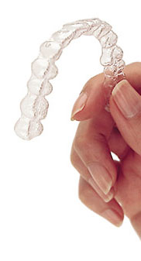

Invisalign

The invisible way to straighten your teeth, without braces.
Invisalign can give you the beautiful straight teeth you've always wanted. It works through a series of invisible, removable, and comfortable aligners that no one can tell you're wearing. So you can smile more during treatment as well as after. And with over 70% of US orthodontists now certified to treat with Invisalign, it has been proven effective in practices nationwide. Dr. Andrew was one of the first general dentist in the country to be trained and certified in the use of these invisible aligners.

What is Invisalign?
- Invisalign is the invisible way to straighten your teeth without braces.
- Invisalign uses a series of clear removable aligners (pictured to the left) to straighten your teeth without metal wires or brackets.

CONSCIOUS SEDATION
Our office only uses conscious sedation. This type of sedation allows bodily functions to remain essentially intact or normal. A patient undergoing conscious sedation will usually speak and respond to requests. In the majority of cases when Oral or Nitrous Sedation are used, a profound amnestic effect is experienced; that is, most of the events of the day after the medication is administered will be difficult or not able to be remembered. In this office three forms of conscious sedation are provided. If sedation is beneficial for your case, our dentist will help you decide which form is appropriate for you:
- Oral Sedation: This comes in the form of pills, a liquid, or a chewable flavoured gummy. This type of sedation has a much slower onset, usually about three quarters of an hour or more. It also has a prolonged effect compared to an intravenous sedation, and is used most often when longer surgical or restorative procedures are being performed, or where a patient is very fearful of needles or injections of any kind.
- Nitrous Oxide Sedation: Otherwise known as "laughing gas", nitrous oxide is administered with a nasal hood that covers the nose. This type of sedation has a quick onset that is completely reversed within minutes of discontinuation. Nitrous oxide sedation offers mild relaxation effects with no amnesia, and can be used for short or long appointments. Often, Nitrous oxide is combined with oral sedation to achieve a slightly more profound sedation when required.


Dental Implants
What are Dental Implants?
Dental implants are natural looking replacements for missing teeth that also provide the same function as your natural tooth. A titanium post is placed into your upper or lower jaw bone. After the bone has grown around the implant, approximately 3-4 months, a tooth, bridge or denture is placed.
Reasons You May Want to Consider Implants:
- To replace one or more teeth
- To provide support for a partial denture
- To increase the support and stability of full upper or lower denture
- To enhance chewing comfort
- To increase confidence while smiling, talking and eating
- To improve your overall psychological health
- To improve esthetic appearance and regain overall confidence

KöR Whitening
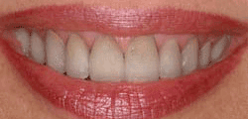You deserve a bright, white smile, regardless of your age. KöR Whitening Deep Bleaching System can restore the beauty of your smile in just two weeks, with results that can last a lifetime.
Over many years, stains from foods can work their way deep into the enamel of your teeth. KöR Whitening Deep Bleaching System provides a thorough removal of these stains from your enamel, rejuvenating your teeth with amazing whiteness. This happens by restoring your teeth's ability to absorb oxygen. Oxygen from the KöR whitening gel is absorbed deeply into the tooth, dissolving stains at the molecular level. Discover the benefits of KöR Whitening!
- KöR Whitening is the only recognized system in the world that will whiten tetracycline (dark) stained teeth, previously thought to be impossible.
- With easy periodic at-home maintenance, your teeth will stay white permanently even while you continue to drink red wine, tea, and coffee.
- During the whitening process, nearly all patients experience low to no tooth sensitivity.
- Teeth whitening has been clinically proven to be entirely safe for teeth and gums, so there is no need to worry about harming your smile.
- In the past, if you had a tooth with a diseased nerve, you'd probably lose that tooth. Today, with a special dental procedure called root canal treatment, you may save that tooth.
- Inside each tooth is both the pulp and the nerve. The nerve is the vestige of the tissue that originally formed the tooth. Once the tooth has been in the mouth for a time, the functioning of the nerve is no longer necessary.
- When a tooth is cracked or has a deep cavity, bacteria can enter the pulp. Germs can cause an infection inside the tooth. Left without treatment, pus builds up at the root tip in the jawbone, forming a "pus-pocket" called an abscess. An abscess can cause the pulp tissue to die. When the infected pulp is not removed, pain and swelling can result. Certain by-products of the infection can injure your jawbones and your overall health. Without treatment, your tooth may have to be removed.
- Treatment often involves from one to three visits. During treatment, your general dentist or endodontist (a dentist who specializes in problems of the pulp) removes the diseased pulp. Next the pulp chamber and root canal(s) of the tooth are cleaned and sealed. Often posterior teeth that have endodontic treatment should have a cast crown placed in order to strengthen the remaining structure. Then, as long as you to continue to care for your teeth and gums with regular brushing, flossing, and checkups so that the root(s) of the restored tooth are nourished by the surrounding tissues, your restored tooth can last a lifetime.
- Most of the time a root canal is a relatively simple procedure with little or no discomfort, involving one to three visits. Best of all, it can save your tooth and your smile!
- Extractions
- There are times when it is necessary to remove a tooth. Sometimes a baby tooth has misshapen or long roots that prevent it from falling out as it should, and the tooth must be removed to make way for the permanent tooth to erupt. At other times, a tooth may have so much decay that it puts the surrounding teeth and jaw at risk of decay, so your doctor may recommend removal and replacement with a bridge or implant. Infection, orthodontic correction, or problems with a wisdom tooth can also require removal of a tooth.
- When it is determined that a tooth needs to be removed, your dentist may extract the tooth during a regular checkup or may request another visit for this procedure. The root of each tooth is encased within your jawbone in a "tooth socket," and your tooth is held in that socket by a ligament. In order to extract a tooth, your dentist must expand the socket and separate the tooth from the ligament holding it in place. While this procedure is typically very quick, it is important to share with your doctor any concerns or preferences for sedation.
- Once a tooth has been removed, neighboring teeth may shift causing problems with chewing or with your jaw joint function. To avoid these complications, your dentist may recommend that you replace the extracted tooth.
- 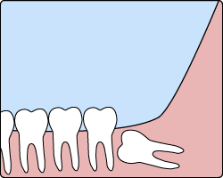Wisdom Teeth
- The removal of wisdom teeth has become so commonplace that it is almost a rite of passage for young adults. Wisdom teeth are a type of molar that is found in the very back of your mouth. There are four wisdom teeth: upper left, upper right, lower left, and lower right. These teeth usually appear in late teens or early twenties but may become impacted (fail to erupt) due to lack of room in the jaw or angle of entry. The most common type of impacted wisdom tooth is "mesial", meaning that the tooth is angled forward toward the front of your mouth.
- When a tooth is impacted, it may need to be removed. If it is not removed, you may develop gum tenderness, swelling, or even severe pain. Impacted wisdom teeth that are partially or fully erupted tend to be quite difficult to clean and are susceptible to tooth decay, recurring infections, and even gum disease.
- Each patient's situation is unique, and your dentist will take x-rays and discuss your particular needs with you. If your dentist recommends removal of your wisdom teeth, it is best to have them removed sooner than later. As a general rule, wisdom teeth are removed in the late teens or early twenties because there is a greater chance that the teeth's roots have not fully formed and the bone surrounding the teeth is less dense. These two factors can make extraction easier.
- In order to remove a wisdom tooth, your dentist first needs access to it. To make this process most comfortable, your dentist will numb the area with a local anesthetic. Your dentist can even use additional medication to safely sedate you during the extraction if you are feeling nervous about the procedure. Because the impacted tooth is frequently under the gums and still encased in your jaw bone, your dentist will need to remove a portion of the covering bone to extract the tooth. To minimize the amount of bone that must be removed, your dentist will often "section" your wisdom tooth so that each section can be removed through a small opening in the bone.
- Once the teeth have been extracted, the healing process begins. Healing time varies depending on the degree of difficulty related to the extraction. Your dentist will share with you what to expect and provide instructions for an efficient healing.

Regular Checkups
Don't brush off regular checkups to the dentist! Regular dental checkups are essential to maintaining good oral health. We encourage regular checkups at least every six months. Seeing the dentist twice a year is recommended because your dentist can:
- Check for problems that you might not see or feel
- Find early signs of decay
- Treat oral health problems early, while they are still manageable
Regular checkups include a thorough cleaning, polishing, and an oral exam by the doctor. During the oral exam, the doctor checks the health of your mouth, teeth, gums, cheeks, and tongue. At each visit, the doctor also checks old fillings and restorations because constant pressure from chewing, grinding, or clenching can cause them to wear away, chip, or crack.

Your First Visit
Your first visit to the doctor typically includes an x-ray that allows the doctor to view the structure of the jaw, the position of any teeth that have not yet erupted, malformed roots, and tooth decay.
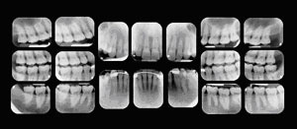
The initial visit also involves getting your medical history. When you share your medical history with the doctor, be sure to provide complete, up-to-date information on your health. Inform your dentist if you have experienced recent hospitalization or surgery, or if you have recently been ill. Also tell the doctor the names, doses, and frequency of any medications you are taking — whether prescription or over-the-counter products — and the name of your physician. Inform the doctor of any changes in your health or medications. It is also important to bring up any fears you may have about dental treatment.
The information collected in your first visit will help the doctor select the safest and most effective method of treatment for you.

Regular Appointments
Regular checkup appointments typically take 20 to 40 minutes. Patients are seen by appointment only. We make every effort to be on time for our patients, and ask that you extend the same courtesy to us. If you cannot keep an appointment, please notify us immediately.

Hygiene Services
Brushing and flossing every day is the first step to maintaining the health of your smile. Regular visits to your Dentist and Hygienist are important so we at Urban Smiles Family Dental can help you maintain your overall oral health and work to prevent any potential problems.
Regular oral examinations, xrays and routine cleanings are just a few of the general care services offered at our practice. To help keep your teeth and gums healthy, we’re also happy to recommend and provide preventative hygiene services like treatments aimed at remedying gum disease, and even professional breath control treatments. Contact us to set up your appointment.
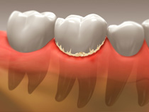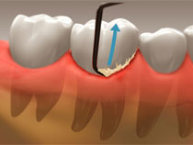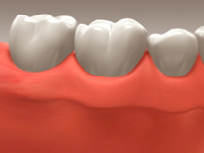

Non-Surgical Gum Therapy
It is possible that in spite of your best efforts you may require more aggressive gum therapy. Like many other ailments gum disease can be quite painless due to its slow progression.
After a thorough periodontal screening and examination we may choose more aggressive therapies aimed at eliminating or reducing the amounts of bacterial poisons and plaque accumulating below the gum line, (generally cleaning and polishing of teeth is above the gum-line). This involves curettage and root-planing and/or treatment with site specific administration of medications to the affected gums. Curettage is the debridement of the soft tissue lining around the tooth. In disease this tissue is chronically irritated by bacteria deep below the visible gum-line and needs to be removed so that proper healing can occur. Root-Planing is the removal and smoothing of micro-amounts of root surface so that a clean and un-infected surface is presented to the healing lining of soft tissue.
These two procedures are generally done simultaneously, may require local anesthesia and are skillfully done by our well trained hygienists under Urban Smiles Family Dental's prescription.
Gum disease does not happen over night and treatment generally is spread out over time as the effectiveness of a procedure needs to be assessed before the next takes place. Generally your condition is re-assessed in time and joint decisions are made about your next step. The services of a specialist (Periodontist) may be required should surgical intervention be required. Often surgery allows for complete healing of the gum and bone, reduced mobility of teeth and a greatly improved prognosis.
Urban Smiles Family Dental's hygiene team will work with you to assure that you have access to the care that best suits your needs. They will also help you hone your home-care skills so that you can maintain the optimum level of health that you want.

Porcelain Veneers
If you’ve ever seen a celebrity go from stained, chipped or crooked teeth to a beautiful, straight, gleaming white smile virtually overnight, you’ve seen what were probably porcelain veneers. Made from a thin but highly durable material, veneers slide easily over your teeth to give you the smile you’ve always wanted! Customizable to any tooth shade and shape, veneers are a long-lasting way to create a natural-looking smile.
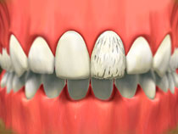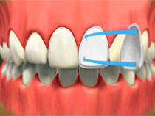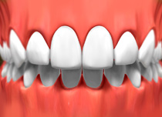

Root Canal Therapy
Patient Forms:
Wisdom Tooth Post-Op & Impacted Tooth Post-Op & Multiple Tooth Removal Post-Op
Each of our teeth contains a long, thin strand of dental pulp—which provides the tooth with nutrients and nerves—that extends down to the tooth’s root. If the pulp becomes infected or injured, the tooth’s nerves die and, often, without endodontic treatment, the tooth dies as well. Root canals are designed to save such damaged teeth.
During the procedure, a gap is drilled into the tooth’s crown and pulp chamber, diseased pulp is reshaped or removed, and the tooth is permanently sealed with a gold, porcelain, or tooth-colored inlay/onlay or crown.
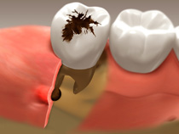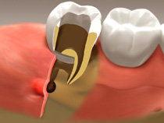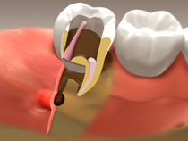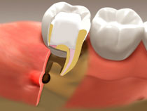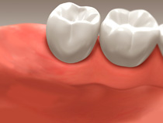

Crowns
Crowns are a type of dental restoration which, when cemented into place, covers that portion of a tooth which lies at and above the gum line. In comparison, composite fillings/inlays/onlays are dental restorations that are used to fill in or cover over just a portion of a tooth. Since dental crowns encase the entire visible aspect of a tooth, a dental crown in effect becomes the tooth's new outer surface.
Crowns are used to rebuild broken or decayed teeth, to strengthen teeth, and as a means by which to enhance the cosmetic appearance of teeth. Crowns can be made out of porcelain/ceramic, gold alloy, or a combination of both.
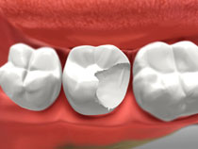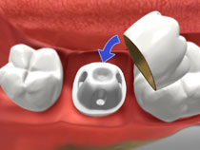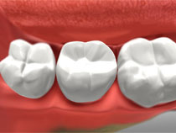

Bridges
Named for the way that they “bridge” the gaps between teeth lost to trauma or decay, bridges restore your smile’s health and beauty by placing durable artificial teeth where your natural teeth are missing. If your missing teeth make you feel self-conscious, or you’re noticing problems with speaking, chewing, or other everyday tasks, ask Urban Smiles Family Dental if a bridge may be right for you. Created and only able to be removed by your dentist, bridges offer a comfortable, semi-permanent option that can enhance your smile.
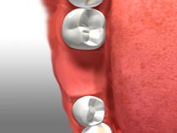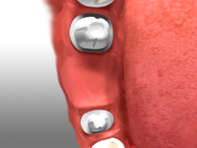
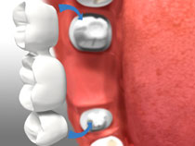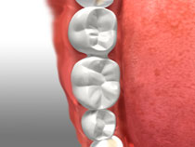

Tooth-Colored Composite Restorations
Gone are the days when tooth trauma and cavities could only be treated with unsightly metal fillings. Today, modern, tooth-colored fillings made of durable resin can be bonded to your teeth for a more natural-looking effect. Composite fillings are virtually undetectable and require only a single appointment to apply.
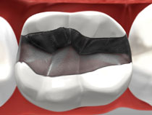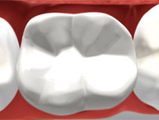

Full Mouth Restoration
If you suffer with discolored, missing, worn or damaged teeth, you know how everyday things—like eating lunch or even smiling at a friend—can be painful, uncomfortable, or even embarrassing. An overall level of neglect can create the need for comprehensive restorative treatment, or full mouth restoration. During a full mouth restoration, Urban Smiles Family Dental will use a variety of restorative and cosmetic procedures to bring your mouth to a healthy, beautiful state. Depending on your specific situation, you may benefit from veneers, crowns, bridges, periodontal or endodontic therapies, or even dental implants and other dental work.
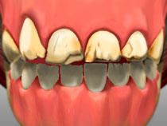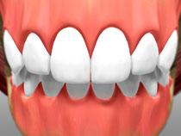

Implant Restoration
Implant restoration involves surgically anchoring implants into the jawbone below the gum line, then attaching an artificial tooth to those implants. After the implant has been placed, your gum and bone will continue to grow around it, ensuring that the implant stays firmly in place.
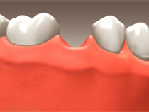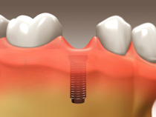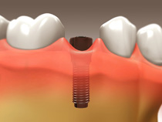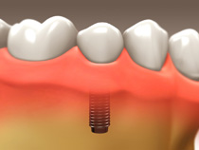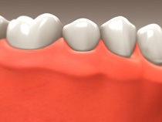

Orthodontics & Functional Orthopedics
Though both are considered Orthodontics, Orthopedics is usually initiated earlier in an effort to assure more favorable facial growth and jaw structure. It is known that only 18-20% of malocclusion in children is genetic. This implies that the remaining 80% of poor bites arise due to environmental factors i.e., poor tongue position, mouth breathing, allergies, or enlarged tonsils and adenoids. As these influences act upon the developing lower face almost from birth it is important to try to and counteract these negative influences early and allow for more normal development. Well timed functional therapy can have an astounding influence on your child's development often discouraging mouth breathing, poor sleep habits and a slow physical growth pattern. Functional orthopedics is usually therapy of short duration, may involve removable appliances and often makes more extensive therapy (braces) unnecessary.
Functional Orthopedics are a great way to help younger patients avoid many of the conditions that have plagued their parents, such as, poor sleep habits, T.M.J. pain, sleep apnea, small lower jaws (weak chin profile), and proud upper teeth (buck teeth) that my lead to poor self-image.
Orthodontics, more classically involves the use of braces that are bonded to the teeth. These braces allow us to control the teeth more accurately so that we can fine tune their relationship to one another and create that beautiful smile.

Porcelain Inlays / Onlays
Well-suited for restoring weakened back teeth, and equally appropriate for restoring more visible tooth surfaces, porcelain inlays and onlays offer a strong, attractive alternative to traditional composite fillings. Typically considered for teeth that need a major portion restored, or teeth that endure heaving chewing loads, porcelain inlays and onlays offer the protection and strength of a crown without the need for extensive tooth preparation. Made from the same strong, tooth-colored material as crowns and bridges, porcelain inlays and onlays are customized to match your tooth shape and shade—and are stronger and more durable than composite restorations.

TMJ (TMD) Therapy
Do you feel pain when trying to open your mouth, or does it hurt to move your mouth from side to side? You could be suffering from the common problem of Tempromandibular Joint pain or Tempromandibular Dysfunction. Other symptoms include:
•Pain in the neck and/or shoulder
•Ringing in the ears
•Hearing loss or ear pain
•Grinding your teeth or clenching your jaw while sleeping
•Constantly feeling fatigued
•Hearing a popping or grating sound, or any other noise in your jaw joints
•Suffering from chronic headaches in your temples or above your eyes
Because there can often be multiple causes for TMJ symptoms, there’s not a “set” way of treating these conditions. That said, the first step in any successful treatment is the proper diagnosis. Urban Smiles Family Dental can perform an evaluation of your symptoms and concerns and suggest a customized treatment therapy for your condition—and in many cases, we can work with you to identify other treatment partners—such as physiotherapists, chiropractors, cranio/mandibular specialists or even massage therapists—who will all work together to bring you relief.

Glo Teeth Whitening
If you want a whiter, more beautiful smile but are suffering from stained teeth caused by everything from tea and coffee to soft drinks and tobacco, you’ll be happy to know that Urban Smiles Family Dental can help. Our practice offers a variety of professional-grade glo teeth whitening solutions, including customizable teeth whitening kits. If your teeth are looking dull, or you’re ready to rid yourself of the stains that have plagued your smile for too long, contact us today for a consultation.

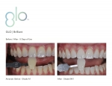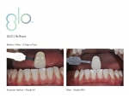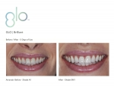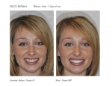

Sedation
General Anesthesia
Also called sleep dentistry, general anesthesia can relieve pain and anxiety by making a patient unconscious during dental procedures. For patients with intense dental fear or those who need major dental procedures, sleep dentistry presents an option that is both comfortable and practical.
If you and the dentist determine that your case is right for sleep dentistry, the dentist will refer you to a facility that uses this method of sedation with the assistance of a specialist anesthesiologist. Sleep dentistry has helped many patients overcome the barriers created by profound anxieties about dental procedures that stand in the way of optimal oral health.
Oral Conscious Sedation
To relieve the very real and often debilitating anxiety associated with dental phobia, we also offer oral conscious sedation, known as sedation dentistry. Patients who feel stressed about dental work, as well as those who need multiple procedures performed in one visit, benefit from conscious sedation.
The procedure involves taking an oral sedative prior to your visit, then receiving nitrous oxide (laughing gas) to supplement the sedative's effects. Your vital signs and comfort level are keenly monitored throughout your visit.
Nitrous Oxide and how does it work?
Commonly referred to as laughing gas, nitrous oxide is used in surgery and dentistry for its pain blocking and reducing effects. It is known as "laughing gas" due to the euphoric effects of inhaling it. The administration of nitrous oxide is used to enhance patient comfort and relieve anxiety for patients of all ages. The gas (a nitrous oxide and oxygen mixture) is inhaled through a face mask. The amount of gas that you receive is monitored and controlled by the dentist to ensure your safety. You will begin to relax and will not recognize pain, so the dentist can perform your dental work while you stay completely comfortable. The effects of nitrous oxide decrease once the mask is removed, such that if the gas is the only anesthesia that you receive, you will very likely be capable of driving yourself home following the visit and can continue your daily activities as normal.

Orthodontics

Custom Design Damon Braces
[Patient Forms: Braces Post-Op & Removable Appliances]
What Makes the Damon System Different?
Passive self-ligating braces that are much more gentle to the teeth. High-technology wires that move teeth much faster and require far fewer adjustments. A new clinically proven treatment approach that aligns the teeth and enhances facial esthetics – usually without extractions.
Damon System Braces are:
- smaller
- more comfortable
- work faster
Clinically Proven Advantages:
- Significantly better results
- Significantly shorter treatment times
- Far fewer adjustments required
Are all braces the same?
With the Damon System, we don't just align the teeth. We create beautiful smiles accounting for a patient's face, profile and other factors in anticipating what they will look like in their 40s, 50s and beyond to deliver results for a lifetime.
How long does treatment take?
Depending on your case, treatment time with the Damon System is up to 50% faster than with conventional braces. Another benefit – far fewer appointments are required during treatment. Since the Damon System works so quickly, does that mean it is harsh or unsafe?
No. In fact, what makes the Damon System work so quickly is that it uses far gentler, more biologically sensible forces than conventional braces. The low-friction nature of the system assures improved tooth position and improved facial harmony.
Will my teeth hurt after adjustments?
Very light "shape memory" titanium wires are used that gently guide your teeth to their ideal position. Many people experience very little discomfort.
Aren't braces big and bulky?
Not any more! Braces are much smaller than they were just a few years ago, and new materials are now used that make them very discreet.
What about adult treatment?
No problem. Adults can be treated quickly, easily, and most importantly, to a high-quality result.
Myofunctional Appliances/Fixed Braces
There are 3 stages of development that are treated by using myofunctional appliances/fixed braces.
Symptoms treatable: Mouth Breathing, thumb sucking, tongue thrusting, overactive lips, reverse swallow, large overbite, teeth crowding, crooked and protruding teeth.
Stage 1 – Prevention/Interception
Ages 3 – 6 years
At this age group we are looking at the position and symmetry of the jaw, spacing of the teeth, breathing and oral habits which may result in abnormal dentofacial development.
If you child can benefit from interceptive therapy the common corrective procedures done at this stage include:
- Orthopedic changes with removable or fixed appliances
- Dental or space maintenance with removable or fixed appliances
- Behavior modification for oral habits
- Referral to a pediatrician for tonsil or adenoid problems.
Treatment initiated in this stage of development is often very successful and many times, though not always, can eliminate the need for future orthodontic or othopedic treatment.
Stage 2 – Interception/Correction
Ages 7 – 9 years
At this stage we are looking at how the upper and lower jaws match, occlusion and available space for all of the teeth.
Some of the common procedures that take place in the second stage are:
- Orthodontic correction with removable or fixed appliances
- Guidance of eruption of permanent teeth with removable or fixed appliances
This is an excellent stage to begin treatment. Your child’s hard and soft tissues are usually very responsive to orthodontic forces. A successful outcome of treatment is dependent on cooperation between the dentist, patient and parent.
Stage 3 – Correction/Rehabilitation
Ages 10 and over
At this stage we are looking at how the jaw and teeth fit and work together, the function of the jaw joint, the facial profile and periodontal tissues.
At this stage treatment involves:
- Straightening teeth and correcting occlusion through conventional orthodontics
- Alignment of the jaws and joints for healthy function
- Positioning of the teeth for improved esthetics so the dentition supports and is in harmony with the profile at maturity.

Removable Appliances
What are removable orthodontic appliances?
Removable appliances are appliances, which can be easily removed and reinserted into mouth. They consist of wires and screws held together by a plastic base and are used to move teeth and jaws into better relationships using gentle force.
What are the uses of these appliances?
They are useful when small amount of orthodontic correction is required. It is sometimes possible to change the way the jaws grow, using orthodontic appliances. A special kind of removable appliance called a functional appliance, harness the power of the jaw muscles and can help with certain types of abnormal growth problems.
What are the parts of a removable functional appliance?
The removable appliance consists of an active element or elements (i.e. metal wires and/or screws), which exert orthodontic forces on the teeth, and retentive elements (i.e. clasps), which help, in retaining the appliance in the mouth. A plastic plate holds these two sets of elements together. It is more commonly used in the correction of teeth in the upper jaw.
What are the advantages of using a removable appliance?
It is relatively simple to adjust, requiring little clinical time. If the appliance causes any irritation the patient can remove it. It can be removed for cleaning; therefore oral hygiene is seldom a problem. It may be removed for contact sports; therefore damage to the patient (and appliance) is reduced to a minimum.
What are the disadvantages of using a removable appliance?
It tends to be rather bulky and takes some time to get used to. It is unsuitable for most treatment in the lower arch, as the shape of the lower teeth does not allow the appliance to be satisfactorily retained. Removable appliances can only carry out tipping movements and other drastic movements like the complete rotation of the tooth is not possible. Co-operation of the patient is very essential for the success of the treatment. Results occur much slower when compared to Braces.
How are removable appliances maintained?
It must be worn constantly to derive early and good results. It should be removed only when eating and playing contact sports or swimming. When outside the mouth it should be stored in a cup of cold water. Exposure to heat can alter the shape and fitting of the appliance. It should be removed in advance before any contact sports. The appliance has to be removed and inserted carefully to avoid breaking the plastic or deforming the wires. The appliance has to be kept clean. A toothbrush is convenient for this purpose.

