SalonInteractive
The Missing Link to Maximize Salon Performance

SalonInteractive provides business intelligence for the entire salon digital ecosystem including: industry experts, manufactures, distributors, salons and consumers. Utilizing a cloud-based, multitenant platform, it can be used as a stand-alone product or interfaced with the salon’s existing software for targeted marketing solutions and guided learning experiences to the end user.

The SalonInteractive platform can be privately branded, is highly scalable, and the content is chosen by you. At minimum, as a stand-alone educational tool it allows salon staff to stay current with the latest techniques, trends and products. Additionally, it can interface with any POS software to gather business intelligence data. When integrated with Floydware’s scheduling and POS tools, however, SalonInteractive provides unparalleled opportunities for end-user interface, education, target marketing, increased sales, and measurable business outcomes.

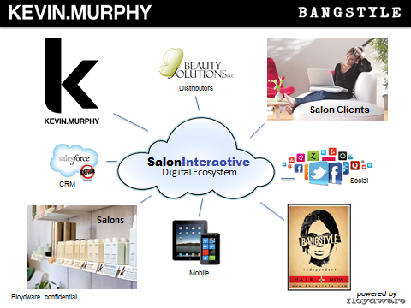

Context Enhanced “Moment of Need” Delivery
Working within the context of real-time salon workflow, SalonInteractive provides the ability to educate and guide the client at the appropriate point-of-schedule/sale “moment of need.” Information about the individual end user (both historical and real-time) is combined with your marketing and educational data to optimize retail performance solutions and drive positive business outcomes.

A context enhanced interface is target marketing at its best. It effectively and measurably guides human behavior to improve business outcomes. When paired with Floydware’s feature-rich salon management system, it can provide pinpoint-targeted information to each individual client. The quality of the user experience is enhanced, and the result is higher sales and greater customer service, involvement and intimacy.

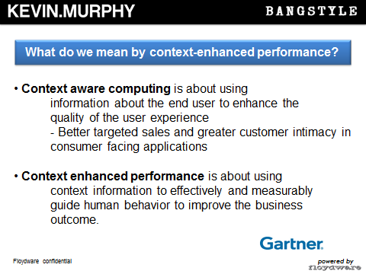
The New Omni-Channel Salon
Floydware data shows that 21% of all appointments were scheduled online by the client in 2012. That has more than doubled from 2011. It is predicted that within five years the number will be 90%, creating an enormous omni-channel opportunity.

SalonInteractive is a valuable omni-channel ally in the interface between the online client and the “brick & mortar” reality of the salon experience. Clients scheduling an appointment online receive situation-specific information on products, services and promotional packages at the moment of need. At this key point, they are most likely to purchase packages and gift cards, be open to learning about new products and services, and reserve products for pick-up on the day the service is scheduled.

Additionally this information is passed on to the in-salon staff and the entire salon digital ecosystem, enabling a truly omni-channel salon retail approach.

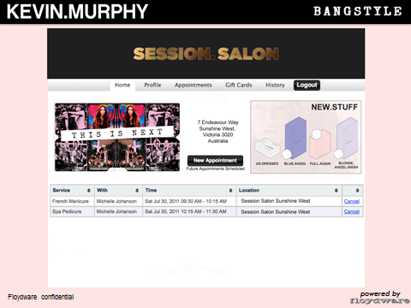
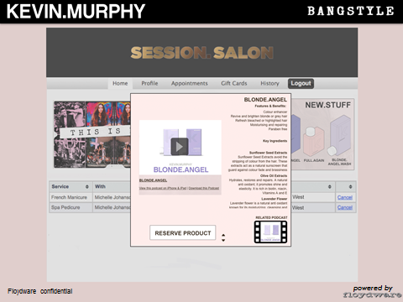

Brand as Partners
Product manufacturers offer a rich array of educational and product information that can be used to enrich the client experience and increase salon profitability. SalonInteractive makes this information readily available at the “moment of need” to drive sales and promote brand loyalty.

Floydware data indicated that our average salon schedules 7,000 appointments each year. With our current growth trajectory we intend to have 25,000 salons using Floydware Salon Management tools in five years. That means SalonInteractive will influence 175 million Scheduled Point of Sale interactions.

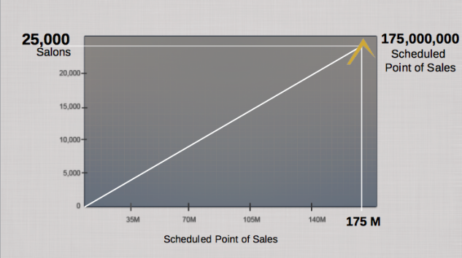

Personalized Role-Based Dashboard
Delivering a highly personalized end user experience depends upon utilizing real-time client data along with product education, creative suggestions and business performance guidance to the salon staff. Shown below is a typical salon stylist dashboard that acts as a central hub for real-time client data, product/business education, artistic thought leadership, client scheduling and business performance analytics. Role-based performance support is delivered at “the moment of need” to empower salon staff and enhance the salon client experience.

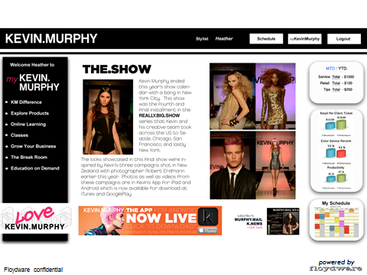

Measurable Business Results
SalonInteractive will integrate with any POS system to provide measurable business analytics and salon performance measurements to drive positive business outcome 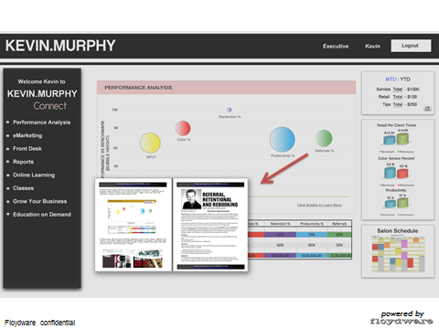

Real-Time Business Intelligence
SalonInteractive gives salons the ability to utilize real-time business intelligence. Real-time data enables timely, predictive business analytics and salon performance analysis, allowing you to proactively identify and correct salon business gaps as well as enhance assets. Access to the entire salon digital ecosystem provides you with innovative business opportunities to create significant new revenue stream

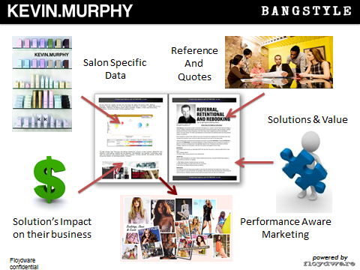

Born in the Cloud
Salon Interactive is the salon industry’s next generation platform, providing tomorrow’s Salon 3.0 functionality today. Its proven cloud foundation comes from Floydware’s industry-leading Rosy Salon Software—a comprehensive suite of salon scheduling and business tools that provides unmatched online features and functions. It can be viewed at: www.RosySalonSoftware.com

Through Floydware’s Value Added Reseller (VAR) program, Rosy Salon Software can be privately branded to become a part of your offerings and create a recurring revenue stream for your business.

