We are after a safety logo for our company ‘Mine Tech Engineering’. There are a few examples below. The words ‘ZERO HARM’ have to be the main focus with a creatrive and meaningful words to remind employees to be safe. We are in the Mining Indestry, so a hard hat or possibly a hand could be in there somwhere? I am leaving options open to see what you come up with.
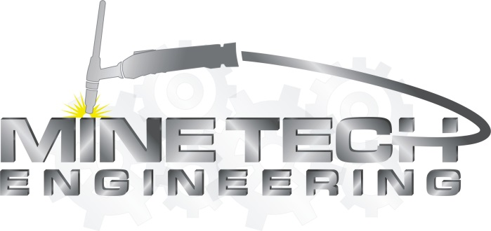

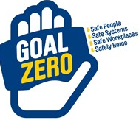
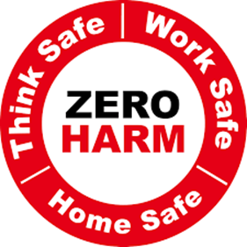
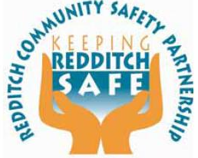
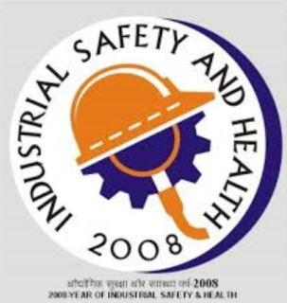
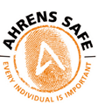
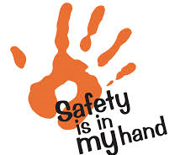
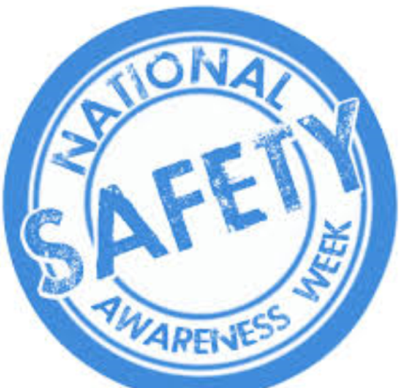
Above is our company logo. We are metal Engineering buisness who manufacture componants for mines from structrual steel, pipework fitting and maching.

