Home Page
Logo
Mosquito Freedom!
Designed in Texas by Texans, specifically for Texas Mosquitoes, the Barefoot Mosquito Control System is the first organically-based mosquito control system that eliminates both mosquitoes and the need for automatic mosquito misting systems.
Our 99.5% organic solution not only minimizes your family’s risk to harmful pathogens such as West Nile Virus, Chikungunya, and Eastern Equine Encephalitis, but it also reduces pesticide exposure by 95% compared to nozzle misting systems. Better yet, our customer’s report the Barefoot system is nearly twice as effective as expensive nozzle systems.
Throw away the sprays, magnets, fans, and other gimmicks that offer little in effectiveness. The Barefoot Mosquito Control System is the only effective and guaranteed method of ridding those annoying mosquitoes, protecting your health, and enjoying your outdoor living environment to the fullest.

Photo of kids playing in backyard
Photo of person gardening
Photo of relaxing by the pool
Video of customer testimonials

The Birth of the Barefoot Mosquito Control System
The company’s founders, Jason Revill and Joseph Barclay have been in the pest control business since 1996. Understanding the life cycles, environments, and habits of all household pests have resulted in effective treatments designed to eliminate pests while minimizing pesticide exposure to their customers. Continually seeking for ways to improve their service led them to their discovery of the Barefoot Mosquito Control System.
What initially motivated the founders is that they are parents of small children and found themselves frustrated with the hazards and annoyance of mosquitoes at their own homes, and the inadequate solutions available to the public.
This propelled the founders into a quest to find a product to tackle the problem of mosquitoes that was 1) Effective 2) Affordable 3) Natural and 4) Safe.
To do this, they became members of the American Mosquito Control Association, and consulted with dozens of etymologists, including those at the Texas Agrilife Extension. What they found was a disconnect between the real experts and the most common method offered.
“We learned from every conversation with urban etymologists that they loathe the automatic mosquito nozzle misting systems. Dumping 600 gallons of pesticides on a property to achieve, at best, 50% control is not just expensive, but hazardous and downright irresponsible. Even if they use a manual misting service, they are usually quite limited as they only use pesticides” Jason Revill
They learned of certain natural organic products that had been tested and proven to be effective at repelling mosquitoes.
“Customer’s don’t want to protect one area of their health (mosquito-borne viruses), while sacrificing another area of their well-being (increased pesticide exposure). Joseph Barclay
Building upon their decades of experience combined with cutting edge research from experts in the field and proven natural remedies they developed the Barefoot Mosquito Control System.
“We were very encouraged to experience the Barefoot system for ourselves just how well it worked. We could send our kids outside to play without spraying them and they would come inside hours later with no mosquito bites. We were even more encouraged by the response from our pest control customers when we began servicing their accounts. We have never experienced the power of word of mouth like we have with Barefoot. It’s very exciting.” Joseph Barclay
After unprecedented growth in the Austin area in 2014, the company is opening up branches across Texas in 2015, affording millions of Texans the opportunity to experience the Barefoot Mosquito method for themselves.

How the Barefoot Mosquito Control System works
Mosquitoes have four distinct life stages (egg, larvae, pupae, adult). Most mosquito control methods fail to control mosquito populations by focusing inadequately on only one of these life stages. The Barefoot Mosquito Control System focuses on the eradication of all four life stages to achieve 90%+ eradication of the mosquito population on a property
- Remedying Conducive Conditions to Prevent Egg, Larvae, and Pupae Development
Before a service can commence, a licensed technician will inspect and identify areas to be addressed that are contributing to mosquito harborages on a property. Remedying these potential nesting sites will eliminate mosquito egg, larvae, and pupae from developing on a property. On a regular basis, these listed items are monitored and addressed to reflect current conditions. These items are surprisingly simple and assist in pesticide reduction.
- Eradication of adult mosquitoes
Utilizing the most powerful equipment available, technicians direct a pyrethrum-based adulticide deep into mosquito harborages at a velocity of 140 mph to eradicate adult mosquitoes on contact. The residual properties of the product will continue to effectively eradicate mosquitoes that attempt to land in these areas for up to 30 days. This potent treatment is dynamic and can penetrate deep into all infested areas of a property. The Barefoot Mosquito Control system is far superior to a traditional static misting system that is limited by its fixed location, clogged nozzles, and inadequate pressure that is often subject to the direction of the wind.
- Repelling adult mosquitoes
A mixture of unique essential oils in the Barefoot solution serve as a strong repellant, preventing mosquitoes from nesting on the property. It also acts as a vertical repellant for neighboring mosquitoes trying to establish harborages on the property. Organic and naturally water-resistant, these oils assist in maintaining product effectiveness even during rainy weather. While these natural oils have an odor become undetectable by humans after only a few hours, mosquitoes detest these odors for up to 30 days.
- Sterilizing mosquito larvae
When standing water cannot be remedied, the Barefoot Mosquito Control System utilizes insect-growth-regulators, to treat water receptacles or standing water areas to prevent mosquito larvae development into adult mosquitoes that eventually seek blood meal. This treatment not only safe for humans, but for all occupants of a property, including fish, birds, and all pets.

Service FAQs
How often do you treat?
Once a customer commences service, the primary goal of the Barefoot Mosquito Control System is to eradicate as many adult mosquitoes and to disrupt the life cycle of the eggs, pupae, and larvae on the property. This is accomplished fully in the first three services which are scheduled approximately 21 days apart. Once the hatching cycle has been cracked, then services resume at a 25-30 day interval.
When is the best time to treat for mosquitoes?
Our mosquito control program begins in April and continues through November for Austin and Dallas. Houston experiences year round mosquito populations, so most Houston customers request continual services. If you experience mosquitoes year round, please contact our office to extend your service months.
Although mosquitoes are active most during the times surrounding dawn and dusk, we are able to achieve remarkable results servicing throughout the day mainly due to the repellency properties of our products.
How long after you treat should I wait to resume outdoor activities?
Because the Barefoot Mosquito Control System utilizes a power mist, not a spray, it dries very quickly, allowing you to enjoy mosquito-free living in as little as 5-10 minutes after our technician drives away.
Is this product safe for my family and pets?
Our products are applied in accordance with EPA guidelines and by licensed techicians according to the safety standards put forth by the product label. Our product is 100% organic, and the adulticide used is a synthetic pyrethroid, a close relative to pyrethrum, which is the extract derived from crushed chrysanthemums. To date, we have never experienced a single misapplication, or any negative health effects from our service to either humans or animals. We work hard to maximize everyone’s safety, by reducing chemical usage and increasing the percentage of organic products—and the best part is that it works!
If all my neighbors have mosquitoes, how will that influence the effectiveness of my service?
One of the best features of the Barefoot Mosquito Control System is its ability to create a vertical barrier that rises around the property that effectively repels mosquitoes as they attempt to breach the barrier.
Does this cover any other pests other than mosquitoes?
Our providers are licensed pest control companies that deal with a wide range of household and commercial pests. Each company offers enticing discounts when service packages are combined. Simply inquire to receive your discounted quote for mosquito and pest services.
Is there an odor associated with your products?
There is a slight odor that the natural oils emit that is detectible for homeowners for approximately the first day after the service is performed. The smell quickly dissipates to our human senses, but remains a strong deterrent for mosquitoes for up to 30 days.
Is your service guaranteed?
Yes. It does require 3 consecutive services to crack the hatching cycle of mosquitoes and create an optimal mosquito-free environment for our customers. Once this has been accomplished, we fully guarantee our service from the third service forward. While on a continual service, if mosquitoes reinfest the property, we will come and provide a booster service at no additional charge, provided that the customer balance is current, and all necessary conducive conditions have been resolved.
What results can I expect from the Barefoot Mosquito Control System?
At Spott, we believe that, although 100% eradication of mosquitoes isn’t possible, there are proven scientific methods which can severely reduce mosquito presence and make one’s property comfortable and livable again.
We aim to give customers realistic expectations at the time of service, based on the challenges we observe on a particular property. As a general rule, by the third treatment, we expect customers to enjoy a 90% plus reduction in mosquito activity. The three weeks following the service are the most effective and in the days following, sporadic mosquito sightings may occur until reapplication.

Mosquito FAQs
To What and Whom are Mosquitoes Attracted?
Mosquitoes detect their host using three primary senses:
- Sight: Mosquitoes see movement of their host
- Infrared: Mosquitoes can detect body heat
- Chemical Signals: Mosquitoes can detect traces of carbon monoxide and lactic acid up to 100ft away
There are a lot of theories surrounding why certain people tend to attract mosquitoes (some are pretty outlandish), however, verified testing in a controlled setting has given us the following conclusions:
- Mosquitoes are attracted to Carbon Dioxide and lactic acid. Therefore larger individuals who emit greater amounts of CO2 are more susceptible to mosquitoes. Movement and activity also contribute to greater attraction as an individual is more likely to generate higher quantities of CO2 and lactic acid.
- The color of one’s clothing is also a contributing factor that determines mosquito attraction. Lighter colored clothing attracts fewer mosquitoes than dark clothing in recent studies.
- Mosquitoes are also attracted to foot odor and sweat.
Why are there so many mosquitoes in Texas?
- The simple answer to this question is that mosquitoes are here for the same reason we human beings love living in Texas. Our lush landscape is dotted with large trees (shade) amongst the rolling hills with lakes and rivers cutting through central and east Texas provide a perfect breeding ground for mosquitoes. Combine the fact that certain cities in Texas, like Austin, have strong environmental policies and are very averse to any city mosquito abatement program, despite our abundant nature preserves and expansive park areas.
How far can mosquitoes travel?
- There are certain species of mosquitoes that can travel up to 35 miles for blood meal, however the primary species in Texas, the Asian Tiger Mosquito is, by comparison, very lazy and usually migrates less than 300ft. Although the Asian Tiger Mosquito is lazy, it presents a challenge in that it feeds not only at dawn or dusk, but also throughout the daytime.
Do all mosquitoes transmit serious diseases?
- Fortunately, less than 2% of all mosquito species are capable of carrying and transmitting West Nile Virus. The Southern House Mosquito in Austin is the mosquito primarily responsible for local infections. Eastern Equine Encephalitis is spread by the species Culiseta Melanura (common name: Black Swamp Mosquito) which frequent woody marshlands. Dog/cat Heartworm is transmitted through multiple species of mosquitoes, but can be sufficiently prevented with medication. (see Disease FAQ for further information)
How does the weather affect mosquito activity?
- Since mosquitoes need water to breed and survive, climates with regular rainfall, high summer temperatures, and high humidity ensure mosquito activity. Once temperatures dip below 60 degrees for a week or more, mosquitoes will discontinue breeding and the overall population begins to decline. Since mosquitoes are not strong flyers, moderate to high wind areas will significantly reduce mosquito activity.
Why does my property seem to have more mosquitoes than my neighbors?
- Mosquitoes are attracted to increased moisture, shade, and the protection of trees, bushes, and shrubs. Common reasons we see for high mosquito activity is overwatering of grass and plants, thick bushes and overgrown plants, and any standing water on the property.
- The surrounding environment also plays a very significant role in localized mosquito activity. Homes that back on to nature preserves, and/or are in close proximity to bodies of fresh water will no doubt be challenged by mosquitoes.

Disease FAQ
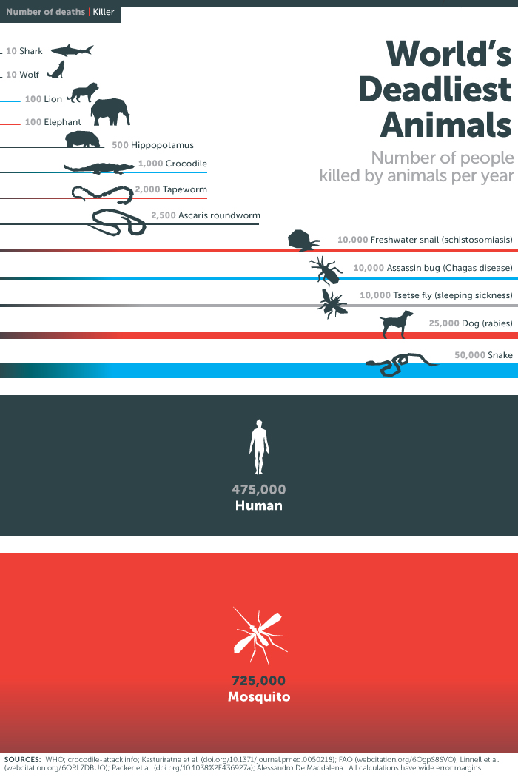
More than just an annoyance, mosquitoes are responsible for more deaths to humans than any other living organism worldwide. Mosquitoes are also responsible for the transmission of fatal and serious diseases to domestic pets and livestock.
West Nile Virus
West Nile Virus was first reported in Africa in 1938 and eventually spread to Europe, the middle-east, Asia, then ultimately the United States in 1999. In that year, only 62 cases were reported primarily in the northeast. However, by 2012, the number of human cases escalated to 5674 and has spread to almost every state. Also in 2012, Texas was responsible for over half of all reported cases in the United States. The mortality rate has remained consistent over the past decade with approximately 5% of cases resulting in death.
West Nile virus is transmitted from birds to mosquitoes to humans, pets, and livestock.
Infections generally have three gradations of seriousness.
- West Nile Fever is the least serious form of the disease. Symptoms generally include fever, headach, headache and body aches, and/or rash—very similar to the flu. This might last a few days or several weeks. Almost 2/3 of those infected report symptoms that remain over a month. Average symptoms last approximately two months.
- West Nile encephalitis is a very serious disease that attacks the brain. It is also classified as a neuroinvasive disease which affects the nervous system. This is a much more serious type of infection, but fortunately develops in only 15-20% of all WNV cases.
- West Nile meningitis (meningoencephalitis) is the inflammation of the brain and surrounding membrane. Similar to West Nile encephalitis, West Nile meningitis is also a neuroinvasive disease, it is often the most serious form of WNV, carrying the highest mortality rate (approximately 10%)
Recovery from infections of West Nile Virus can be painfully slow and many patients report permanent symptoms, such as muscle weakness and brain damage, which prevent them from regaining full health.
Eastern Equine Encephalitis (EEE)
Considered the most virulent abrovirus, Eastern Equine Encephalitis is transmitted to humans and horses by infected mosquitoes. It is primarily found in freshwater swampland in the Atlantic and Gulf Coast in the Eastern and Southern United States.
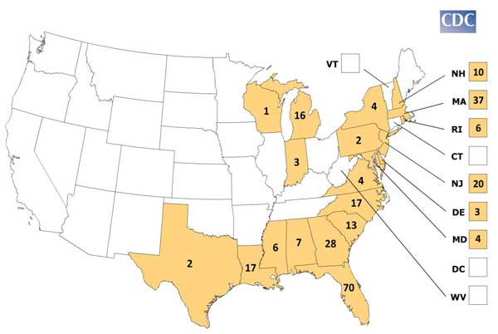
Similar to West Nile Virus, EEE is spread from birds to mosquitoes to humans. Once a human or larger animal has been infected, the transmission of the disease to other people or larger animals is no longer possible.
Thankfully, the majority of people who are bitten by an infected mosquito will not become symptomatic. However, for those serious cases of EEE infections, symptoms arise with the sudden onset of fever, sore throat, headache, chills, and nausea. In the most severe cases, disorientation, seizures, inflammation of the brain, and coma may occur. The most disturbing statistic regarding EEE is that approximately 33% of people who develop EEE perish, while survivors typically suffer mild to severe brain damage. Many patients are admitted to institutional care for the remainder of their lives. While there is a vaccine for horses, a human vaccine is not currently available.
Chickengunya

