2. CAR BADGE WINGS LIKE EGYPTIAN EAGLE

ET initials where the B is
Wings to be like eagle below



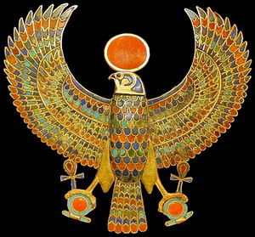

3. STYLISED EGYPTIAN CHARIOT

Stylise Egyptian chariot in place of horse/ carriage as like a lino print per Hermes….maybe remove reconfigure the bow/ arrow (less aggressive) so down by side
Exec Transit where the Hermes is

