I like all of these lambs/concepts…

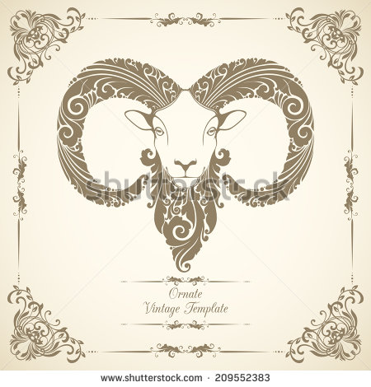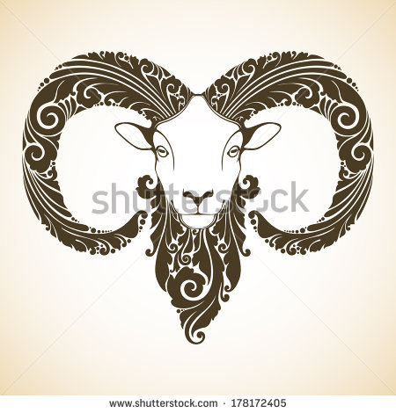
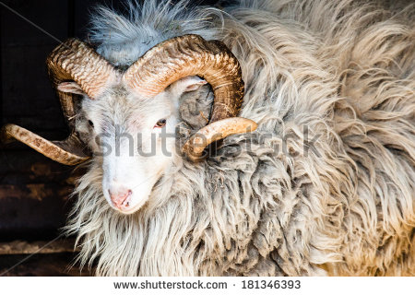
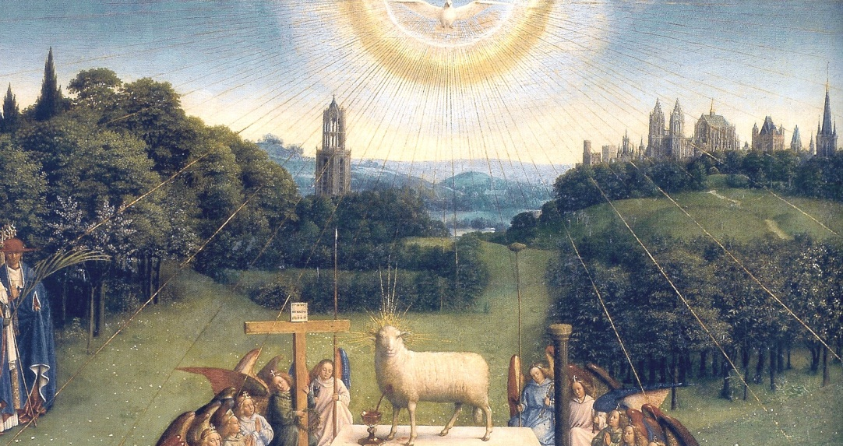
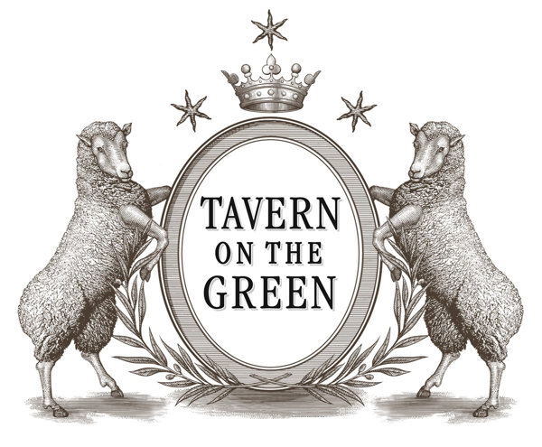

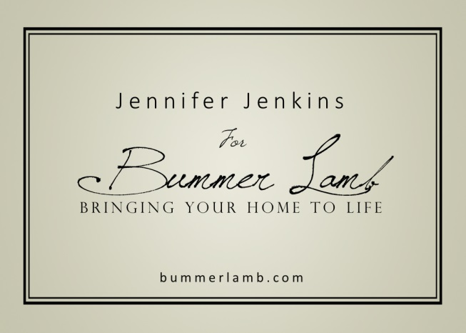

(Company name font: Jellyka Saint-Andrew's Queen)

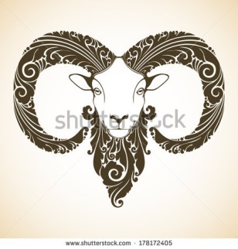
Bummer Lamb

Home Design & Fine Furnishings

Thoughtful Renovations

Custom Kitchens & Baths

Inspired Home Furnishings

Bringing your home to life…

