WINE  House Wines  $5  Chardonnay  Cabernet Sauvignon  Merlot  Pinot Grigio  Zinfandel  - Rotating Seasonal Wines - from $6  Pinot Noir $6  Red Blend $6  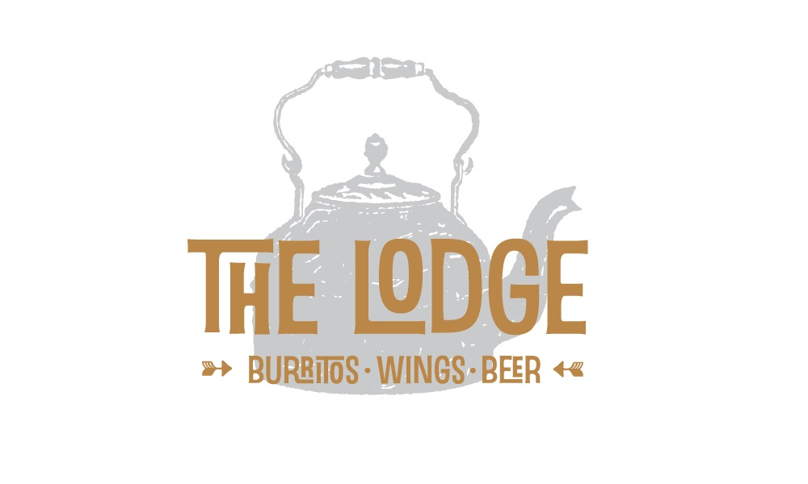About Us  The Lodge is the heart of Copper Kettle Cottages. We are open to the public year round. The Copper Kettle provides lodging options to guests looking to experience all the area has to offer & The Lodge provides good times and a warm friendly atmosphere to all who wish to enter. Whether you stay for a week, a night...or just a drink - The Lodge at The Copper Kettle will deliver a memorably good time. .  Contact Us  Phone: 518.734.3575  Email: info@copperkettlecottages.com  Web: www.copperkettlecottages.com |  |  |  |  |  |  |  | 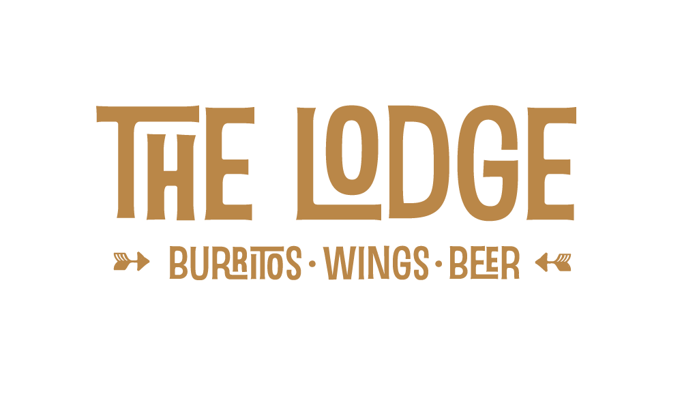Open  Thurs: 4pm – 12am  Friday: 4pm – 12am  Saturday: 4pm – 12am  Happy Hour Specials  Wing Night Specials Every Thursday  Get Some…  Located At  Intersection of Rt 23 & Rt 296  Windham, NY  518.734.3575
  BREWS
  DRAUGHT  Guinness  4.2% /$7  Palm (Belgian Ale)  5.4% /$6  Black Velvet  $7  *Rotating IPA*  From $6  *Rotating Seasonal*  From $6  ___________________  IPA  Dog Fish Head 90 Min  9% /$6  Founders All Day IPA  4.7% /$5  Stone  6.9% / $6  _______________________  STOUTS  Brooklyn Black Chocolate 10% /$6  Left Hand Nitro Milk  6.8% /$6  *Additional Beer Selections Available – Ask us about our Specials* | LOCAL  Ithaca Apricot  4.9% / $5  Ommegang Rare Vos  6.5% /$6  Ommegang Witte  5.2%  $6  _________________  LAGER  Budweiser $4  Bud Light $4  Coors Light $4  PBR 16 oz. Can $4  Brooklyn $5  Yuengling $5  IMPORTS  Corona $5  Spaten (Lager) $5  ______________________  MISC.  Angry Orchard Cider  5% / $5  Magners Irish Cider  4.5% $5  Dales Pale Ale  6.5% / $4  Harpoon UFO Hefeweizen: 4.8%/ $5
  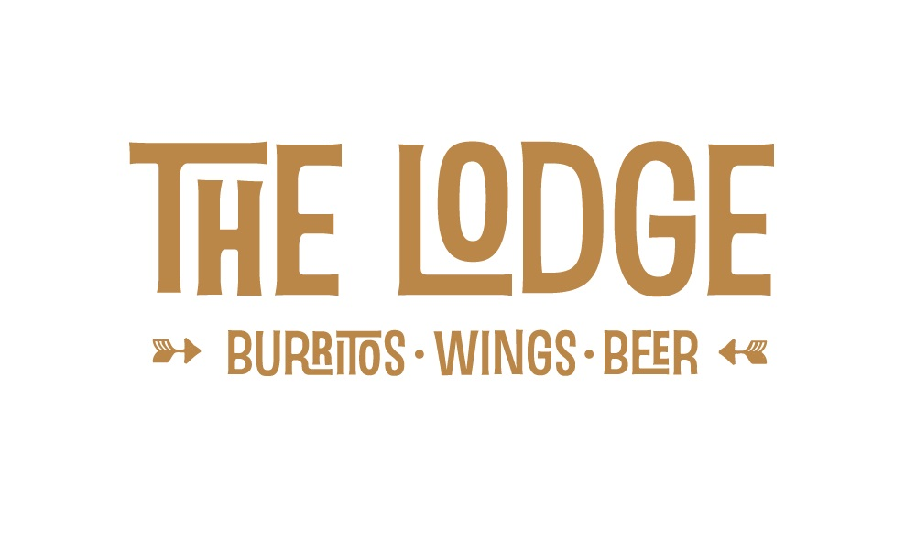
  Located at…
  Intersection of Rt. 23 & Rt. 296
  Windham, NY 12496
WINGS  Buffalo Style  Mild: Sweet & Tangy  Medium: Bold & Spicy  Hot: Teary-Eyed & Sweaty-Browed  $9  Specialty  BBQ ..………………………$9  Ha-B-Q (hot!) .……………...$11  Shanghai Garlic .……. $11  Hot Honey Thai ….….. $11  RazbaNero (hot!) ….…… $11  All Sauces Are Homemade!  Sampler  Dozen wings - Mix and match $15  Your choice of 3 flavors (4 wings ea.)  All wings are served with Blue Cheese or Ranch, Celery & Carrots |  |  |  | Burritos  Build your own!  Includes choice of meat, toppings & side of salsa and chips  All Ingredients made fresh daily!  Meats  Red Chile Grilled Chicken Marinated in a Red Chile Ancho sauce – this grilled chicken is the perfect blend of sassy, salty, savory and mild spice  $9  Spicy Shredded Beef Slow cooked in a Chipotle Pepper sauce – saucy & spicy  $9  Pork Carnitas Wrapped in bacon and slow roasted – our pork is seasoned to perfection with subtle hints of clove and citrus  $9  Veggie Wrap up your favorite combination of meat-free toppings to create a vegetarian delight (guac included)  $7  Personalize |  |  |  | EXTRAS  Basket of Chips & Salsa $3  Basket of Chips & Guacamole $4  Basket of Steak Fries $4  Kids Basket of Fries & Nuggets $5  Deep Fried Smore $3  Drinks  Coke…………………………………………………………………$3  Diet Coke………………………………………………………….$3  Sprite……………………………………………………………….$3  Ginger Ale……………………………………………………… $3  Mello Yello………………………………………………………..$3  Shirley Temple……………………………………………….. $3  Iced Tea …………………………………………………………..$3  Sweet Tea……………………………………………………..…$3  Kids Milk………………………………….….………………$1.50  Kids Cranberry Juice .……………..……………….$1.50  Kids Apple Juice …………………….………….……..$1.50  Kids Soda……………………………….…………….……$1.50  Coffee ………………………………………………….. $1.50  Hot Tea …………………………………….…………….. $1.50  Hot Chocolate…………………………………….…….$1.50
  Cheddar Jack Cheese  Sour Cream  Black Beans  Refried Beans  Cilantro Lime Rice  Lettuce | Red Onion  Bacon  Pico de Gallo (mild tomato salsa)  Medium Salsa  Hot Salsa  Guacamole (add $1.00)

