Optional Extras Hire

Thank you for booking my act. Your booking already includes a number of great features and visuals such as themed backdrops, 6ft banner stands, lighting, inflatables and projections.
I have a number of extra hire services available at a reduced rate for clients that have booked my act (50% off competitors’ prices). If you would like to add any of them to your event, please specify which ones you would like in an email 5-7 days before your event.

Photo Props Screen, Props box & Red Carpet Props £50.00

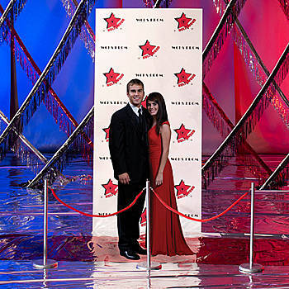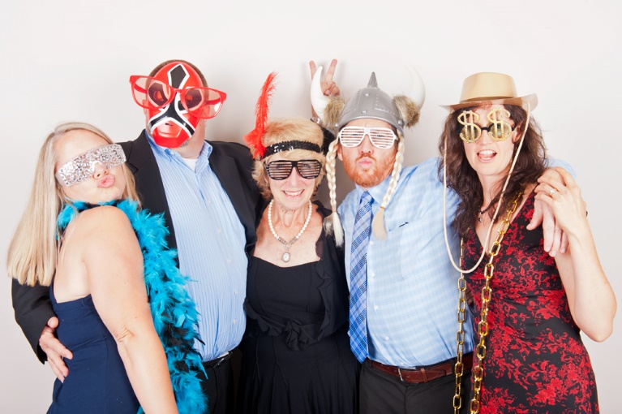

Make some memories with this fun photo booth package. Watch your guests come out of their shell. Strike a pose!
Guestbook Post Box & Postcards £35.00

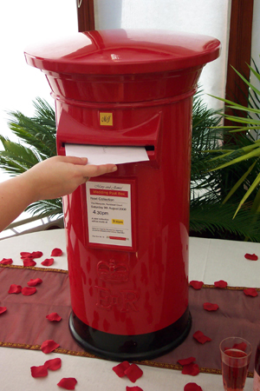

This post-box will create a nostalgic centre piece at your event. The package includes post cards for your guests to write a message on plus a fun stamping kit. At the end of your event, your postcards will be collected and presented in an authentic mail bag.

Sweet Table & Personalised Candy Bags £140

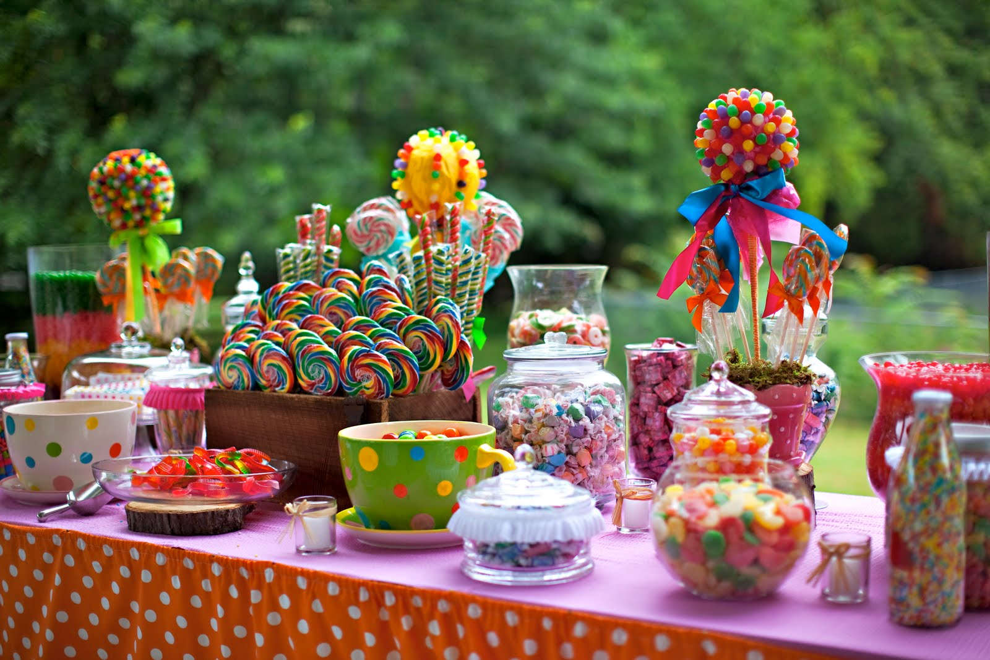

A sweet table with a vintage twist with enough candy for 80-120 guests. Chrissie also provides personalised candy striped paper bags. The table includes stunning sweet jars, novelty display stands and scoops. The table can also be lit for effect. Please ensure that a 4-6ft table is available at the venue.

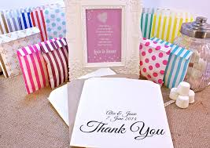

Ferrero Rocher Heart Display £70.00

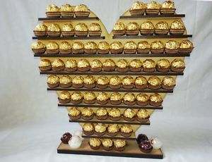

Treat your guests to a luxury chocolate and they will feel like ambassadors! This impressive heart holds 144 Ferrero Rocher chocolates and will add the wow factor to your event. Please keep a small table available at your venue.

Giant Vintage Games Package x 4 £25.00
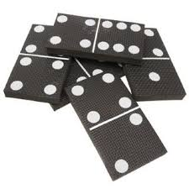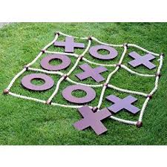
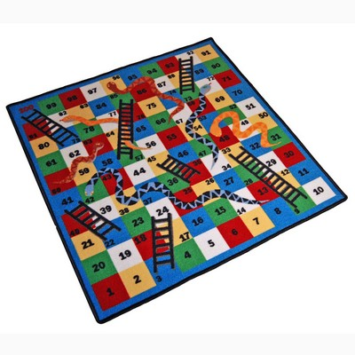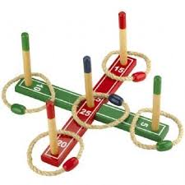

This package is great for parties with children attending, not to mention any big kids at the party!

Las Vegas/Circus Love Heart £25.00

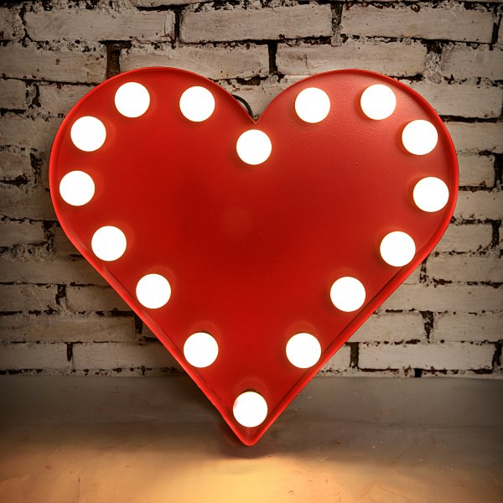

Create a vintage/retro vibe with this stunning love heart, a real eye catcher!

Love Heart Umbrellas x 4 £20
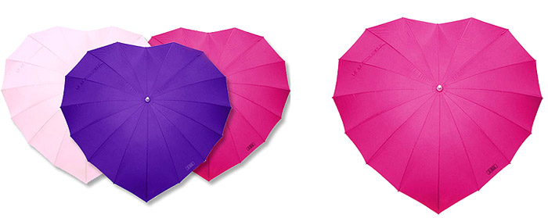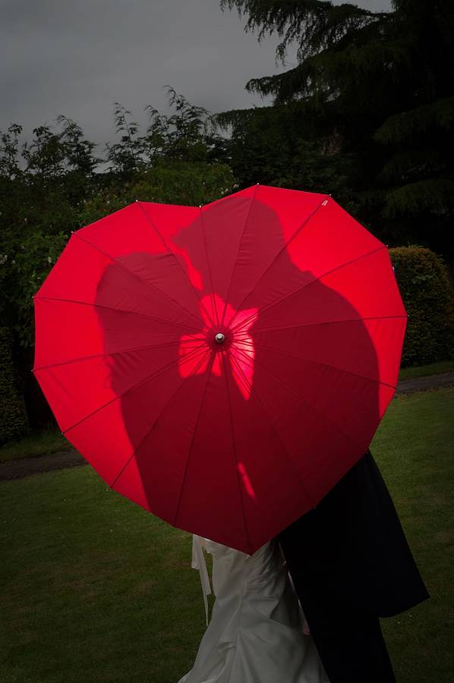

Four love heart umbrellas for hire. Great for outdoor wedding photography.

Director Clapper Boards £10.00

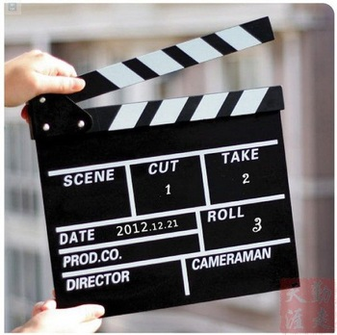

A set of four director clapper boards to display around your venue, perhaps on the window sills.

Air-blown Inflatable Birthday Cake £20
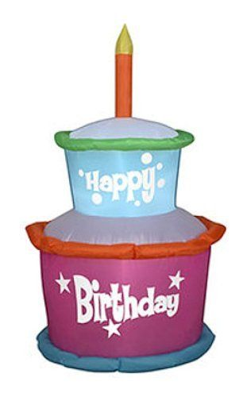Watch this cake sway all night!

Kitsch Props & Table Ornaments £20

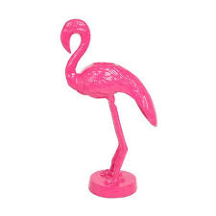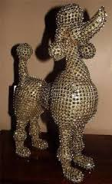
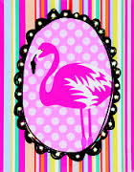

Some extra kitsch décor for your room. This package includes two flamingo tea lights, a diamante poodle and an led lit flamingo canvas.
Thank you for looking at the optional extras available. If you have seen anything you would like to add to your event. Please state which ones in an e-mail to Chrissie at livevocalist@yahoo.co.uk and I will add them to your booking.

