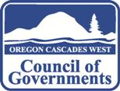
Right: Logo of Oregon Cascades West Council of Governments (Logo for this project should not emulate this logo, except in color).
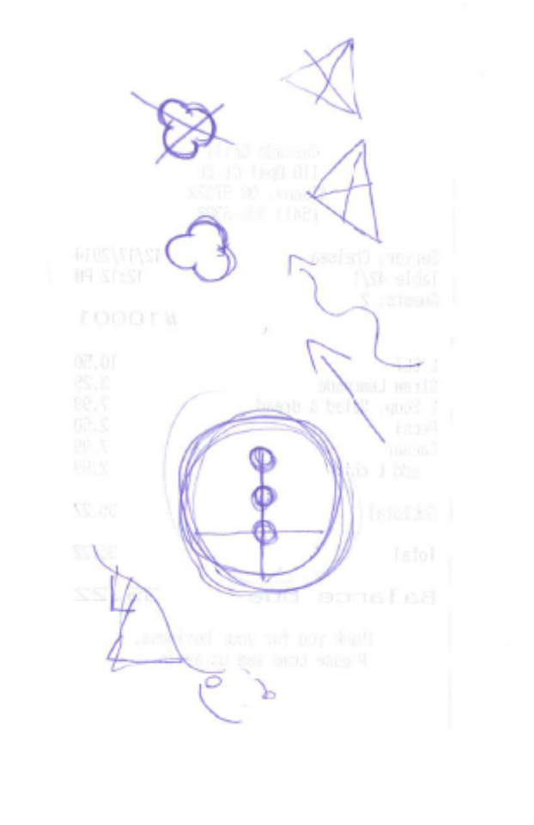
Below: Conceptual sketches showing motion and linkages between Linn, Benton and Lincoln Counties.
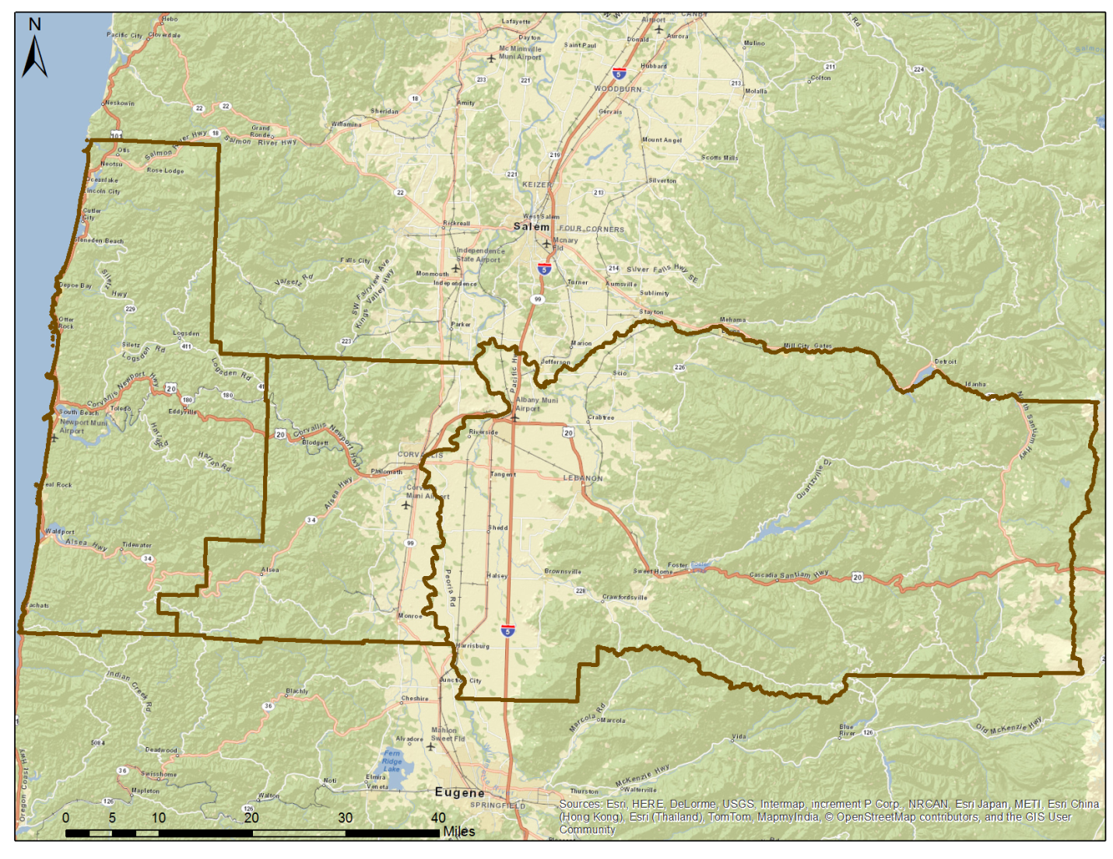
Bottom: Map showing Linn, Benton and Lincoln counties

