Request for Design: Logo

Name: Meathead
Tag line: True Food & Drink
Concept: Meathead is a more polished, rustic dive-bar where everyone is welcome, offering a high-quality meat-focused menu at low prices.

The Room:

The room features existing design elements that give it an indie feel with wood and brick highlighting the interior. It will likely feature both low and high tables to give it a sense of separation between restaurant & lounge, but will not be physically divided or separated.

Comparison Companies:

Browns, Original Joe’s, Boston Pizza, The Warehouse, Jack Astor’s, Beer Town, Canadian Brewhouse

Brand Positioning:

Want to be a drinking destination, where people can go to drink but also to get great food, similar to Original Joe’s. Accomplish this through attractive beer, wine, and cocktail lists.

Want to be a fun destination, where people can gather, socialize, and co-mingle. Accomplish this through upbeat atmosphere, great room design that facilitates conversation (possibly communal tables), and attracting the right staff/guests.

Want to be a high quality food destination, with food comparable to the quality of Brown’s. Focused on high quality meat dishes – likely lots of burgers and pizzas.

Want to be the place with the best atmosphere – the best possible mix between restaurant, lounge, and pub. Take the best of each of the 3 and fuse them together.

Want to accept families and encourage our guests to watch sports on our selection of TV’s, but we don’t want to be defined as a family place or a sports bar (like Boston Pizza is), and want to be similar to how Browns is perceived.

We want to be viewed as an affordable place – not a place that uses cheap ingredients to come up with a cheap product, but a place that has low prices for high quality food.

Character: “You hate your job? Why didn’t you say so? There’s a support group for that. It’s called “everybody” and they meet at the bar.”

Possible Design Elements:

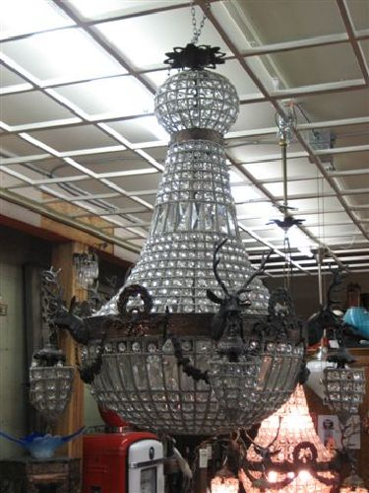

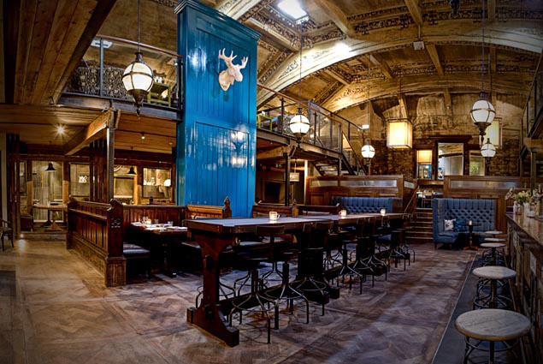

https://www.etsy.com/ca/market/faux_animal_heads

