Are you really LinkedIn?

Here are some Clever Cat Marketing top tips on how to maximise your LinkedIn experience.

Contents

Introduction
Strategy
Promotion
Connections
Views
Groups
Skills
Recommendations
Content
Recruitment
Depth
Next steps

Introduction
In recent years social media websites have reached stratospheric popularity and are a great way of reaching both current and potential clients.

If you’re looking to expand your professional network and attract business then LinkedIn can provide both these opportunities, easily and effectively via one simple to use platform.

LinkedIn is the largest professional networking website in the world, with over 200 million members who you can potentially ‘connect’ to.

It is definitely an area worth investing both time and money in, whether that means offering training sessions for your team or outsourcing your communications to a specialist marketing agency.

Along with other forms of social media, LinkedIn should form part of your digital marketing strategy for 2013 or you risk finding yourself left behind and out of the increasingly important online conversation.

Strategy

Before logging onto LinkedIn, it’s worth investigating social media strategy.

Various psychological and sociological research on social media has proven how to be most effective on various sites.

You wouldn’t undertake the same digital marketing strategy on Facebook as you would on Twitter, for example.

See how similar companies and professionals operate their pages, and look at what works successfully and gets a good response.

People don’t like to be inundated with the same message, even online, so be wary of over-posting.

If you’re unsure, you can either experiment until you’ve found what works for you and your business or you can consult a professional for advice.

Promotion

Social media provides you an opportunity to sell your products, whether yourself or your company.

On LinkedIn, your profile is your opportunity to sell yourself to potential employers or clients so make sure you complete your profile entirely.

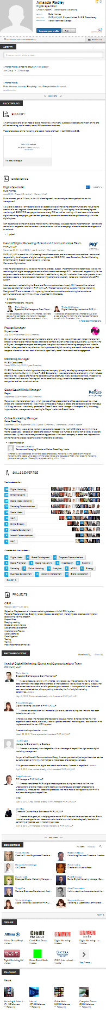
LinkedIn works as your online CV and is a form of digital marketing for both you and your company. As a major international website, LinkedIn ranks highly on search engines and therefore think carefully about your keyword optimisation when writing your profile and summary.

It’s worthwhile creating both a personal profile and one for your company, as both will assist your SEO. This is a cheap and effective way of boosting your online presence and shouldn’t be overlooked or underestimated. To put this in perspective, LinkedIn regularly lists in the top three results on Google when searching for business professionals, so you should definitely be featuring on it.

Connections

When it comes to networking online, there’s no such thing as a bad connection.

Whenever you have a meeting or attend a seminar you should make a note of the names of people you meet and send them a connection request on LinkedIn. Even if you’re not currently going to do business with them you might in the future if they or you change company.

Like the old adage says, it’s not what you know, it’s who you know and on LinkedIn it is also about who knows who.

Your connections are referred to as 1st degree connections, someone connected to one of your connections but not directly to you is a 2nd degree connection.

You can still view the profile of a 2nd degree connection and they will be flagged up in appropriate searches you run and vice versa as there is the possibility of an introduction through your existing network.

The bigger your pool of connections the better, a profile connected to 450 people can have 10,000,000 (that’s 10 million!) people in their wider connections. This could even grow at a rate of an extra 25,000 connections a day. If you’re into networking then LinkedIn is the place to be.

Views
Even using the basic free account LinkedIn provides you with the means to check who has seen your profile and you can set up your account to automatically notify you by email when your profile has been searched for or viewed.

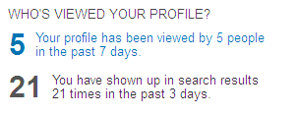

This can give you a good indication of whether your profile is attracting your target market, and if not you can edit it and assess the response and make appropriate alterations.

Are you selling yourself to the right people?
If not, experiment with your copy and tone.
Are you reaching the right people?
If not, expand your network.
Are you happy with the reach and response?
If not, be more active and get involved online.

It can take time to build your online persona, but the rewards can make it worth the investment.

Keep in mind that you if you can see who has viewed your profile other members can see when you have viewed their profile. If you have a meeting with a potential client remember to have a look at their LinkedIn profile, hopefully they will notice this and be impressed that you have done your homework before the meeting.

Groups

LinkedIn is free and open to everyone, from freelancers to CEOs, which means you can reach out to anyone in any particular industry.

You can also join one of the various groups which are designed to connect like-minded people.

There are groups for University Alumni, similar professions or those with particular interests such as running your own business or website development.

The group community is a great way of reaching out to those who may have more business expertise and can therefore act as a mentor figure, or to discuss your progress with people going through a similar experience.

Here, you can share your tribulations and learn from other people’s mistakes before making them yourself.

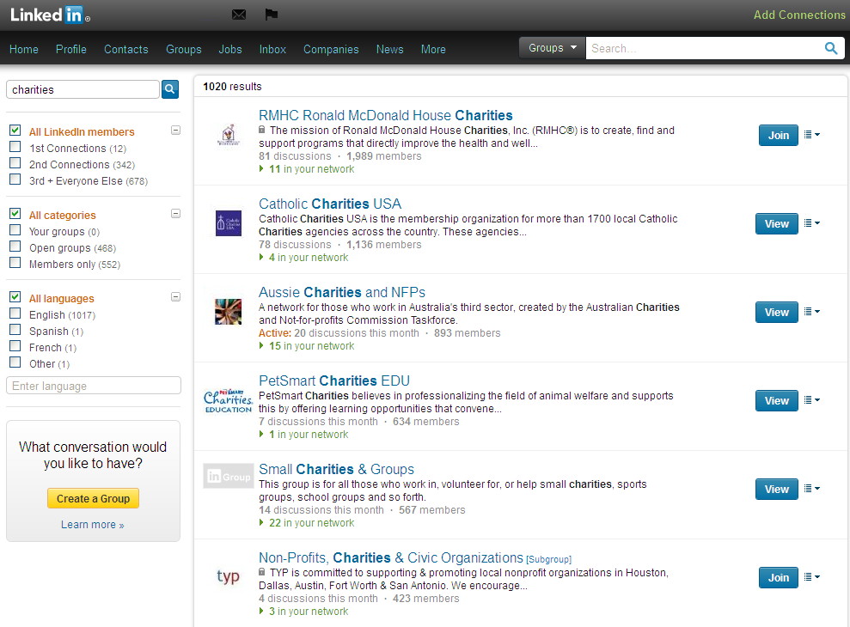

To join a group simply type in an appropriate keyword in the search box on the Groups home page. You’ll see a selection of groups which you can join including information about that group such as a description and how many members are in that group. Check out how many discussions have been started that month and look out for the Active symbol that LinkedIn displays on particularly busy groups.

Some groups are open to the public and some are members only, this means that when you request to join a members only group an administrator from the group will review your profile to see if your background makes you an appropriate member of that group.

Whichever groups you join make sure you get the most of out of them by joining in the conversation, social media is about dialogue.

Skills

On your profile, you can also select skills and attributes which you have and that are demonstrated by your employment history.

These can then be endorsed by other members who have worked with you – acting as a reference for your profiled skills.

In return, you can endorse the skills which you believe they have and you’ll then be listed on their profile as one of their endorsements.

This is an interactive method of recommending someone’s knowledge and expertise to both of your followers whilst creating a positive working relationship between your connections.

Ensure that you keep your skills up to date, if you learn a new skill than add it to your profile, if you can back it up with a qualification.

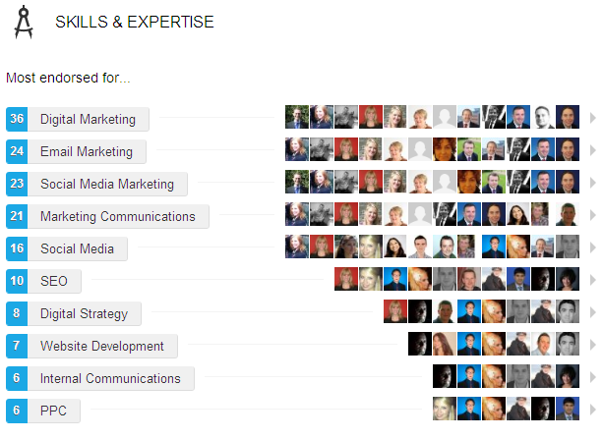

Recommendations

If a skill endorsement isn’t enough there are recommendations which you can both give and receive. A recommendation acts just like a personalised letter of recommendation and carries a lot of weight with the reader.

You can request recommendations from people you know or you can recommend them and hope they reciprocate.

Once you have received a recommendation you have the opportunity to request changes from the person who recommended you. For example if someone says they have worked with you for five years but it has actually been seven you can ask them to make that amendment.

Once you have been recommended you can decide whether or not you wish to show that recommendation on your profile.

Content

Similar to Facebook or Twitter, on LinkedIn you can post status updates and interact with your connections by liking their posts or profile information and changes. It’s a sleek method of communicating with all of your business contacts in one go, and saves time on lengthy round robin emails.

LinkedIn also provides interesting content and news written by its members – promoting thought leadership in a sharing environment which can boost your own profile and drive traffic to your website.

For people you can’t connect to (you can only connect to people you actually know), there’s a ‘follow’ option that enables you to receive updates from them on your home page.

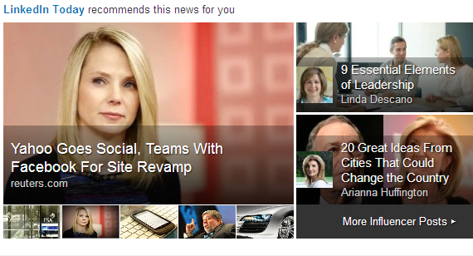

Creating high quality material could generate you thousands of followers and thereby expanding your network and sphere of influence even further.

These articles are recommended for people based on their interests, job and previous browsing history so you'll be targeting people more likely to be interested in what you're saying and therefore increasing the chances of a response.

At the same time, you'll be received articles targeted for you and can join the online conversation by liking, sharing or commenting.

Recruitment

Used by a variety of professionals, LinkedIn connects people. It's a popular site for recruitment consultants to source potential prospects, so make sure that your work history is accurate and, more importantly, true.

As a social site, it would be easy for past employers to highlight that you didn’t actually spend weeks travelling around the globe wining and dining clients so don’t take this risk.

It's also used by Human Resources departments checking up on job applicants so it should closely mirror your CV but don't be repetitive and copy and paste it word for word as this will look obviously lazy.

Creating your online profile is a similar process to writing a CV, and the same rules apply. Be relevant and succinct, otherwise people won’t bother to read your profile and connect with you. Sell yourself with every word.

Depth
It’s important to remember that people trust and buy from people, so your online persona should portray you as a rounded individual.

LinkedIn gives you the option of highlighting key projects that you have been involved with, and by doing so you are adding depth to your work experience and standing out from the crowd.

This is a great chance to talk about projects you partake in outside of the boardroom, or demonstrating your involvement in key industry events.

You can also upload information about any volunteer work you've participated in, which will give people a better overview of your past experience, interests, and charitable involvement.

Next steps

Clever Cat Marketing provides training sessions on maximising your LinkedIn profile both for professionals and businesses. For more information, contact us today to see how we can help you get the best out of your social media output.

