Statement of Capabilities
[Document subtitle]
Lighting Maintenance inc
832A Oregon Ave Linthicum Maryland 21090

Company Profile

Lighting Maintenance Inc. (“LMI”) is a certified Woman-owned electrical contractor, founded in 1991 by Hilary and Michael Yoder. We are a family owned business that designs, builds, maintains, and repairs electrical systems and provides Energy Efficient Lighting Solutions. LMI serves Commercial, Retail, Industrial, Utility, and Government sectors in the Mid-Atlantic region. Our capabilities include maintenance, construction, and design services.

Mission Statement

We measure our success through the quality and depth of our Relationships, Performance, and Solutions. We are committed to the growth and prosperity of our organization that occurs by applying these Critical Core Values to all areas of our business (Employees, Colleagues, Clients and Vendors):

- Honesty – Truthful in all aspects
- Integrity – Being fair and sincere - Applying strong moral principles and ethics.
- Perseverance – We don’t give up - Striving to satisfy our commitments.
- Respect – People and Property – Holding both in high regard.
- Safety – Maintaining the welfare of employees, customers and the public
- Sustainability – Balancing today’s resources with the healthiest future in mind – People/Processes/Planet.
- Learning thru Reflection – Examining our successes and failures always striving to learn and grow.

Safety

LMI’s commitment to safety is a top priority, our employees receive continuing safety training such as OSHA 10/30, tool box talks, and surprise work site inspections to ensure compliance with our Safety Policy. Due to the nature of our work particular attention is paid to Electrical Safety, Fall Protection, Miss Utility Rules, Arc Flash, Work Zone Safety, High Voltage Clearance, Dielectric Testing, and Bucket Safety.

Key Contacts

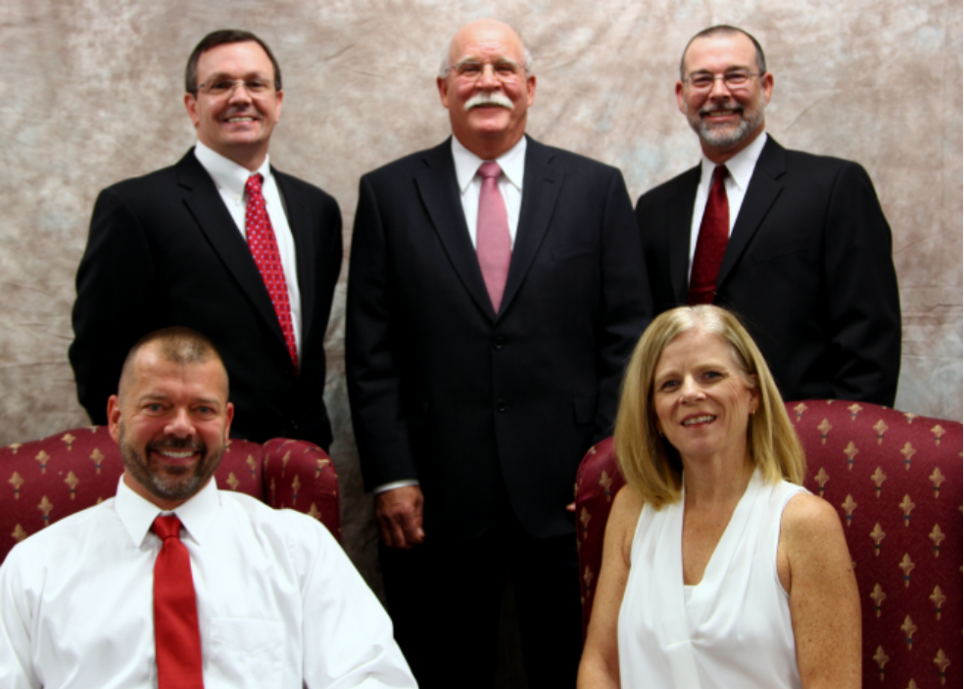

Hilary Yoder (front right)
President (Owner)
O. 877-279-7373 x204
Hyoder@LightingMaintenance.com

Mike Yoder (front left)
Vice President (Owner)
O. 877-279-7373 x214
C. 301.252.1717
Mike@LightingMaintenance.com

Paul Bradford (rear left)
Chief Executive Officer
O. 877.279.7373 x214
C: 410.710.3714
Pbradford@LightiningMaintenance.com

Richard Yoder (rear right)
Director of Preconstruction
C: 301-674-0161
Ryoder@LightiningMaintenance.com

Phil Tonolli (rear center)
Director of Purchasing
C: 703-906-5925
PTonolli@LightingMaintenance.com

Energy Saving Lighting

Turn-Key LED Lighting Solutions
Audit Design Installation Financing

Electrical and Lighting Services

- Cable Testing and Repair
- Code Corrections
- Commercial Lighting
- Commercial Maintenance
- Control Wiring
- Controls Switchgear
- Electrical Services
- Emergency and Standby Power
- Infrared Testing
- New Construction
- Occupancy Tenant Inspections Repairs
- Photometric Studies
- Power backup Systems
- Roadway Lighting
- Signs Construction
- Signs Repairs
- Sports Lighting
- Switch Gear
- Underground Wiring

Traffic Signals, Utility, and Line work

- Backhoe service
- Bucket truck service to 100’
- Cable lashing
- Cable splicing
- Digger Derrick service
- Directional Drilling
- Duct banks
- Fault Location & Repair
- Insulated bucket trucks
- Lighting Repairs
- Man holes installed
- Outage repair
- Stray Voltage Testing
- Street Light Construction
- Street Light Upgrades
- Traffic Signal Installation
- Traffic Signal Maintenance
- Traffic signal repair
- Transformer pads
- Transformers
- Trenching
- URD cable repair
- Utility Locating
- Utility pole replacement
- Utility poles set
- Vacuum Excavation

Locations

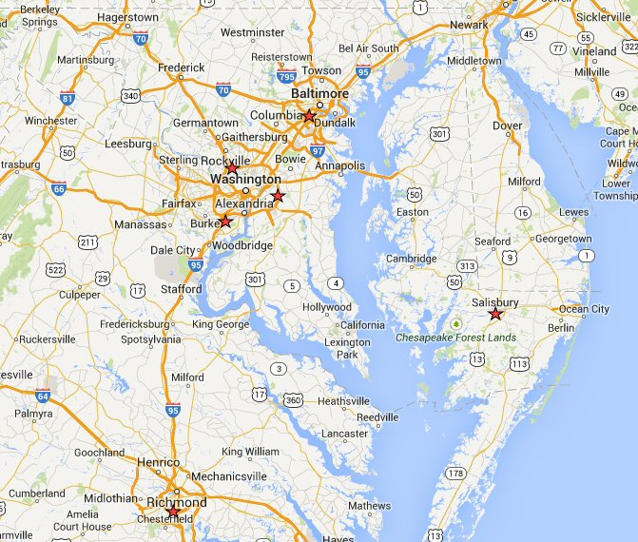

Headquarters
832 Oregon Avenue Suite A
Linthicum, MD 21090

Eastern Shore Operations Center
799 North Salisbury Blvd Suite 1200
Salisbury MD 21801

Richmond Operations Center
2077 E Whitehill Road
Prince George, VA 23875

NOVA Operations Center
7411-A Lockport Place
Lorton, VA 22079

PG County Operations Center
7909 Cryden Way
Forestville, MD 20747

Montgomery County Operations Center
14714 Southlawn Lane
Rockville, MD 20850

Licensing

Lighting Maintenance Inc is a fully licensed and bonded electrical contractor in the Commonwealth of Virginia, the State of Maryland, Delaware, and in the District of Columbia.

License Number
Virginia Electrical Contractor Class A 2705 0327 46A
Maryland Electrical Contractor 02259641
Washington DC Electrical Contractor ECC900315
Delaware State Electrical Contractor 2004205945

Certifications

Lighting Maintenance Inc. is a DBE/MBE certified Woman Owned Business.

State Number
Virginia DBE# 663270
Maryland MBE #09-581
Washington Airport Authority LD2010-00027-2013
Prince George’s County 10-6088
City of Baltimore 10-357921

For Additional Information Please Visit us at:

www.LightingMaintenance.com

Strategic Partners


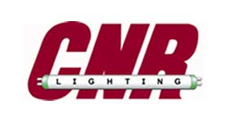











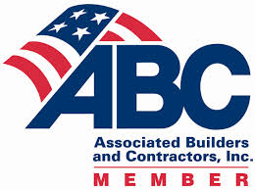
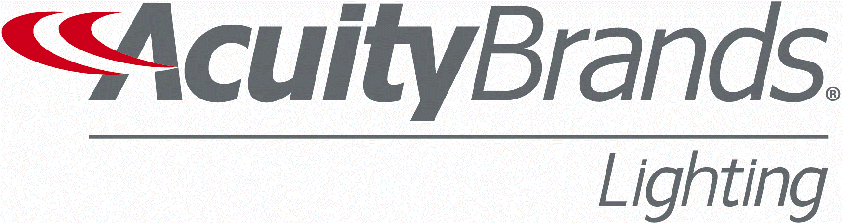
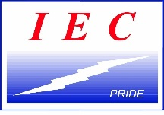
Na

