Blame It On Style

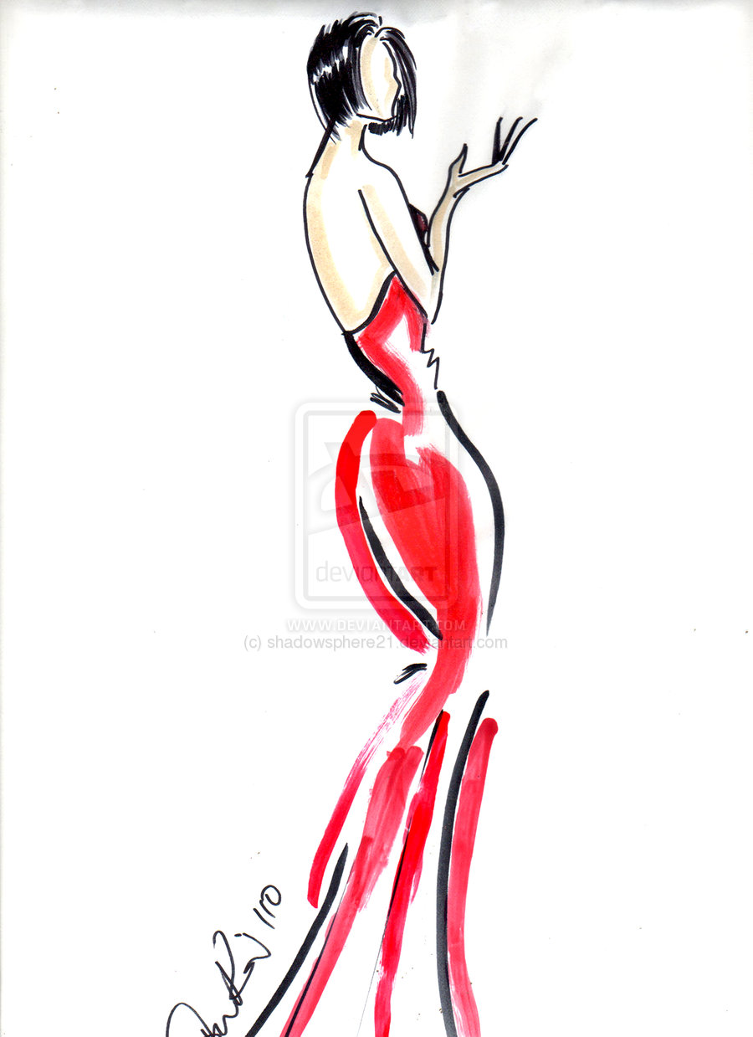
Blame It On Style
By Irene

