Proper wound healing requires a team approach. The product supplier must be completely in sync with the clinician, insurance company and patient.

Ally Medical experienced staff understands the importance of rapid service in the wound healing process along with the documentation requirements of Medicare, Medicaid, Medicaid Managed Care replacement plans and commercial insurance.
- Our New Client Coordinators work with the treating clinician and client to help implement a wound care supply plan of care.
- We coordinate all the documentation requirements and provide rapid home delivery of wound care products as prescribed by the treating clinician.
- We carry over 1,200 standard and advanced wound care products from the industry’s leading manufacturers, including cutting edge new technology many providers do not have access to.

WOUND CARE SUPPLIES

- Antimicrobial dressings
- Wound cleansers & skin care products
- Hydrogel dressings
- Standard roll gauzes & tapes

- Hydrocolloid dressings
- Calcium alginate dressings
- Foam dressings
- Transparent film dressings

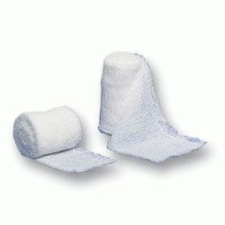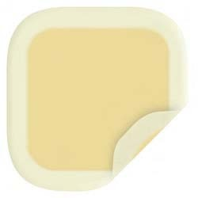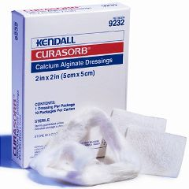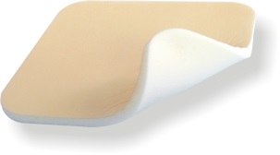
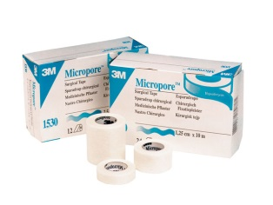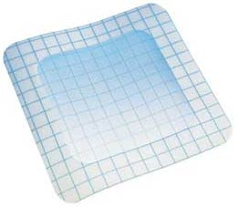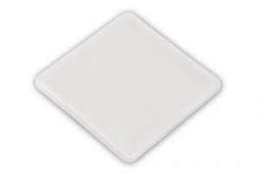



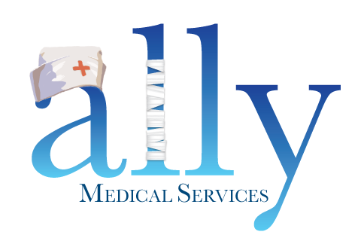
You have a lot going on. We’ll take it from here.

RAPID REFERRAL LINE (866) 684-2507 • FAX (866) 695-2183 • Support@Ally247.com

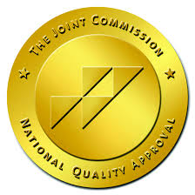




When my father developed a foot ulcer due to his diabetes, Ally Medical worked with the wound care center that was treating him to get his supplies covered by his insurance. They shipped his dressings directly to the house and took care of all the paperwork too.

You have a lot going on. We’ll take it from here.

