No other medical products supplier has more experience understanding the unique needs of patients using catheters.

Ally Medical’s experienced team understands the importance of compliance to a urinary catheter plan of care. We are experts on the complex coverage criteria and documentation required by insurance companies for use of these products in the home.
- Our professionally trained New Client Coordinators work with each client, their case manager and clinician to create a specialized product plan of care.
- Friendly, knowledgeable Client Service Representatives contact clients each month to assure the product plan of care is being implemented properly and supplies always arrive on time.
- We stock the largest selection of urological catheters & supplies of any provider in the country from the industry’s top manufacturers.
- Product samples available for same-day shipment.

UROLOGICAL CATHETERS & SUPPLIES

- Foley catheters, insertion & irrigation kits
- Male external catheters
- Bedside drain bags & leg bags
- Catheter security devices & fasteners
- Bowel irrigation kits

- Intermittent catheters
- Closed-system catheters
- Hydrophilic catheters
- Coude-tip catheters
- Compact/discreet catheters

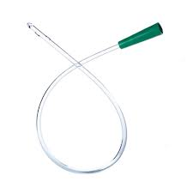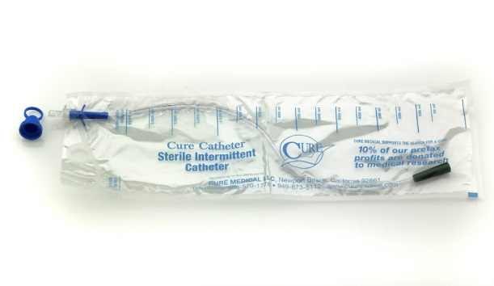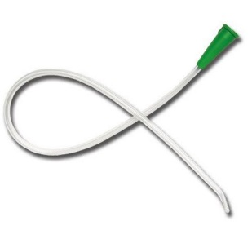
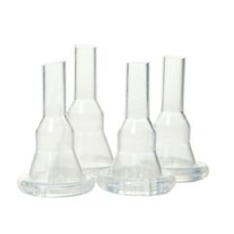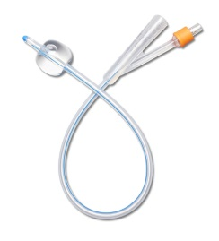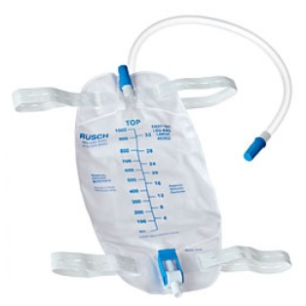
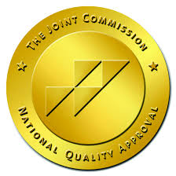



You have a lot going on. We’ll take it from here.

RAPID REFERRAL LINE (866) 684-2507 • FAX (866) 695-2183 • Support@Ally247.com



After my injury, Ally Medical helped me select the right catheter and worked directly with my doctor and insurance company to qualify me for the products I need. Now, I get my products shipped right to my door each month with no hassles.

You have a lot going on. We’ll take it from here.

