MEDICAL NUTRITION & ENTERAL FEEDING SUPPLIES

Accurate, timely communication is vital to servicing patients who require medical nutrition products and equipment.

Ally Medical’s experienced staff has helped thousands of clients and referral sources navigate the complex coverage criteria and documentation required by insurance for medical nutrition, enteral feeding pumps and supplies.
- Our professionally trained New Client Coordinators work with each client, their case manager, dietitian and clinical specialist to create a specialized medical nutrition product plan of care.
- Our Client Service Representatives contact each client every month to assure the product plan of care is being implemented properly.
- Prompt, comprehensive hospital bedside teach & training and in-home feeding pump sets-ups.
- Carrying the largest selection of medical nutrition products and enteral feedings pumps and supplies of any provider in the country.

- Nutritional supplements
- Disease-specific nutritional formulas
- Complex & metabolic medical foods

- Enteral feeding pumps & sets
- Low profile gastrostomy tubes & extension sets
- Bolus & gravity feeding kits

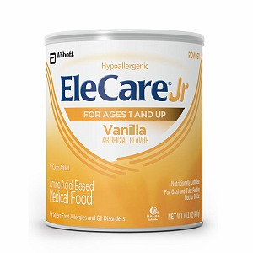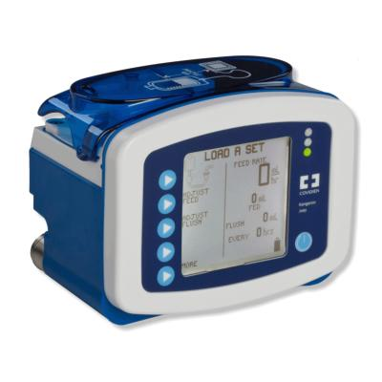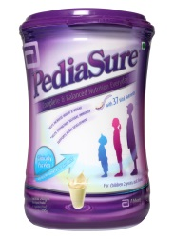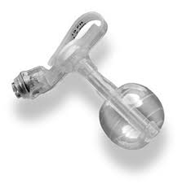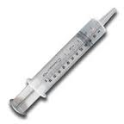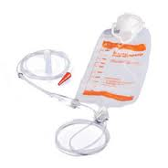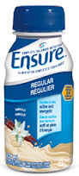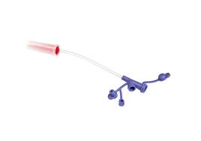
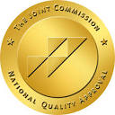

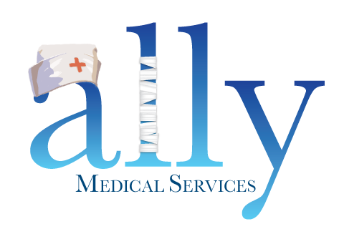
You have a lot going on. We’ll take it from here.

RAPID REFERRAL LINE (866) 684-2507 • FAX (866) 695-2183 • Support@Ally247.com

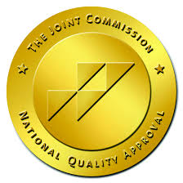

- A sense of urgency goes a long way – we understand the importance of getting vital medical supplies to clients accurately and on time.

Ally Medical’s team worked with my daughter’s gastroenterologist, dietician and case manager to develop a medical nutrition plan of care and kept me informed throughout the whole process. Now, I don’t have to worry about when her feeding supplies will arrive each month.

You have a lot going on. We’ll take it from here.

