Patients suffering from incontinence deserve respect, dignity and understanding.

Ally Medical has years of experience helping clients who use incontinence products. Our team understands the complex coverage criteria and documentation required for insurance coverage of these supplies.
- Our New Client Coordinators take the time to work with each client, their family, case manager and clinician to assure the best product to fit their individual needs.
- We stock all sizes of incontinence products and have access to professional brands not available in retail stores to serve a wider variety of clients.
- Product samples always available for same-day shipment.

INCONTINENCE SUPPLIES

- Pant liners & drip collectors
- Latex-free gloves
- Washcloths & wipes
- Bladder control pads

- Pull-up protective underwear
- Youth pull-ups
- Adult & bariatric briefs
- Underpads

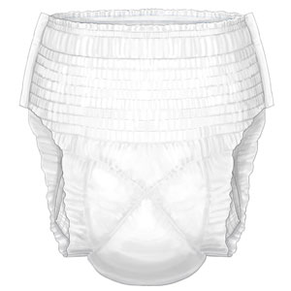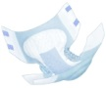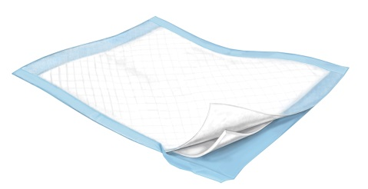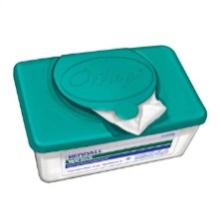




You have a lot going on. We’ll take it from here.

RAPID REFERRAL LINE (866) 684-2507 • FAX (866) 695-2183 • Support@Ally247.com

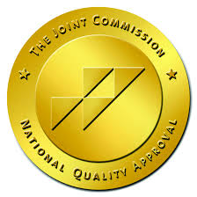




Ally Medical helped us get our son’s incontinence products covered through our insurance provider. Their team worked with our case manager and doctor to obtain the appropriate documentation and now we have the supplies shipped directly to our home. It’s one less thing we have to worry about each month.

You have a lot going on. We’ll take it from here.

