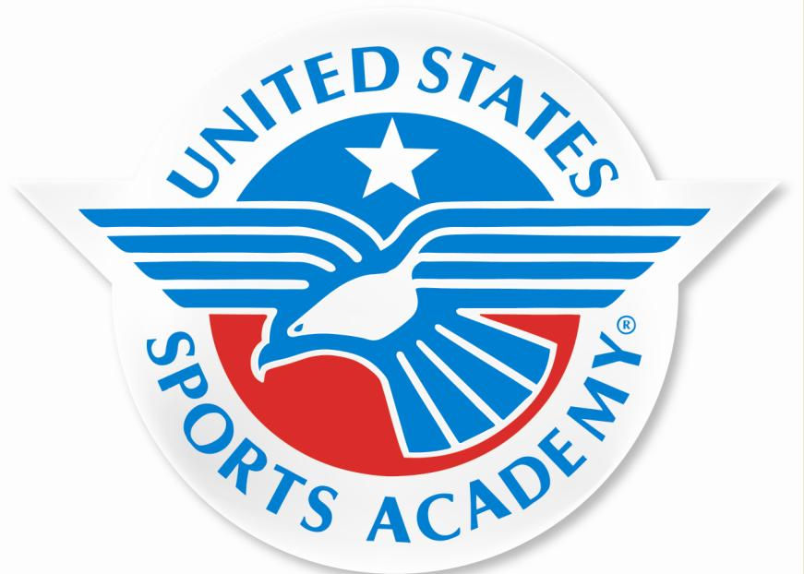















• Only institution in the world offering accredited sports education program at the baccalaureate, master’s and doctoral levels

• Has delivered certification programmes to over 250,000 students in 60 countries

• More than 600 Singaporeans have completed programs awarded by USSA. Many are currently holding senior positions in SAF, Singapore Sports Council, and National Sports Associations.

• Well qualified and experienced trainers approved by the United States Sports Academy

INTERNATIONAL SPORTS DIPLOMA
IN SPORTS COACHING

Program Objective
The Diploma in Sports Coaching is designed to equip students with the essential knowledge and skills, helping them to succeed in coaching all levels of sports, focusing on sports coaching methodology, sports psychology, sports medicine, sports strength and conditioning, sports administration, sports facilities and event management, sports nutrition and sports coaching technology. It consists of 9 modules and an industry attachment of 200 hours plus a project paper.

Duration: 12 months (Full-time)/ 18 months (Part-time)
Intake: January / April / July / October
Entry Requirement: English Proficiency IELTS >4.0/ GCE “N” or “O” level / SPM or Form 5 / SMU2 / ITE Sports Management / ITE Sports Fitness / Senior High School 2nd year or 11 years of education in overseas institution.
Assessment: Written Examination, Industrial Project, Report

Course Structure:
• DES001 Sports Administration - The course will help the student understand the sport manager’s position and the environment in which performance occurs.

• DES002 Sports Facilities and Events Management – This course studies the principles involved in planning, marketing, producing and evaluating sports events and facilities.

• DES003 Sports Marketing - This course includes an in-depth study of sport marketing and the influence it has in accomplishing objectives in today's world of sport.

• DSF002 Sports Nutrition - This course introduces students to the essentials of nutrition, food production and the workings of the alimentary system and looks at relation of these elements to exercise.

• DSF003 Human Anatomy and Physiology – This course will help the student to understand the structure and functions of the various systems of the human body.

• DSS001 Sports Coaching Methodology - This course covers theories and their practical application in teaching sports and sports skills. It is designed to enable students in gaining competence in applying competitive tactics and strategies appropriate to the sport environment. Particular emphasis is placed on developing a coaching philosophy with an emphasis in coaching ethics, conducting effective and efficient practice sessions, utilizing game management strategies, and skill analysis.

• DSS002 Sports Psychology - This course covers skills and application of psychological principles used in sports. It provides an insight into how psychological factors, such as anxiety, motivation, concentration, and confidence of coaches and trainees can affect performance in sports.

• DSS002 Sports Psychology - This course covers skills and application of psychological principles used in sports. It provides an insight into how psychological factors, such as anxiety, motivation, concentration, and confidence of coaches and trainees can affect performance in sports.

• DSS003 Sports Medicine - This course is designed to give students a basic understanding of sport-related injuries and how to recognize and provide emergency treatment, along with ensuring proper follow-up medical care. It covers the basic principles of sports injuries and rehabilitation to allow students to manage medical problems in sports and thereby improving the compliance of athletes in the management of sports-related problems.

• DSS004 Sports Strength and Conditioning - This course is designed to study the fundamental principles of training and nutrition in sports. It provides students a solid knowledge of strength and conditioning as it relates to anatomical and physiological systems challenged by sport conditioning, strength training, and an awareness of fitness and nutrition programs which can be used to enhance individual and team performance in sport

• DIP001 Mentorship - This is the practical part of the programme, involving 200 hours of lectures and practical sessions under the supervision and guidance of an approved trainer in the sports related industry. Students are also required to submit a 5000 words project report for assessment.

For the duration of the full time programme, students will attend a full-day course, comprising
3.5 hours of classroom lectures and tutorials.

For the part time programme, students will attend lessons twice a week comprising of 3 hours of classroom lectures and tutorials.

Students will sit for a written examination at the end of each module. On passing all the modules, students are to do an industrial project of 200 contact hours, before the Diploma is awarded.

Fees Structure:

# The prevailing Good and Services Tax (GST) is excluded from the FPS.
Fees Breakdown  [shows the full breakdown of total payable course fees] | Total Payable  (S$)
Enrolment fee (Non-Refundable) | 160.50
Course fee  Course material fee (non-refundable) Examination fee (internal) (non-refundable) Examination fee (external) (non-refundable) | 9,416.00  214.00  107.00  1,712.00
(A) Total Course Fees Payable#: | 11,449
(B) No of Installments%: | 6
(C) Installment Amount (C = A/B) | 1,908

% Please refer to Clause 3.2 for the imposed collection cap.

Installment Schedule | Payment by 6 Installments
Installment Schedule | Amount (S$) | Date Due
1st Installment  2nd Installment  3rd Installment  4th Installment  5th Installment  6th Installment | 1,908  1,908  1,908  1,908  1,908  1,909 | Upon commencement/  1st month  3rd month of course  5th month of course  7th month of course  9th month of course  11th month of course
(A) Total Course Fees Payable: | 11,449 | N.A.

*Please delete as appropriate

