Refer to the three logos on the 4th page and choose the matching one.   | For stylish sunglasses, prescription glasses and eye exams in Wanganui | Phone symbol (06) 347 6072  address symbol 97A Victoria Avenue, Wanganui  Add Facebook symbol
Home About Eyewear Book an Eye Exam Specials/Promotions All About Eyes News Articles Other Stores Contact

Gallery modern images – wording for on the image - ‘three stores, one vision’ or ‘All you need is the right pair of specs
Make five side buttons with the same or better images, can go anywhere on the site

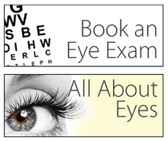
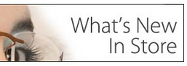

Largest sunglasses selection in Wanganui  Relevant image    For the latest brands and designer sunglasses come in and see the friendly team at Eyes on Victoria. There’s something for everyone with thousands of glasses in store – view our selection online now.  We’re also the exclusive stockist in Wanganui of Ray Ban sunglasses and optical frames.  ‘More info’ button or arrow to find out more.. | Wanganui’s Prescription glasses experts – perfect fit guaranteed  Relevant image    Eyes on Victoria is your One-Stop-Shop Eyecare store and have a huge range of prescription lenses, contact lenses and the very latest European trend-setting fashion eye-wear.  Take a look at our selection of prescription glasses now.  ‘More info’ button or arrow to find out more.. | For eye exams in the heart of Wanganui  Relevant image  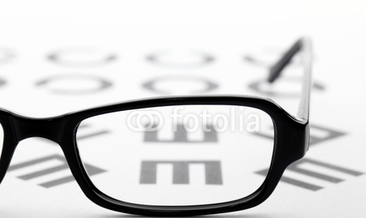  Eyes on Victoria offers complete eye examinations in store. Our Optometrists offer free annual check-ups and glasses fitting.  And all our glasses come with a full replacement warranty on all new frames and lenses sold – Book an appointment now.  ‘More info’ button or arrow to find out more..

Now it’s three stores – this is from the current website we want to make the home page more modern - http://www.eyesonvictoria.co.nz/


Brands to include on somewhere on the page,:

Footer: Note – need to show in the footer that they have the two other stores – make this stand out

Nav  Home  About  Eyewear  Book an Eye Exam  Specials/Promotions  All About Eyes  News  Articles  Other Stores  Contact | Open hours  Monday - Friday 9am - 5pm  Saturday - 9am - 1pm  Statutory Holidays – closed  Address  97A Victoria Avenue  Wanganui 4500  New Zealand | Other stores    View website  View website

Want the design to match the store – The green and brown from this page should be present in the website as well
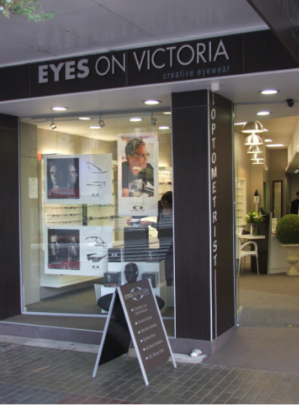
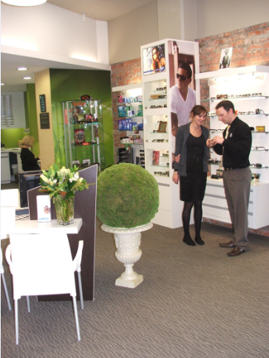

Colours ideas from customer:
Eyes on Victoria: green, dark tan/brown. Modern, stylish. Have a stylish women on the home page.

Other images:
The team

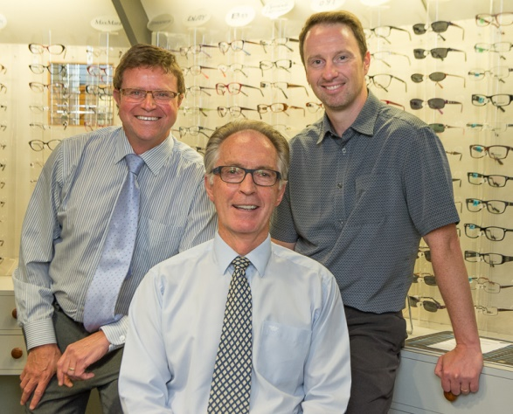
Please used the logo that best suits your design, either



Or



Or

