Brand name (logo) : TurboCash
Slogan: Turn things into cash

(Home Page)
About Us How it Works? FAQ Contact

Use Your Valuables to Get the Cash You Need Fast!
(Backround picture with online form)
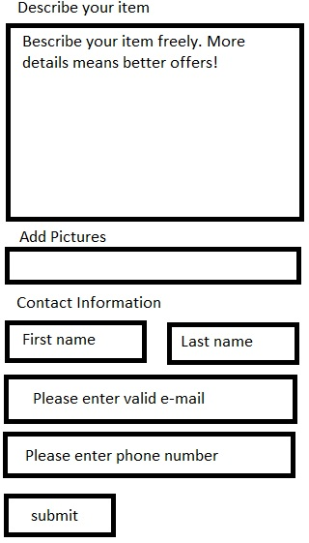 | APPLY ONLINE (button)  Tell us about your valuable item to get a cash offer within 60 minutes

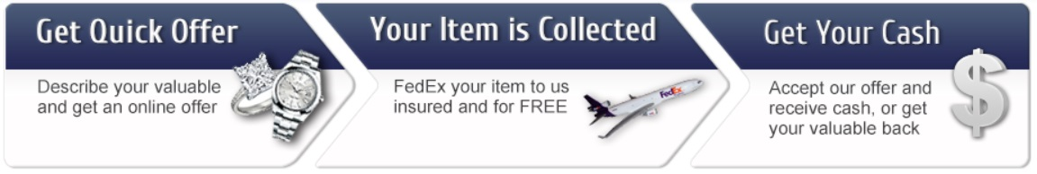

About us

100% Insured
All items shipped, and purchased by TurboCash are fully insured
plain text, plain text, plain text, plain text, plain text, plain text, plain text, plain text, plain text, plain text, plain text, plain text, plain text, plain text, plain text, plain text, plain text, plain text, plain text, plain text, plain text, plain text, plain text, plain text, plain text, plain text, plain text, plain text, plain text, plain text, plain text, plain text, plain text, plain text, plain text, plain text, plain text, plain text, plain text, plain text, plain text, plain text, plain text, plain text, plain text, plain text, plain text, plain text, plain text, plain text, plain text, plain text, plain text, plain text, plain text, plain text, plain text, plain text, plain text, plain text, plain text, plain text, plain text, plain text, plain text, plain text, plain text, plain text, plain text, plain text, plain text, plain text, plain text, plain text, plain text, plain text, plain text, plain text, plain text, plain text, plain text, plain text, plain text, plain text, plain text, plain text, plain text, plain text, plain text, plain text, plain text, plain text, plain text, plain text, plain text, plain text, plain text, plain text, plain text, plain text, plain text, plain text, plain text, plain text, plain text, plain text, plain text, plain text, plain text, plain text, plain text, plain text, plain text, plain text, plain text, plain text, plain text, plain text, plain text, plain text, plain text, plain text, plain text, plain text, plain text, plain text, plain text, plain text, plain text, plain text, plain text, plain text, plain text, plain text, plain text, plain text, plain text, plain text, plain text, plain text, plain text, plain text, plain text, plain text, plain text, plain text, plain text, plain text, plain text, plain text, plain text, plain text, plain text, plain text, plain text, plain text, plain text, plain text, plain text, plain text, plain text, plain text, plain text, plain text, plain text, plain text, plain text, plain text, plain text, plain text, plain text,

How It Works
TurboCash offers quick cash against valuables including jewelry, precious metals, luxury watches and diamonds. TurboCash is now the fastest and easiest way to sell valuables online.
Here's how you can fast cash in three very fast and easy steps:
1. Get a quick offer
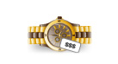
Upload a photo of your valuable items or simply provide a description to get an initial buy offer with no obligation whatsoever.
We'll send you our offer within 60 minutes, together with a FedEx label that you can print out.
2. Your item is collected FREE

Your valuable item will be collected by FedEx courier free of charge. Packages are tracked from the moment they leave our customer's door to the moment we receive them. Valuables are insured from pick up or drop off until their return to owner.
3. Get your cash
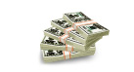
Once your item arrives at our secure facility, our certified evaluators will verify that your valuable item matches our initial offer. If so, the money is forwarded to you within a few minutes.

APPLY HERE

Frequently Asked Questions (FAQ)
What does iPawn do?
We believe that there is no reason why it should be so difficult or expensive for individuals and small businesses to to sell their luxury goods for a fair market value, especially during tough times. TurboCash is out to change this. We are committed to bringing you closer to the funds you need, with no further delay.
What types of items do you accept?
TurboCash only accepts valuables for which we are well-qualified to evaluate and appraise. We typically accept: Jewelry & Diamonds - most types of precious jewelry including rings, bracelets, necklaces and earrings made from gold or platinum, with or without diamonds Branded Watches - luxury watches including Rolex, Cartier, Omega, Breitling, Audemars Piguet, Patek Philippe, Tag Heuer, and many more. Precious Metals - we accept all types of gold (not plated), sterling silver, platinum, and palladium.
What items do you not accept?
Here are some examples of items that we do not currently accept:
- Electrical items such as laptops, mobile phones or iPods
- Automobiles
- Boats
- Art and antiques
- Firearms
- Other collectibles
Why TurboCash vs Ebay?
We understand how valuable your items are to you and they should not be handled by just anyone. Whether they have sentimental value or are a one-of-a kind item it is our priority that your item is handled by only the best and with the utmost care. It all begins with a professional in-house inspection that is entirely objective, taken care of by us for no extra charge. Then we put in the work to sell your item to the highest bidder out of a network of trusted buyers who truly understand the value of your item. Once there is a transaction agreement, the buyer is committed with no last-minute changes. Lastly, when a transaction is completed, you get your money right away. Ultimately, TurboCash acts as a trusted middle man, preventing fraud, theft, and dishonesty. You will get the highest market value with almost no risk or effort.
Why should I trust your evaluation team over my local jewelers appraisal?
Our experts are qualified to appraise all types of valuables from jewelry, to watches, to precious metals. Your valuable will only be appraised and handled by the very best in the industry. Meanwhile, the appraisal will be entirely objective as we are not the buyers of your item. The purpose of the appraisal is to present it to other trusted buyers to use as a reference. While your local jeweler is likely to be highly qualified to properly appraise jewelry, it is best practice that all appraisal and handling of your items be done in house.

What if my valuables are not in perfect condition?
You can still get cash against them. Jewelry and precious metals are appraised based on their weight and quality (e.g., the size of the diamond or the weight and quality of the gold that makes up the valuable), so we can still give cash against them even if they are broken or incomplete. Watches, however, will achieve a better money value if they are in proper working condition. It is always preferable to receive valuables in their original box and/or with the payment receipt.
Why do I need to send my items?
In order for us to make a fair and accurate offer, it is necessary for our trusted, in-house appraisers to physically inspect your item. This is as equally beneficial to you as it is to us. If we relied solely on images and descriptions, we could potentially make an offer that is too low for a very valuable item. You can also rest-assured that your items will be safe and secure both while in transit and at our secure facilities. Throughout the entire process your items are fully insured and protected, strictly handled by our in-house appraisers.
How do I send my valuables to you?
Your valuable item will be collected by a FedEx courier free of charge. We even email you a FedEx label that you can print out. Packages are tracked from the moment they leave your door to the moment we receive them. Valuables are insured from beginning to end.
How much does shipping cost?
We cover most shipping expenses, including collection and insurance of your valuable item from your home to our secured facility.
What happens if my valuables get lost or stolen?
In the extremely unlikely event that this happens, your valuables are insured from the moment they are collected. You will be compensated according to market value in accordance with regulations.
If i reject the offer will you send back my item?
Yes. If you are not satisfied with our offer simply request for the item to be sent back to you. We will immediately send your item back in the same condition it was sent to us, no strings attached.

Contact us

Simple contact form

