Please excuse the bad format. Format this properly for us. Thank you.
Nutrition Facts
Serving Size: 1 tablespoon (12g)
Serving Per Container: about 28
Amount Per Serving  Calories 60 | Calories from Fat 35

 | % Daily Values *
Total Fat 4g |  | 6%
Saturated Fat 0g |  | 0%
Trans Fat 0g |  | 0%
Omega-3 (Alpha-Linoleic Acid) 2.4g |  | 150 %
Omega-6 (Linoleic Acid) 0.8g |  | **
Cholesterol 0g |  | 0%
Sodium 0mg |  | 0%
Total Carbohydrates 5g |  | 2%
Dietary Fiber 5g |  | 20%
Sugar 0g
Protein 3g |  | 6%

Calcium 75mg (8%) | * | Potassium 75mg (2%)
Iron 1.65mg (9%) | * | Magnesium 42mg (10%)
Zinc 0.33mg (2%) | * | Phosphorus 100mg (10%)
*Percent Daily Values based on a 2,000 calories diet.
** Daily Value not established

(add bottom half content from below)
Ingredients: Raw Organic Chia Seeds
Use this format. But use information from above. Add bottom half content
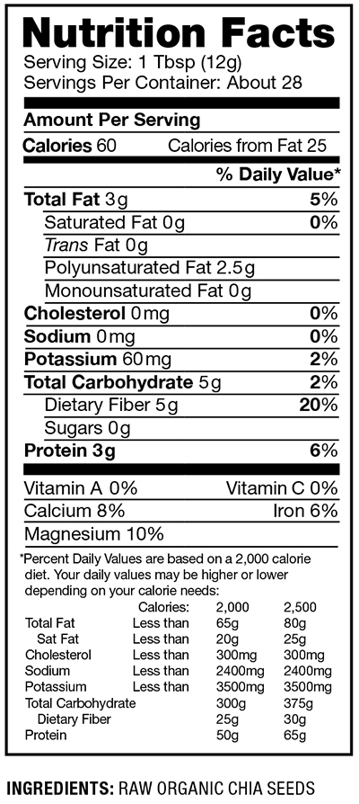

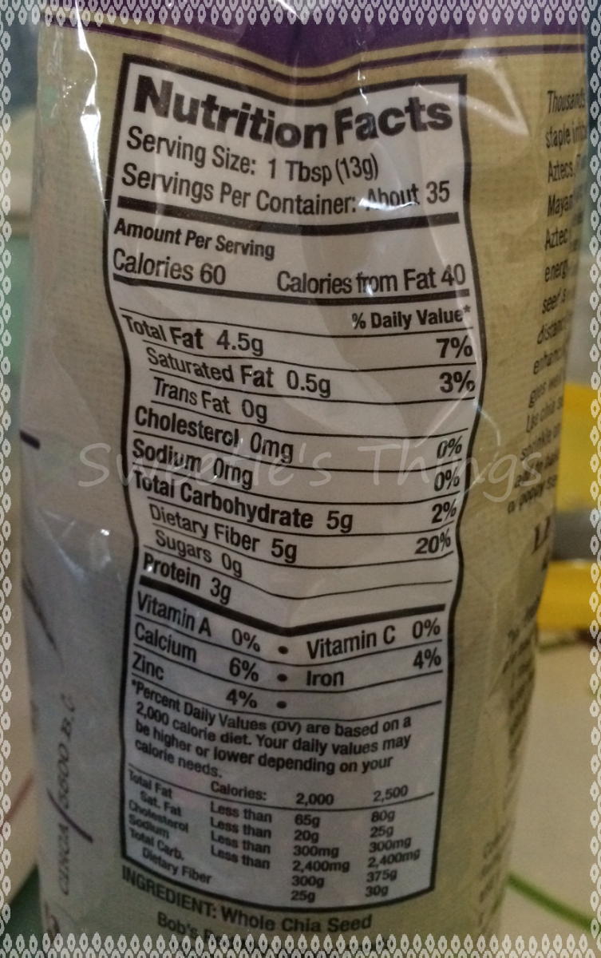
Set up mineral and vitamin section like this.

