Size: 6” x 7.5” x 3.25

Product Detail:
Organic Chia Seeds
Net Wt: 12 oz (approx. 340 g)

BACK SIDE: (temporary text use as place holder, can be reword/arrange to fit your design needs. You can use some text or all.)
Tolip Nutrition Chia Seeds are a whole, vegetarian superfood naturally rich in Omega-3 essential fatty acids, dietary fiber, antioxidants, protein and amino acids. Revered as a natural appetite suppressant and offering a comprehensive range of nutrients, vitamins and minerals, this mild tasting seed is a great addition to smoothies, juices, salads and many other recipes. Dating back to ancient Aztec warriors and used today by endurance athletes and health enthusiasts alike, just a spoonful a day is an easy and delicious way to support your digestive health and satiate your appetite.
Our organic chia seeds can be easily incorporated into your diet. Use them on yogurt and oatmeal, in smoothies, added to sauces as a thickener, or even used in baked goods as a replacement for egg.
Making a comeback in healthy diets, these super seeds are an excellent source of essential minerals such as phosphorous, manganese, calcium, sodium and potassium. In fact, to provide a comparison, 3 tbsp. of chia has:
- 15x more magnesium than broccoli
- 6x more calcium than whole milk
- 30% more antioxidants than blueberries
- 2x more potassium than bananas
- 8x more omega 3 than salmon
- 3x more iron than spinach
- 7x more vitamin C than oranges
(the image below was something we saw that looked interesting if it could be recreated for this packaging based on above info
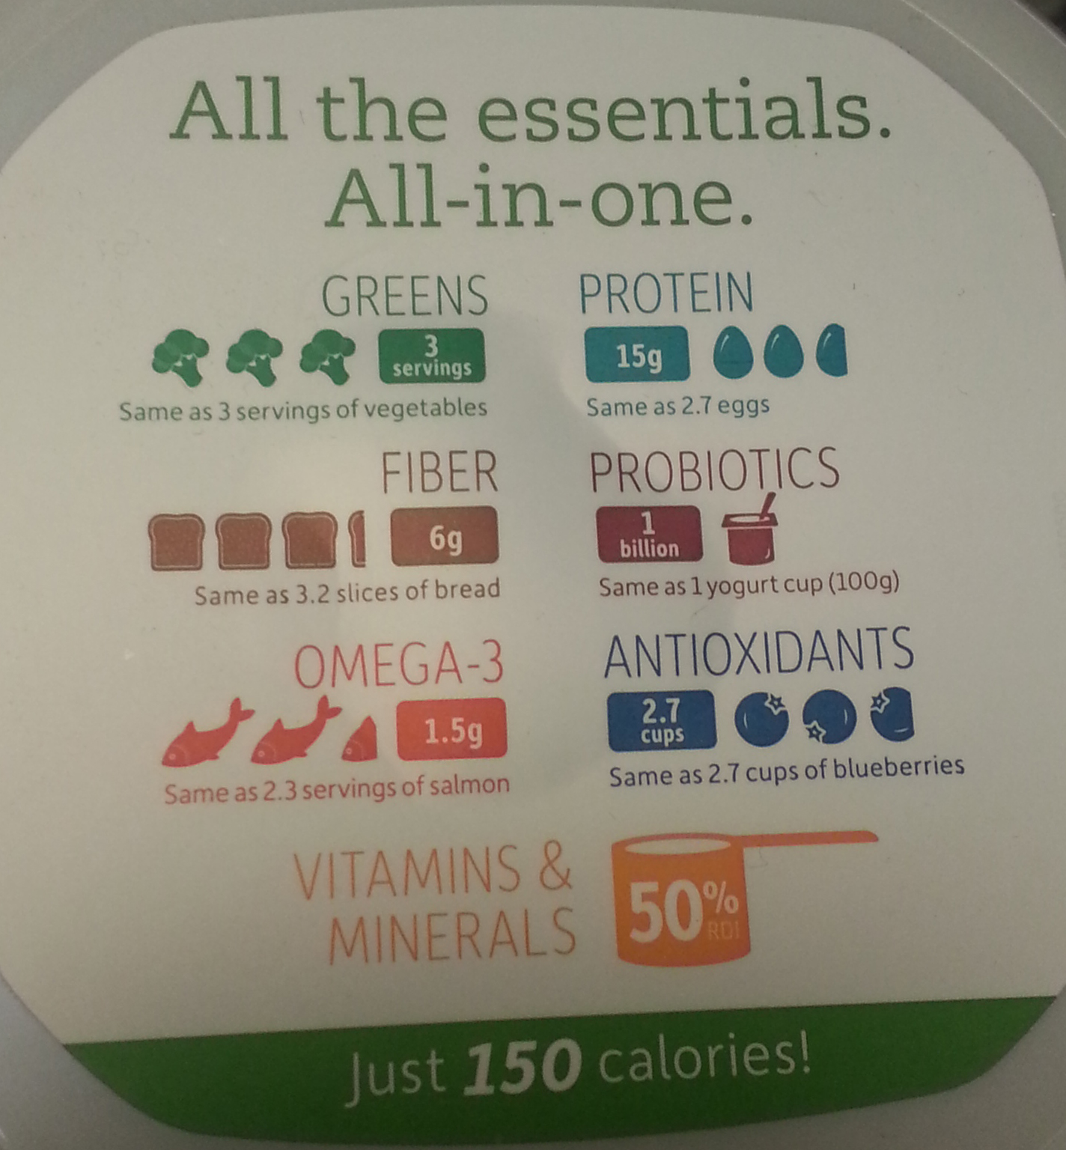
We aren't kidding when we say these tiny seeds pack a mighty punch!
OUR CHIA PRODUCTS ARE:
Certified organic and non-GMO
Unrefined
Vegan
Raw
Gluten-free

Nutritional Facts (See Chia Seeds Nutritional Facts.docx)

Ingredients: Organic Chia Seeds (Salvia Hispanica L)

UPC Code: 852668065354
Tolip Nutrition
Garden Grove, CA 92843
(800) 987-1788
TolipNutrition.com

