- Our pouch will have a spout coming out of the top left corner like the following sample:
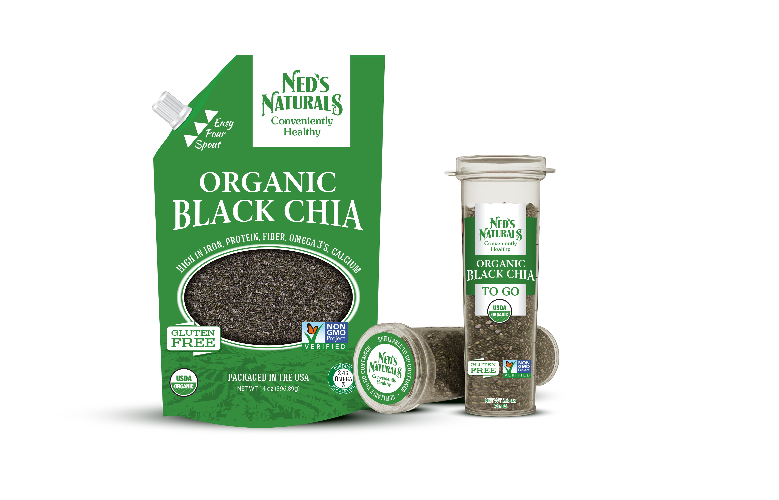

- We would like a window design. That’s not the typical oval shape. One possibility is to use our logo emblem as the window. (we have two style. The first in yellow might be better). The window should be in the shape of the logo and not the inside or outside only (the logo itself is drawn by the chia seeds showing through the bag). But we do not want to restrict your creativity so feel free to introduce your own ideas.



- Here are some of our competitors packaging that we liked. We like them because of their unique windows to display the chia seeds. They are not overcrowded with unimportant design. It is very easy for customers to see that the product is for Chia Seeds.

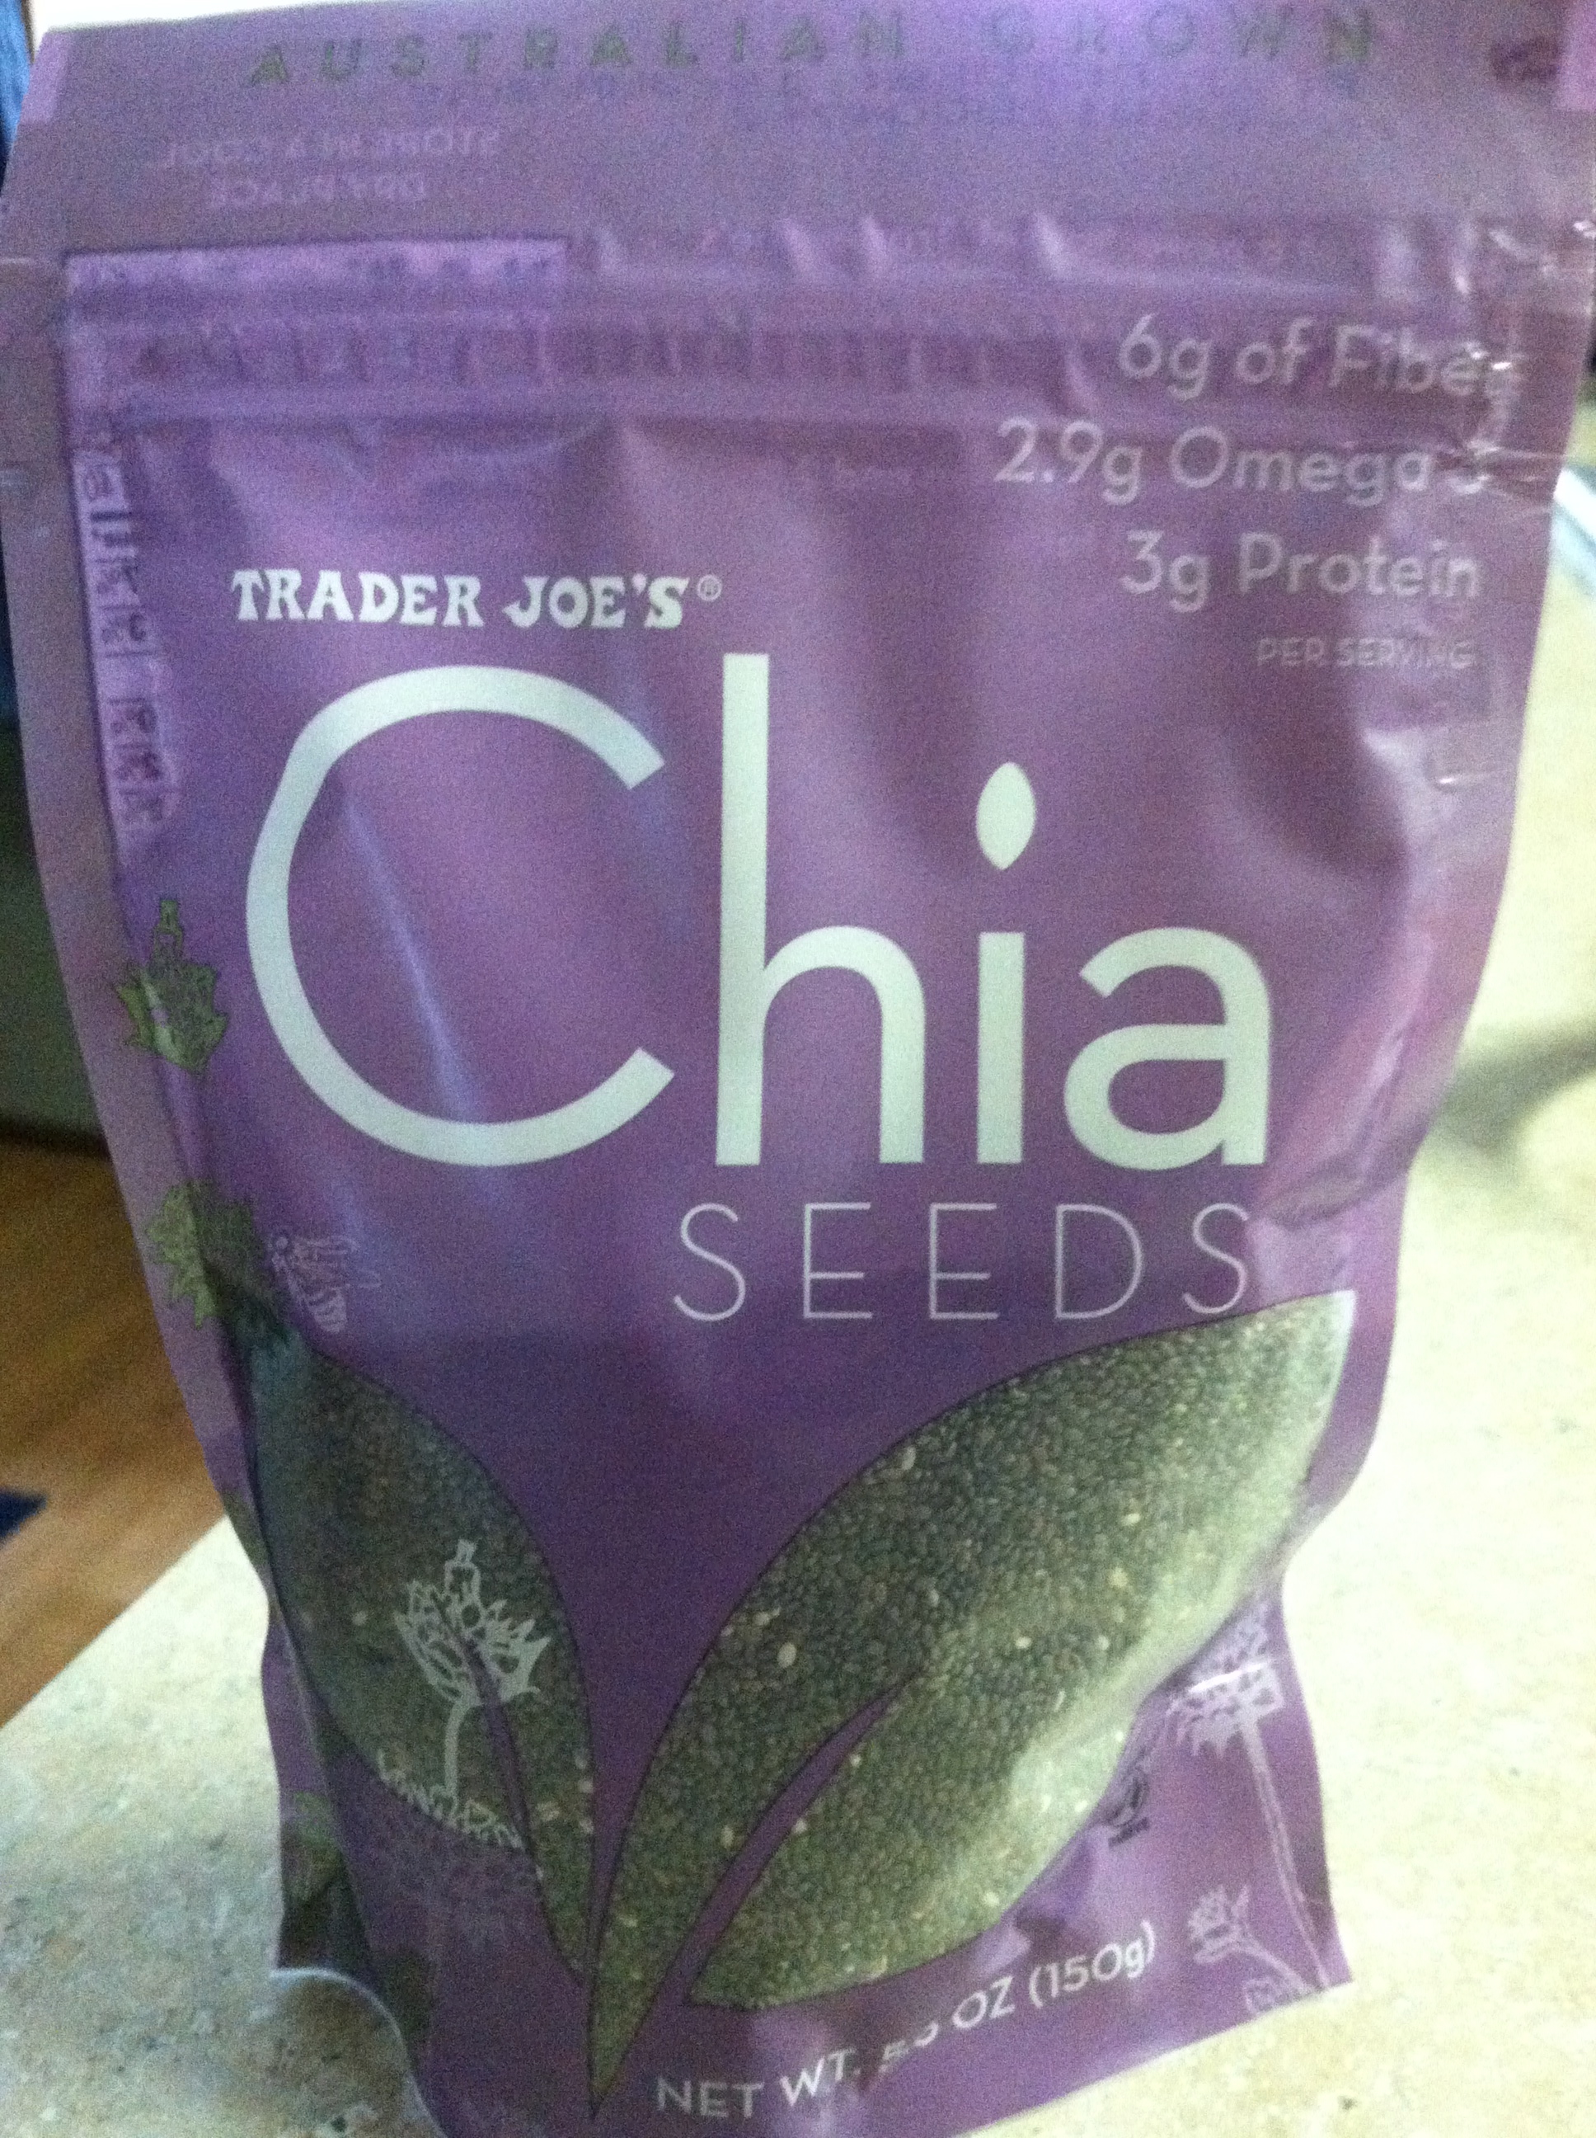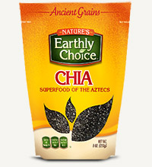
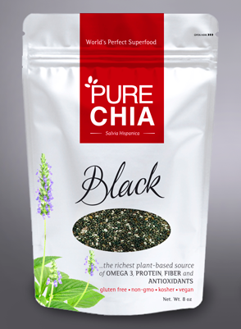

The Mamma Chia design is very different. We would love to see something like this. It clearly shows CHIA SEED but it’s also clean and shows the logo.

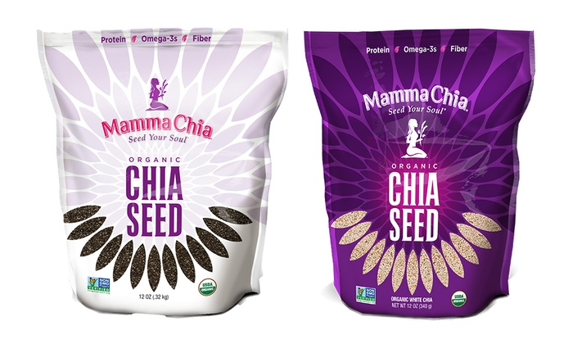
The Salba Chia has nice basic colors. We are imaging a similar design like this. Except in place of the leaves our logo and be placed there.
