Table of Contents
Job Type 1
Task Outline 1
Task Description 2
The tag line 3
The write up 3
Other main features of Bi-Seal Knife Gate Valves 3
Things to take note of: 3
3 images to be uploaded 4
Possible background 5
Some appealing Mining Industry Advertisements – from Australian Mining magazine 6

Job Type
Advertisement Design for Bi-Seal Australia
Task Outline
Create an Advertisement Design for Bi-Seal Australia

Task Description
Bi-Seal Australia is an innovative Australian based manufacturer of Knife Gate and Slurry Valves. Bi-Seal have an existing range of Valves . The advertisement is designed to launch a new Bi-Seal product – a Titanium Knife Gate Valve. The advertisement is for a full page of a monthly mining magazine.
The MAIN selling points of this valves are:
- It’s a first for an Australian manufacturer to design and build a Titanium Knife Gate Valve.
- Titanium will withstand the most corrosive slurries.
- The new valve has the same robust design as the existing range of Bi-Seal’s valves.
.
Bi-Seal want the main picture as a diagrammatic pictorial of a valve with bullets labelled as (CL , Temp, pH, Abrasion) being repelled by new Titanium Armour. The background could be a blue sky or any that works well with the existing colour scheme of the website: There are the images below create the picture.
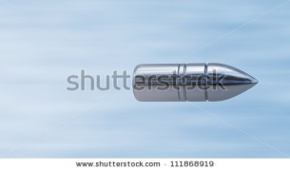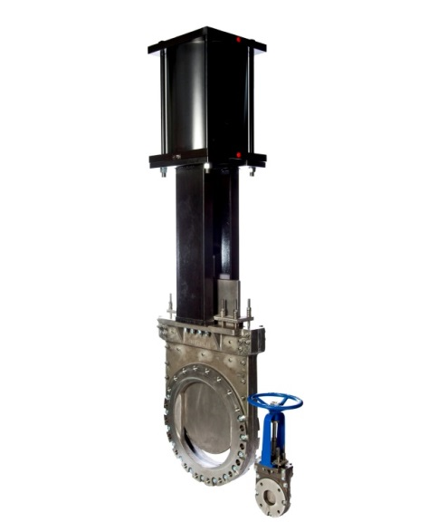


http://bi-seal.com.au/www/home/

The tag line

“Corrosion a problem? Checkout our latest armour”

The write up
- Titanium has remarkable corrosion resistance allowing the Titan to stay in severe service longer.

Other main features of Bi-Seal Knife Gate Valves

Bi-Seal continue to manufacture in Australia by choice. It’s the best way to listen to our customers and solve their challenges.

Things to take note of:
We would like one of the valve photo’s to be included – the best looking photo.
Do not want a product flyer, but an advertisement to catch the attention of the users
http://multimedia.aspermont.com/web_files/AMM_mediaKit.pdf
Please refer to page 2 of the media kit for dimensions of the full page
Full Page (FP)
Trim Size: 210mm(w) x 297mm(h)
Bleed: 220mm(w) x 307mm(h)
Safe Area: 198mm(w) x 285mm(h

3 images to be uploaded
Please choose one of these 2 photos of the valve.
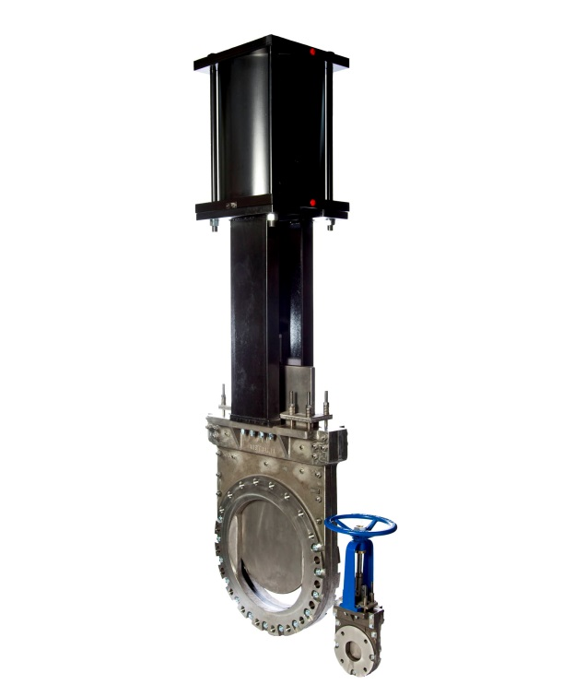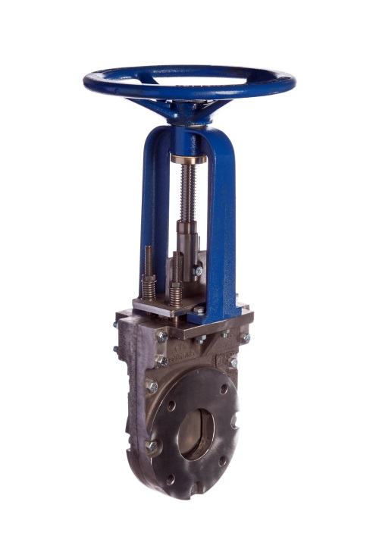

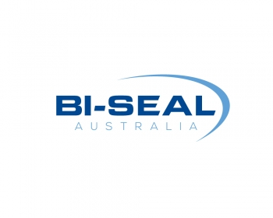

Possible background
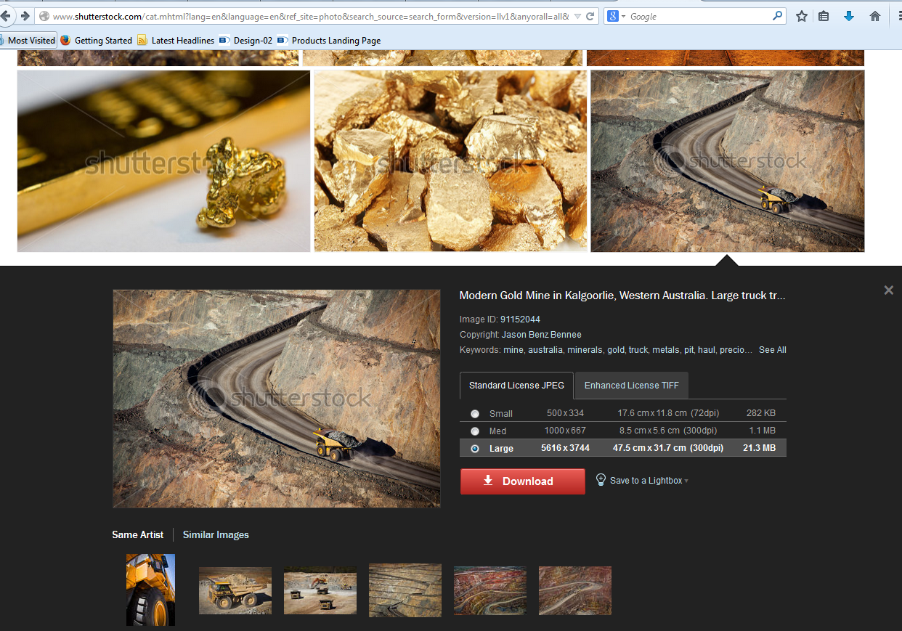

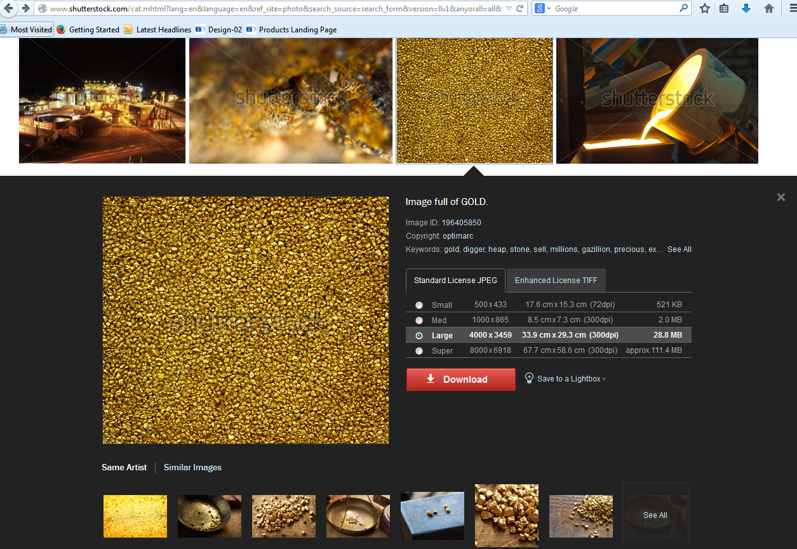
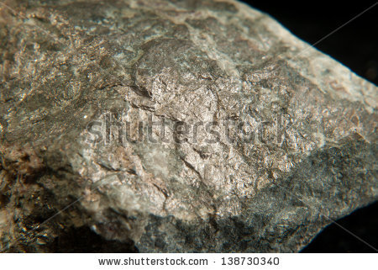


Some appealing Mining Industry Advertisements – from Australian Mining magazine
