- Logo
- (Main title) 2015 SPECIALS
- (3x specials with tittle, caption and picture)
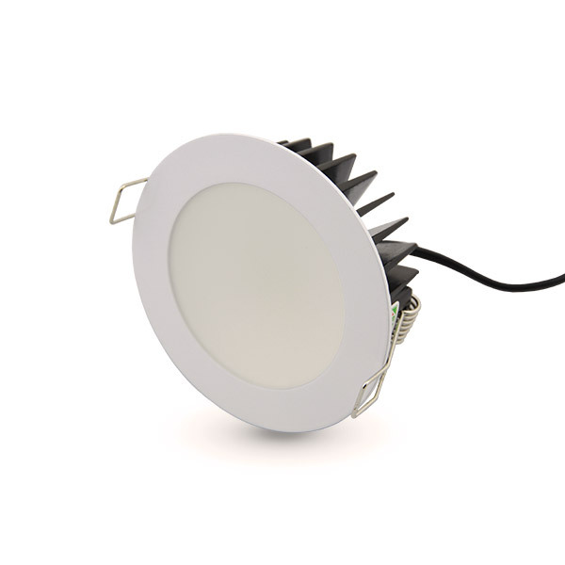
(Title) Supplied & Installed high quality LED Down lights
Just $99 each Inc GST
(Caption) Energy-Efficient LED lights that add ambiance & Brightness into the room

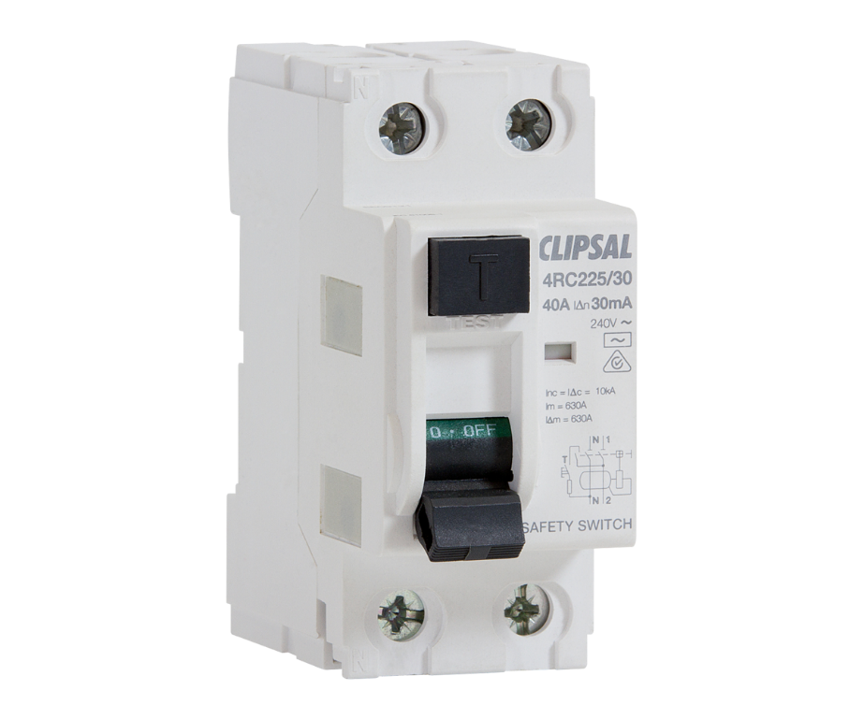
(title) RCD’S supplied and installed for $200 each inc GST

(Caption) Safety Switches can Save your life, please contact us for more information

(tittle) Security Light Supplied and Installed for $160 inc GST

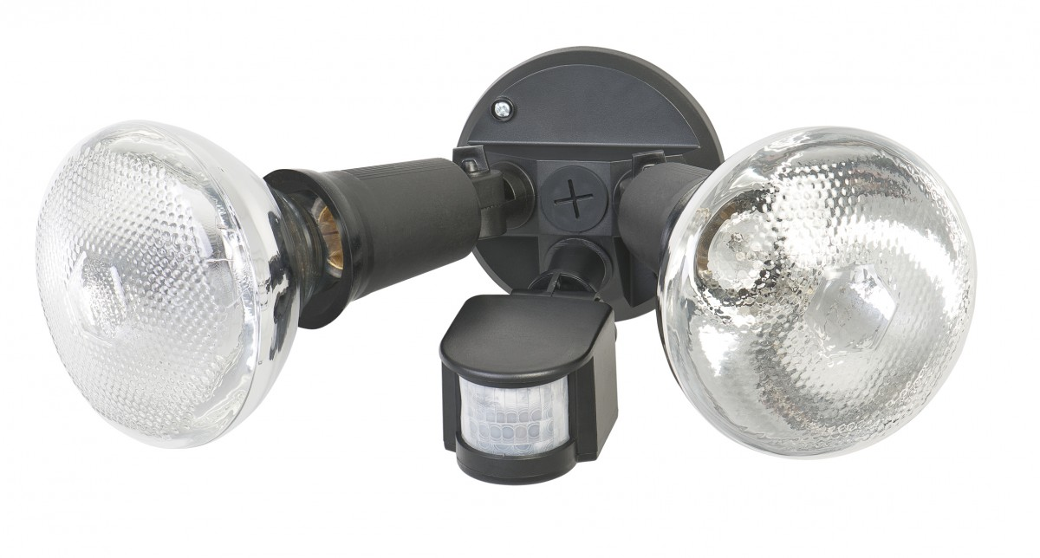
(Caption) Compact Security Twin Flood Light In is a high quality and professional floodlight which is designed to provide high illumination

- (Company Information)
0400 475 748
www.megalite.com.au
info@megalite.com.au
PO BOX 704 COMO

- (Business Information)
EC 11393
ACN: 50 601 374 770

- (a slogan/ sentence)
“YOUR RELIABLE & AFFORDABLE ELECTRICIANS”

