Hello! My name is Christine Fopma. I offer simple, fun and insightful solutions to seemingly complicated clutter and organizational problems. I am here to help if you are ready to change your home and/or workspace.  My experiences of working with family, friends, co-workers and clients has proven my hard working, energetic, fun and supportive attitude makes it easier for them to get things accomplished. Helping people sort through, and be rid of, the mental and physical obstacles that have kept them stuck along with participating in their enthusiasm when they see immediate improvement is rewarding for me.  I welcome the opportunity to earn your confidence through ethical, reliable and dependable hard work | Organizing & Decluttering Services  Christine Fopma  301-525-5964  info@clutteredtoclarity.com  www.clutterredtoclarity.com  Rockville, MD Serving MD, DC & VA  Clarity: “The Quality or State of Being Clear”
  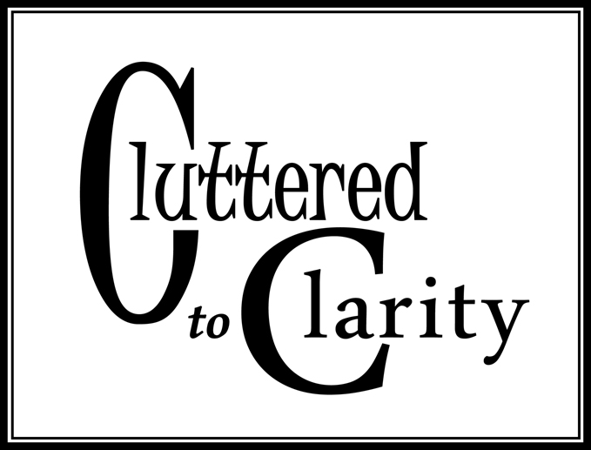  Organizing & Decluttering Services  301-525-5964  info@clutteredtoclarity.com  www.clutterredtoclarity.com  Rockville, MD | 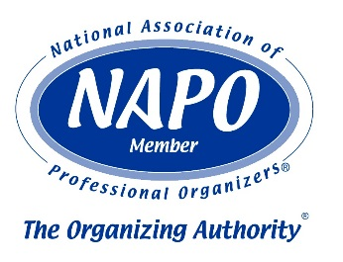  PRIVACY & ETHICS:  I abide by the standards as outlined in the NAPO Code of Ethics. Any and all information provided by you, as well as information or circumstances seen on site will be handled in a nonjudgmental, respectful and confidential manner.
Getting organized isn’t all about everything being in its proper place.  It can also require overcoming fears and anxieties such as:  “How do I start?”  You begin by getting help from a professional. No one can do everything; everyone needs a helping hand at times. (I bring my vehicle to a mechanic when it needs service, even for just a simple oil change!)  “Am I going to have to get rid of ALL my things?”  Definitely not! There is a process that will help you decide what to keep and what you would be willing to part with. (I can help you determine the practical and monetary “worth” of something. Only you can determine its personal “value”.)  “I don’t have time”  Now you will! Getting organized will actually save you time. You will know where that “thing” is, find it quickly and avoid the time it takes to run out and purchase a new “thing”. (You will have actually created more time to enjoy the lifestyle that is important to you.)  We all have anxiety about something that prevents or inhibits us from taking action toward a solution. Whether you want someone to take over the project or a helping hand (nudge) is all you really need, a professional organizer is the perfect way to get started. Getting organized is going to be a process of progress, not perfection. It will require some level of support and continued work on you part, but the rewards will far outweigh the efforts.  TOGETHER WE CAN CONQUER THE CLUTTER AND CREATE CLARITY | What is a professional organizer?  “A Professional Organizer enhances the lives of clients by designing systems and processes using organizing principles and through transferring organizing skills. Professional Organizers help individuals and businesses take control of their surroundings, their time, their paper, and their systems for life.” – National Association of Professional Organizers  Whether you are too busy, too confused, over whelmed, tired, stressed or just don’t know where to start, I offer a variety of hands on services to help you bring a sense of fun, freedom and functionality to almost any space.  ATTIC – TO – BASEMENT:  - Sorting – Purging - Organizing  PAPER CONTROL:  - Sorting – Purging - Organizing  - Household, home office & home based filing systems  DOWNSIZING:  - Sorting – purging - organizing - labeling  - Packing & unpacking  REMOVAL:  - Light trash & proper disposal  - Donations & light recyclables to proper locations  - Shredding Service  FOLLOW UP:  - Routine “clutter maintenance” visits  For projects not listed above, please contact me.

