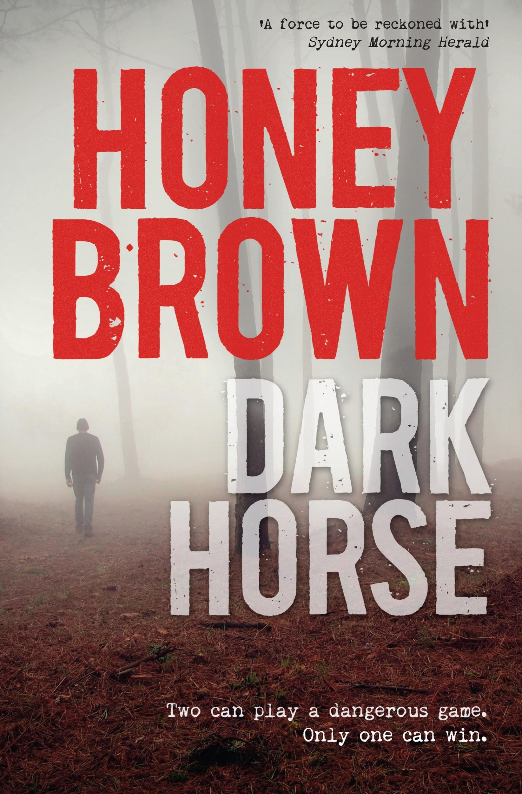

Include the Dark Horse Films Logo

Dark Horse Information Pack
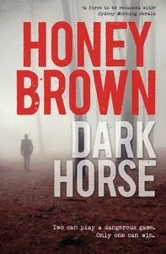
It's Christmas morning on the edge of the rugged Mortimer Ranges. Sarah Barnard saddles Tansy, her black mare. She is heading for the bush, escaping the reality of her broken marriage and her bankrupted trail-riding business.

Sarah seeks solace in the ranges. When a flash flood traps her on Devil Mountain, she heads to higher ground, taking shelter in Hangman's Hut.

She settles in to wait out Christmas.

A man, a lone bushwalker, arrives. Heath is charming, capable, handsome. But his story doesn't ring true. Why is he deep in the wilderness without any gear? Where is his vehicle? What's driving his resistance towards rescue? The closer they become the more her suspicions grow.

But to get off Devil Mountain alive, Sarah must engage in this secretive stranger's dangerous game of intimacy.

Praise for ‘Dark Horse’ and Honey Brown

'Brown is the best writer of psychological suspense in Australia. Nothing is quite what the reader expects as Brown deftly steers her narrative to conclusion. One of those books that has to be read again to see how she does it.' Lucy Sussex,Sunday Age
'A ripper. Brown keeps the pages turning and the pulse racing with a masterful, sexy and chilling plot.' Weekend West Australian
'Honey Brown does an excellent job of this taut and atmospheric thriller, successfully adding a darkly sexy tone. The characters are well drawn and charismatic, and the twists are great.'Bookseller+Publisher
'The pace is compelling, the tension superb and the plot veers into a breathtaking twist. A finely crafted, stunning psychological thriller that I can't recommend strongly enough.' Book'd Out
'A story that takes an unrelenting hold and doesn't let go. ... a gripping, suspenseful, rollercoaster of a read.' Great Aussie Reads
'A taut suspenseful psychological drama of the best kind.' The Hoopla
'There's a sense of foreboding craftily interwoven with the darkness of sexual desire running from the first to the last sentence in this achingly powerful suspense thriller.' Australian Women's Weekly
'Insightful and moving.' Adelaide Advertiser
'A taut psychological thriller . . . the most filmic of stories.' The Sun-Herald
'Engaging as hell.' Australian Book Review

Link to the Trailer for the book

https://www.youtube.com/watch?v=sbkGjjary8g

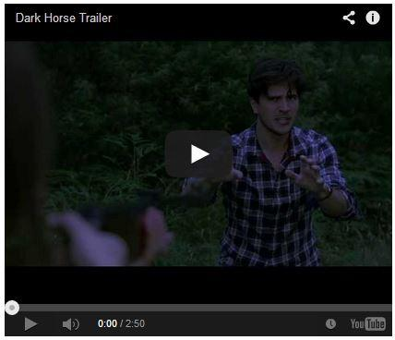

Dark Horse synopsis

Sarah Barnard has lost her trail riding business, her horses, her house and her husband. Avoiding the daunting task of facing family on Christmas Day, she sets off on her beloved black mare, Tansy, into the rugged Mortimer Ranges.

A rainstorm higher up in the ranges sweeps a torrent down Spinners Creek, trapping Sarah on Devil Mountain. Unable to ride down, she rides higher, to the summit, to the remote Hangman’s Hut. A young man, a bushwalker also trapped by the flooded river, joins Sarah there. Heath is friendly, capable and handsome. But right from the start there are elements to his story that don't ring true.

The hostile weather sets in and prevents Sarah and Heath from raising the alarm and alerting authorities to their whereabouts. The two are confined to their small area of shelter and safety. Sarah suspects it’s not just the wild weather she should be wary of though; it becomes clear that Heath is hiding his real reasons for being on the mountain. Despite the uncertainty Sarah feels, an attraction between her and Heath develops. The intimacy and closeness they start to share is perhaps natural in the isolation, but as the days stretch on and their feelings deepen, it begins to feel equally unwise and reckless.

Dwindling food supplies test their bond. The pressures of survival cause confrontations and accusations between them. Just as their frustrations peak, an unexpected landslide collapses Hangman’s Hut and pins Heath beneath the rubble. Sarah is forced into action.
She rides Tansy down the mountain to Heath’s abandoned car. His vehicle provides clues to who Heath really is. Even his name isn’t real. He is Brody Heatherton, licensed trapper and hunter, and within his car is an arsenal of weaponry. Worrying as Brody’s secretive side is, Sarah still feels compelled to return to the mountaintop with the car jack needed to free him.

Sounds of activity down near the river make Sarah change her plans though. Riding against the clock, knowing every second counts in her effort to help Brody, Sarah gallops down to the scoured-out river and its crumbling banks. She sees the huge effort underway to restore Spinners Bridge.
It’s not only rescuers desperate to get across to Sarah and Brody though, there’s a heavy police contingency waiting to scale the mountain. The sight of snipers, and a SWAT team confronts Sarah. She knows then that Brody has kept something very big from her. Sarah is torn between cooperating with the police and returning to Brody to save him.

Sticking with her promise to return, Sarah leaves the rescue effort behind. She ignores the police commands and flees with them in pursuit. In the deteriorating weather conditions, Tansy and Sarah climb the dangerous slopes of Devil Mountain.
Reaching the summit, Sarah fears she has taken too long and will be too late. Brody is alive though; his fate down to seconds. Sarah puts her own life at risk to free him. They escape as the last of Hangman’s Hut is flattened by the slipping soil and rock.

Bruised, battered, exhausted, Brody and Sarah wait for the police to arrive. There is nowhere to run and no point anymore in hiding the truth. The extraordinary reason the police are coming is revealed as Sarah and Brody confess their individual moments of deceit. It’s a dangerous game they’ve been playing. The truth is as unexpected and powerful as the flashflood that trapped them.

Every conversation, every touch, every deception between Sarah and Brody will need to be examined. It won’t only be Brody answering questions, but Sarah too.
Dusk falls as the SWAT team closes in. An accidental shot is fired and Tansy is wounded. Sarah’s cherished black mare disappears, injured, into the night, and Sarah, having now lost everything, kneels and surrenders, giving in.

In the criminal trial that follows, what happened between Sarah and Brody at Hangman’s Hut is examined and cross-examined. The sensational facts of the case make worldwide news. When Brody takes the stand, his account of the days trapped on the mountain change the course of the trial, leading to Sarah’s incarceration and institutionalisation. But is Sarah unstable and unwell? How much has Brody twisted the facts? And how much has she? Seen through Sarah’s eyes, something very different played out on the mountain.

Despite it all, the unusual and close bond between Sarah and Brody remains. Their time together and feelings for one another aren’t easily let go of or forgotten, and just like the mystical sightings of Tansy on the slopes of Devil Mountain, it may never be clear who Sarah and Brody really are and what they are capable of, only they know how much of their behavior at Hangman’s Hut was down to understanding and love or fear and survival.

The Characters

Describe them - Ask Honey Brown if she has them

The Actors & Director & Producers

Who and why and include pics

Dark Horse the Film
http://www.slideshare.net/belair1981/pitching-a-film

Log line for the film? Ask Honey Brown
If you already have a short pitch, great. If not, try the following formula with five elements:
“My story is a (genre) called (title) about (hero) who wants (goal) despite (obstacle).”
It’s an action comedy called Nerd Ops about two competing National Security Administration computer prodigies who must become field operatives and work together to save the world from a terrorist hacker organization.

Genres - Include example pictures to show mood/themes

Identify themes

Target audience - why it would attract them - and main selling points - use the Gillian Flyn comparison

Comparison Themes, and Chart their performance - Gone Girl - Mountain top version of dead calm
boxofficemojo.com
http://goodinaroom.com/wp-content/uploads/Good-in-a-Room-Nerd-Ops-Research-Example.pdf

Why it is the perfect first project. Its a classic 2 hander thriller, with a twist that has stumped the most ardent of thriller readers “Include quote”. The one location and limited characters will keep the budget down, while the mountain top location and constant rain will offer a unique look and feeling of dread.
A very strong female lead for a actress in later thirties, early forties, which is a rare thing these days, and the quality of writing, along with her character being onscreen for 98% of the film, will make it attractive to top quality actresses, and should offer excellent award nomination chances.
Showcase what is original about the project, themes, characters, etc

Next Steps - Find Writer, and other producers, build website to start engagement with Honey Brown Fans, and link to a Crowd Funding project for initial development costs, moving onto Screen AU/NSW/VIC funding when key creative roles have credited people attached

The Producer: David Sullivan

Dark Horse Films - Mission

New production company names after the first project and also it fits perfectly with the types of project we will build a portfolio of, being initially $2M ish films and documentaries

The Author: Honey Brown

Honey Brown lives in country Victoria with her husband and two children. She is the author of four books: Red Queen, The Good Daughter, After the Darkness and Dark Horse. Red Queen was published to critical acclaim in 2009 and won an Aurealis Award, and The Good Daughter was longlisted for the Miles Franklin Literary Award and shortlisted for the Barbara Jefferis Award in 2011. After the Darkness was selected for the Women's Weekly Great Read and for Get Reading 2012's 50 Books You Can't Put Down campaign. Her fifth novel, Through the Cracks, will be published in 2014.

