Logo Design Thoughts

- Do any existing logos appeal to you & why? If so, please provide a link to a picture of each logo.
Logos that are appealing | Why ?
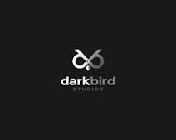 | What I like  Unique, Different, Mystical (Makes me want to know more about this company)  Gives impression of a formal, corporate firm that could be large.
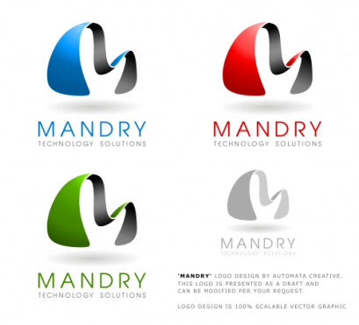 | What I like  Unique, Different and colour variants look nice.
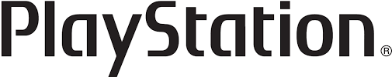 | Nice Unique, Typeface
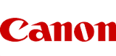 | Nice Typeface, Unique
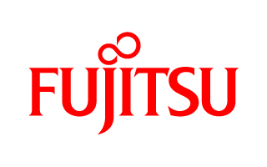 | Unique Typeface, Really like the combination of Typeface and small minimalist graphic on top
 | Uniqueness in the flipped honey bee
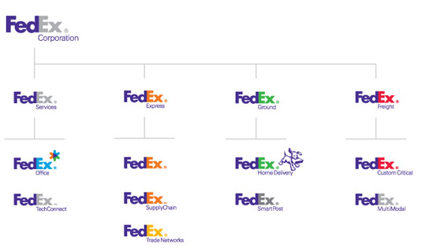 | I really like the simplicity and the Fedex Variant
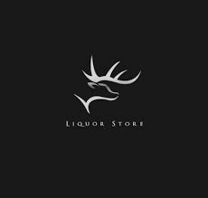 | Like the top image…which is not unique but fits in uniquely here.
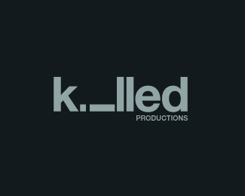 | Unique Typeface
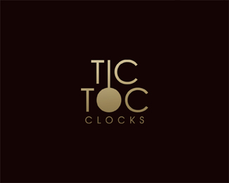 | Again like the typeface with small graphic
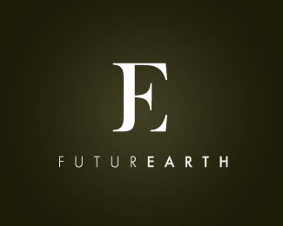 | Again nice typeface symbol, although I would prefer a graphic in place of a letter
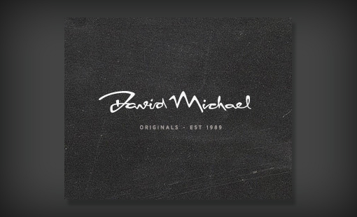 | Like the unique typeface however this typeface is more suitable for fashion brands
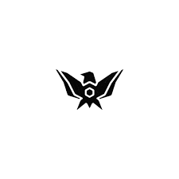 | Like the graphic, thought not sure how something similar could be incorporated in the logo.
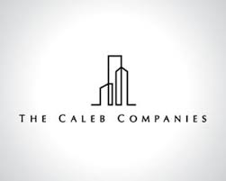 | Like the minimalist design, thought it gives away the fact that this company is in infrastructure or real estate.
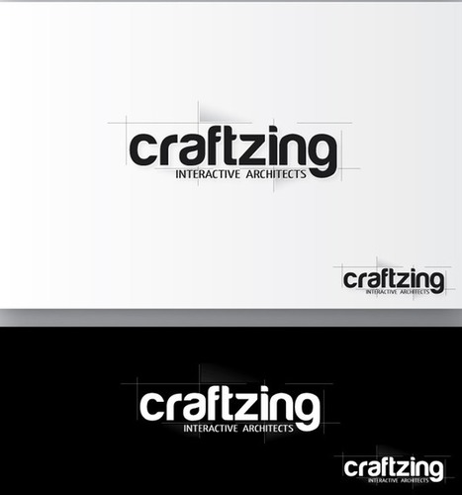 | Liked how they played around with the typeface
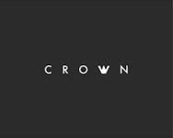
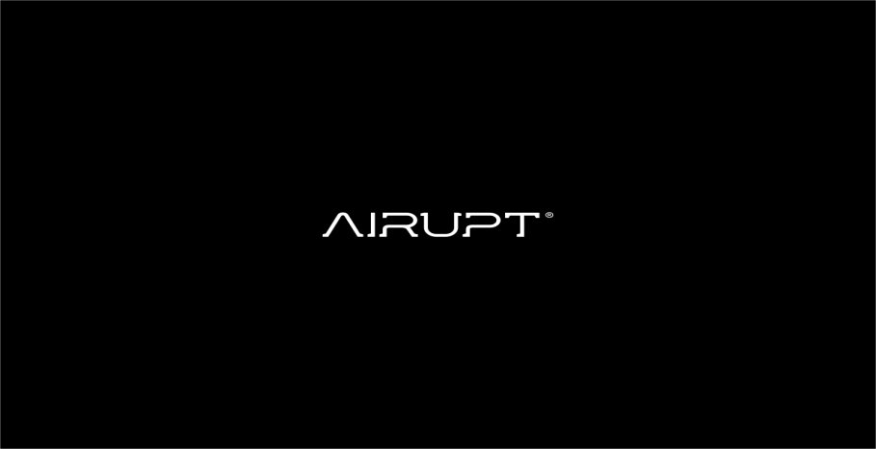 | Really like the typeface

