Front

Insert Logo—(Feel Free to Change Colors if Needed. You Don’t have to use logo if you don’t want to)

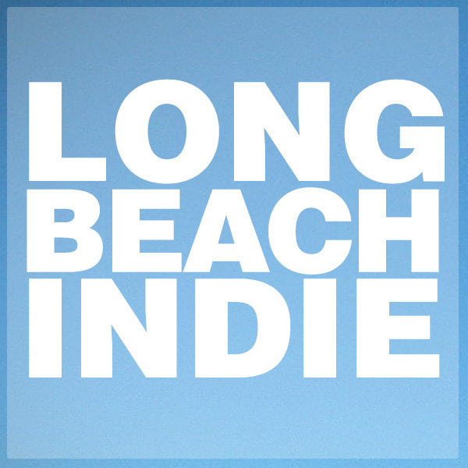International Film Festival

Film, Media, and Music Conference

September 2-6, 2015—Long Beach, California

Cinemark at the Pike Theaters/Long Beach Convention Center/Renaissance Long Beach Hotel [You can place this line where it fits best]

Call for Papers, Films, and Exhibitors Now Open!
(Paper Deadline April 1, 2015)

longbeachindie.com

Back

Long Beach Indie International Film Festival
Film, Media, and Music Conference

September 2-6, 2015—Long Beach, California

Long Beach Indie(LBI) is an international film festival, conference, and college fair taking place September 2-6, 2015 in scenic downtown Long Beach, California.

In 2014 we screened 91 films from 24 countries, drew more than 3000 attendees, and received coverage in over 300 international media outlets. The Dam Keeper, our winner for Best Animated Short Film, was nominated for the 2015 Academy Award in the same category.

Oscar nominee Margaret Avery (The Color Purple), multiple Grammy winner David Porter, Grammy nominee Xocoyotzin Herrera, and Emmy winners Charles Ragins (The Simpsons), Mark Kirkland (The Simpsons), and P. Frank Williams (Unsung, American Gangster) were featured presenters.

We’re looking for filmmakers, scholars, musicians, archivists, journalists, and television and digital media producers to bring their art, intellect, and energy to this year’s event.

PRESENT A PAPER

LBI Film, Media, and Music Conference

We invite full panels and individual papers on any topic (e.g. theory, production, history, criticism, preservation, etc.) related to film, television, music, and digital media. Registration includes a 10-film screening pass.

Paper Submission Deadline April 1, 2015

SUBMIT YOUR FILM

LBI International Film Festival

We’re looking for feature-length and short films, television pilots, web series, and music videos. Women and diverse directors are especially encouraged.

Deadlines | Early | Regular | Late | WAB Extended
 | 2/1 | 3/1 | 4/1 | 5/8

Insert Withoutabox and Film Freeway Logos/ You can delete these logos if it makes design too crowded

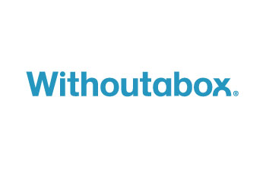

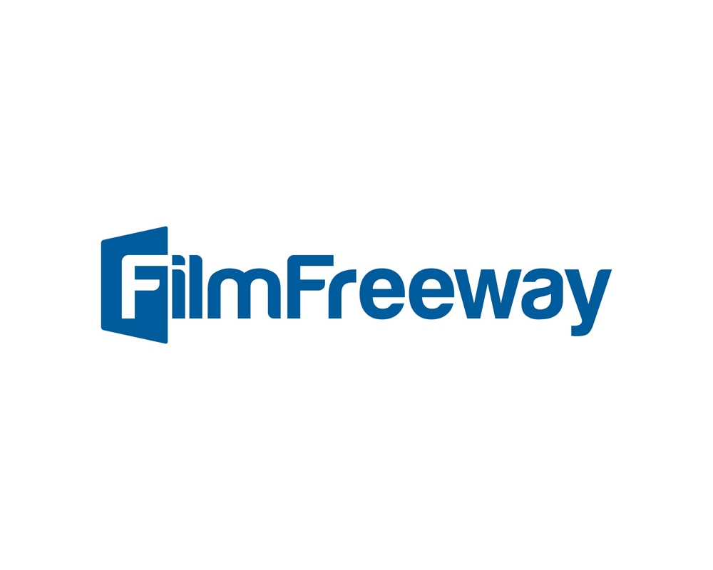

RECRUIT DIVERSE STUDENTS

LBI College and Career Fair (September 5, 2015)

Highlighting options in higher education and careers in arts and entertainment, our College and Career Fair is a great way for progressive colleges and career training programs to recruit students from Southern California’s diverse talent pool.

Exhibitor Deadlines | Early | Regular | Late
 | 3/1 | 5/1 | 7/1
 | $275 | $350 | $425

(You can remove table or the info contained in it if it’s too crowded)

To submit, register, or to get more information visit:

longbeachindie.com

Contact Long Beach Indie at info@longbeachindie.com

Mailing Info

Long Beach Indie International Film Festival
65 Pine Avenue Suite #375
Long Beach, CA 90802

