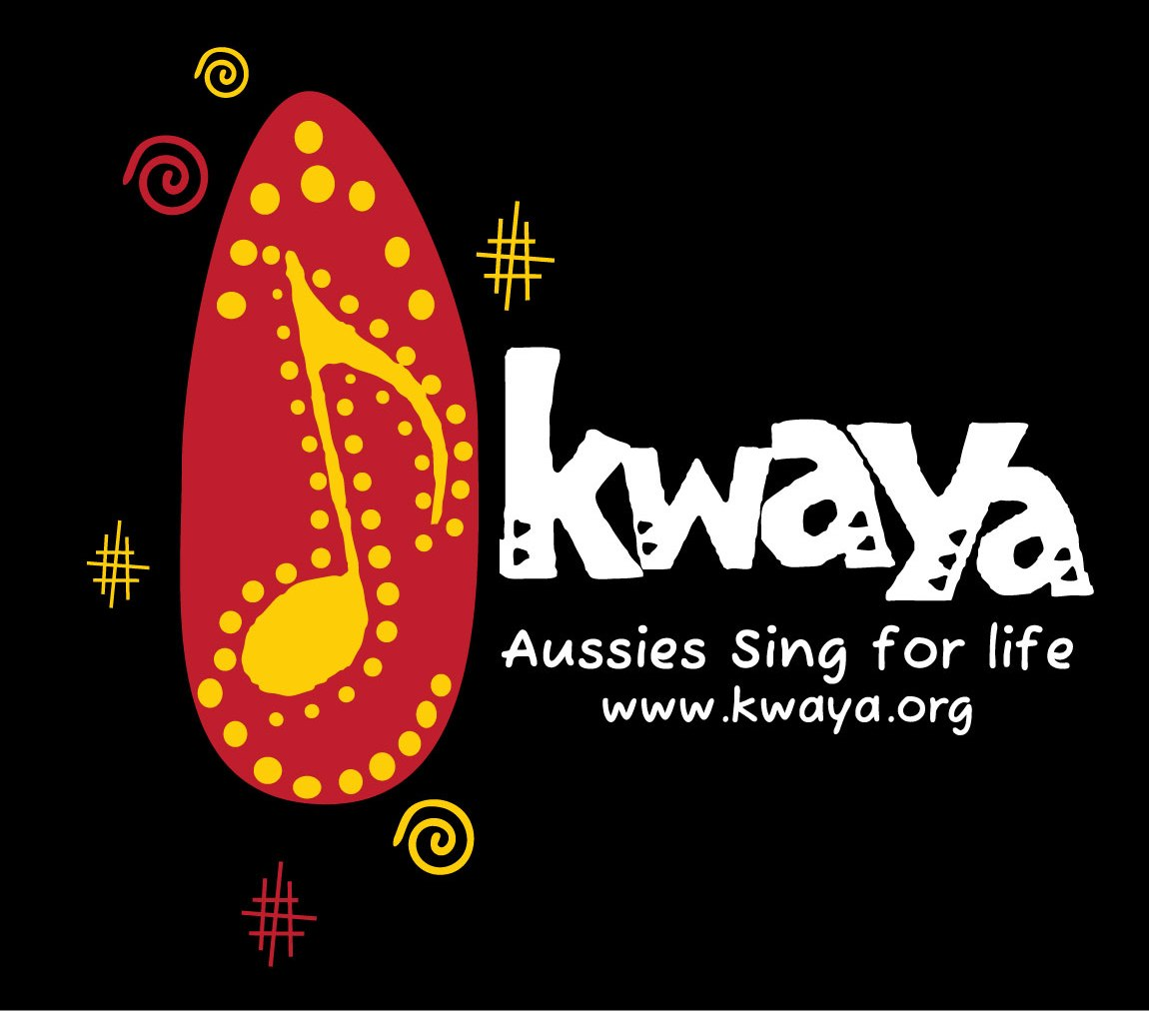
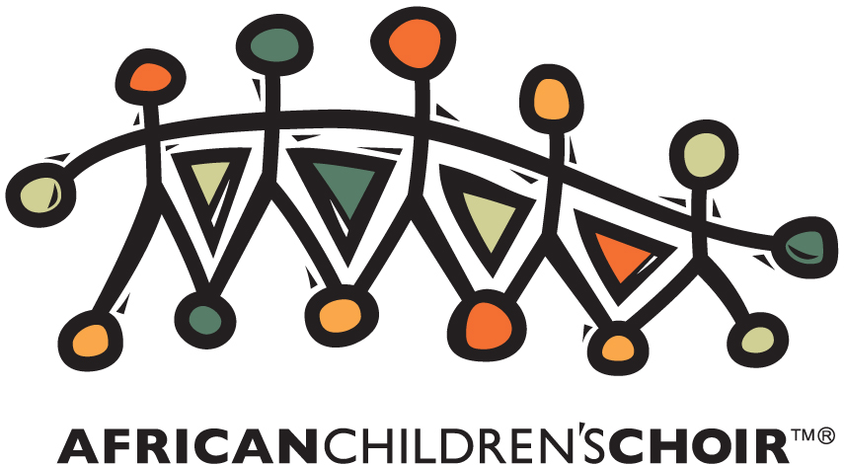
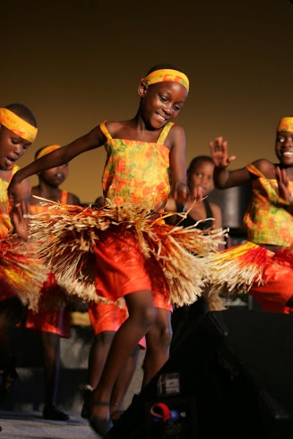
TICKETS and info at www.kwaya.org

CONTACT: Marsha Gusti 0433 134773

VICTORIA
Geelong
Sunbury
Melbourne
Bendigo
Albury

A.C.T.​
Canberra

N.S.W.​
Nowra
Sydney
Wollongong
Blue Mountains
Port Macquarie
Laurieton
Taree
Bellingen

QLD​
Byron Bay
Gold Coast
Sunshine Coast
Brisbane
Font for UNDER ONE SKY
Jellyka Jellyfish from www.dafont.com
Under One Sky
The African Children’s Choir
Australia Tour
A

