Hi,
I would like to adjust the specifications for this logo competition by providing more input and guidance. I had tried to leave it as broad as possible to encourage creativity and hopefully get something that I had not even considered. However, I would now like to provide more focus as below.
I would like a solid square or rectangular logo.
I would like the ability to have a solid colour/black background and have the ability to use it in black and white as well as infusing my favourite colours of turquoise and bright green (lime) eg it could be printed onto black tshirt with white print only or turquoise and lime.
I would like it to feature:
- A simple compass or half compass dial.
- The central pointer pointing to north would be a stylised simple person doing a yoga pose with upswept arms (see attached graphics with some examples ofsimilar pictures).
- The words : Explore Yoga Travel.
(I would like it to be simple and easy to print on stationery, webpages, advertismenst and tshirts - so it could feature just the above but if you feel it needs more it could be stylised by feautures like leaves, henna swirls or lotus petals).
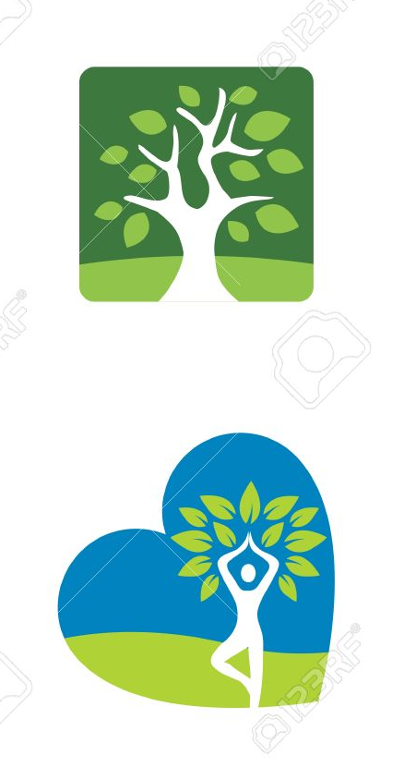
tree pose as pointer (not leaves) + I like these sort of colours.
I would like a solid background logo (square or rectangle). However I would like the ability to be able to print it with with just a black background and white printing plus the ability to print with similar green and blue colours of the heart logo below (but the name needs to be very clearly read still in the colours please).
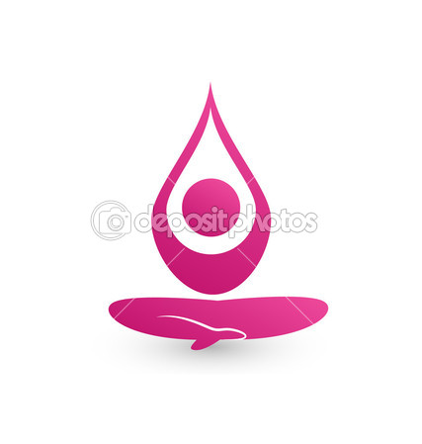
Or sitting yoga pose as shown in these three pics for north pointer with nice upswept arms.
