 | Someone who helps me unravel my problems and make them clearer
 | Someone who shares their knowledge and helps me develop my own processes/approach
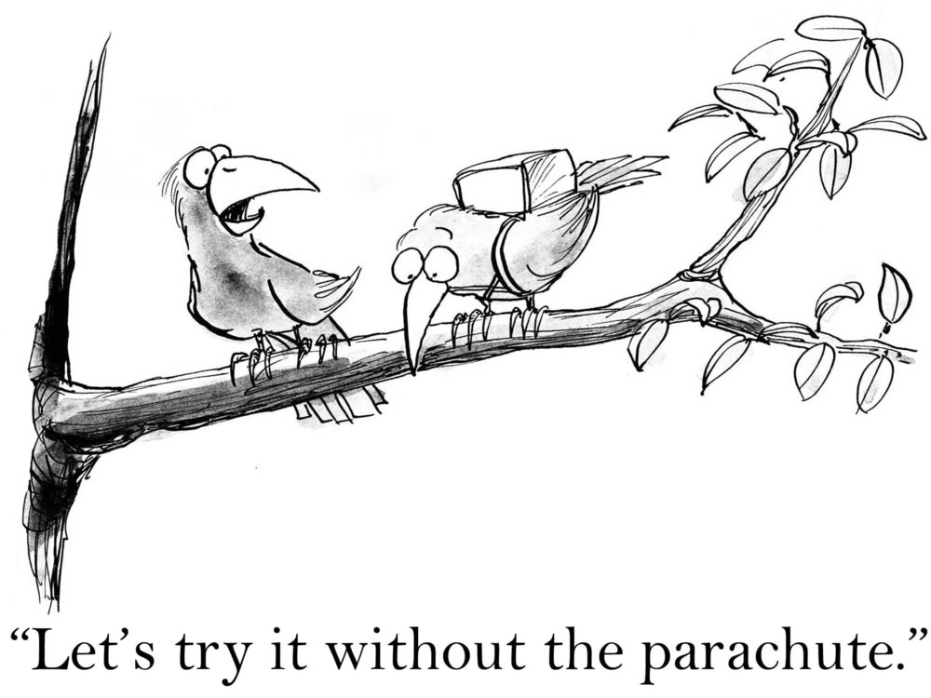 | Giving me tools so I can do it on my own
 | Like an imaginary friend  Always there to support me
 | Whispering friend  Helping me on what to say and do in the times of need
 | Helps me get out of the hole / helps me overcome obstacles
 | Maybe he’s invisible, but helps me keep afloat
 | Someone who provides a helping hand

