Please find below more details of the elements that we like:

Top menu/header:
- White top menu with red line beneath, stretching across the entire page. For inspiration please see https://smartify.no/ (please don’t look at the font for the menu points)
- Logo and menu points in one line within the white menu (please see brief for menu points. Remember no flags for the two languages).
- The logo and menu points are not to be wider than the header picture, which should not be the entire width of the page.

Background:
- The background should not be white, to create a contrast to the menu. Perhaps a light shade of grey.
- It will probably be nicest with background space between the top menu and the header picture.

Header picture:
- Not the entire width of the page (hard to find pictures that will look good in wide screen, without it covering the entire screen).
- If possible we would like to see the picture boxes of the destinations (Norway Tours, Sweden Tours etc). in the screen without having to scroll down.

Search box:
- We like the transparent search box as per below, but would not want it to cover the entire height of the picture. Nor do we like the Search…
- Please see the wireframe for the order of the drop down menus in the search box. The text should be within the drop down menus only.

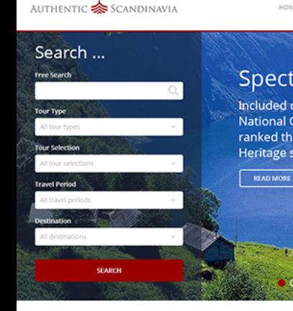
Destinations:
- As per wireframe, picture boxes with Norway Tours, Sweden Tours, Iceland Tours, Combination Tours.
- Arrow on the side to indicate that there are more boxes to the right
- Could you please try with the text for the picture boxes on the top so that it is immediately visible on the screen without scrolling down (if it is not space for the whole picture to show on a standard laptop). Alternively something similar to this (but with Norway Tours etc.):
- 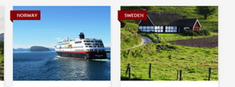

Scandinavia Specialist, Customer service (FAQ), Travel Experiences, Customer Protection, Travel Insurance:
- We do unfortunately not like any of the suggestions received. The below is the one which is most interesting…
- We do not like the signal colours of the red and green boxes. These should be more in the same style as the others.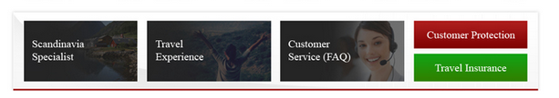
- We want the background for these boxes to a different shade than the overall background.

Special offers, populars tours:
- Instead of two rows I do like this:
