Thank you very much for all your submissions!

Please see the attached wireframe for an overview of how we would like the home page to be organized.

- The main picture should not cover the whole width of the page (it is difficult to find pictures that fit that wide frame without the picture covering the whole page.
- As I would like the main picture to change (three different pictures) there should not be too much disturbance in the picture (the search box and the text for the pictures)
- I would like for the logo, top menu, main picture and picture boxes with Norway Tours, Sweden Tours, Iceland Tours and Combination tours to appear on the screen without having to scroll down.
- Transparent search box over the picture, with inline text in drop down menus
- The text in the drop down menu should be All Destinations, All Tour Types, All Tour Selections, All Travel Periods. The Free Search. And Search button.
- With regards to the top menu I am not really happy with any of the suggestions. I like the one we have on our website per today, but it would need to look more modern. Is this something you can work with?
- Perhaps we can add contact and language (EN and GE – no flags due to customers from all over the world) to the top menu.
- I like the below look for the picture boxes for Special Offers and Popular Tours (perhaps something different for the Norway Tours, Sweden Tours etc?):
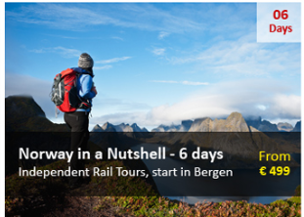
- Special offers: The 06-days in the top right corer will be replaced by the 10% off.
- Popular Tours: The 06-days in the top right corner will be removed
- I don’t like the yellow colour of the price must be changed to i.e. our blue colour.
- The frame around the Scandinavia Specialist etc boxes is not a hard frame, but a different shade from the other background
- The Scandinavia Specialist etc boxes should perhaps not be pictures as I am worried that it will be too chaotic with all the pictures.
- I like the following footers (perhaps a combination of the two):
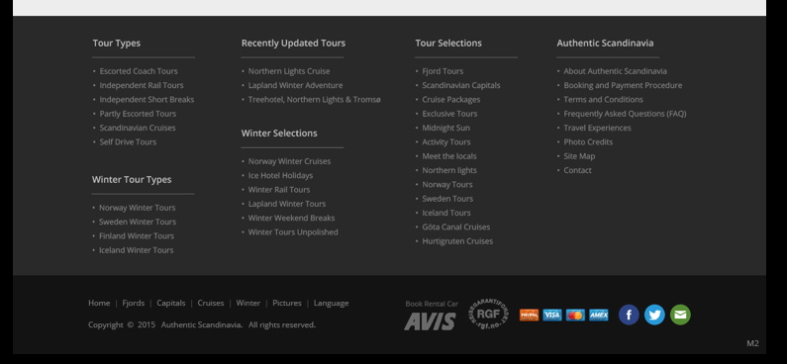
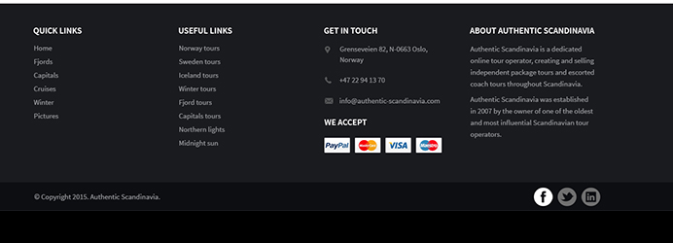
- The tour types and tour selection should be included. I also like the get in touch and we accept the following credit cards. The about Authentic Scandinavia intro text, first paragraph is good, below I would include the following links: About us, Booking & payment, Terms & conditions
- We also need to fit in site map and photo credit.
- I like that the top menu is repeated below with a darker background, as well as copyright, social media buttons and the RGF logo.

