FRONT OF CD COVER
PIPERLAIN (LOGO)

EMBRACE (TEXT)
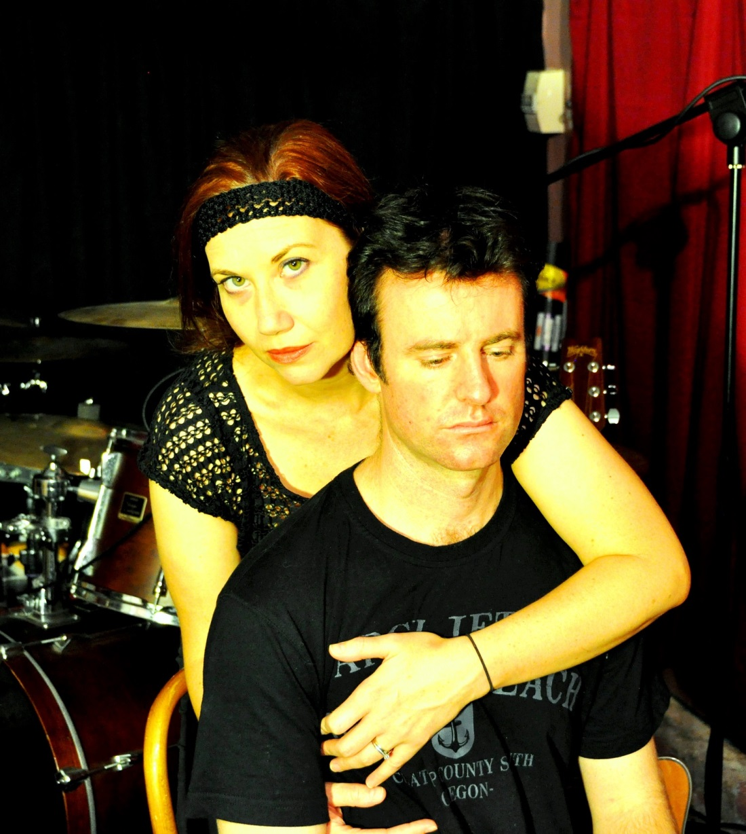

You can stylise this image, experiment with it to make it look stylish

BACK OF CD COVER

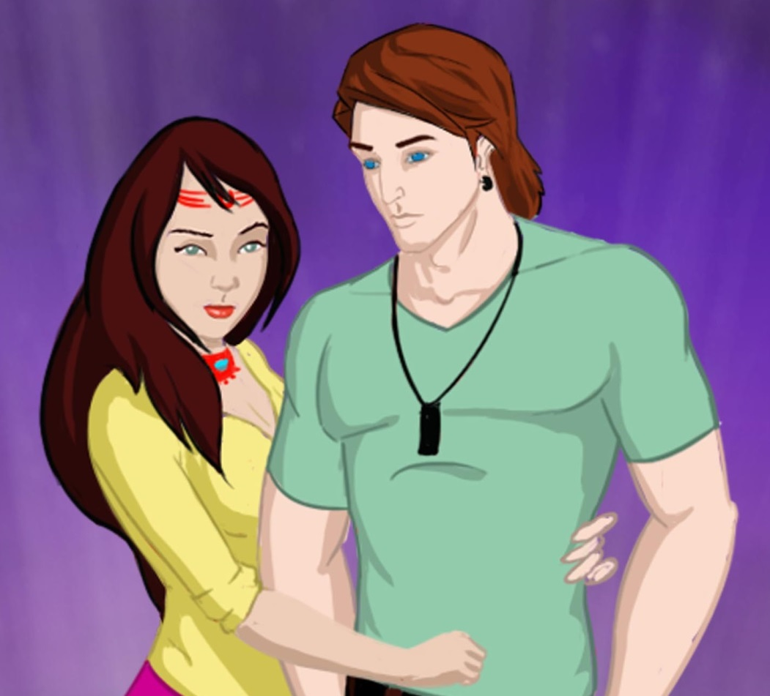
Embrace……………………….....3:38
Release Me…………………..….4:55
Now…………………………..…….3.06

Put the “P” in a circle like the ©
Put the characters in a TV set and remove the purple background. Note: This image may be replaced.

Vocals: Rebecca Voorn-Knight and Benjamin Knight
Guitars, Drums, Keyboard, Percussion: Benjamin Knight
All songs produced by Benjamin Knight and Rebecca Voorn-Knight with producer Josh Telford and executive producer Paul Iannuzzelli. Recorded at The Grove Studios. Mixed by Peter Holz (Embrace and Release Me), Jackson Barclay (Now) and Benjamin Knight (Now). Mastered at Studios 301 by Steve Smart.
Animation character design and animation music video clip by Lumicel www.lumicel.net. CD Artwork by XX sourced at DesignCrowd www.designcrowd.com. SFX credits: drewkelly, connum, bates8590, chewiesmissus, adam-n, ashfox, juskiddink, charel-sytze, eelke, bknight
For more information visit the Piperlain site at www.piperlain.com or www.facebook.com/piperlain.
© and (P) 2015 Audiofunk <Audiofunk logo> BARCODE
Made in Australia. All rights reserved.

Piperlain (logo)
Embrace (text)
Imagery
© and (P) 2015 Audiofunk <Audiofunk logo>
Made in Australia. All rights reserved.

SPECIFICATIONS - Please visit www.diskbank.com.au/templates/ for artwork specifications and templates
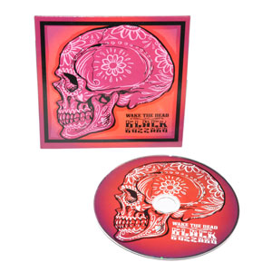
Cardboard sleeve

